A Major Mid Project Report on

**AI NEXUS: An Integrated Multi-Modal AI System**

Submitted in Partial Fulfillment of the Requirements for the Degree of **Bachelors in Software Engineering** Under Pokhara University

Submitted by :-

**Mr. Mehfuz Alam, 211724**

**Mr. Subash Magar, 211735**

**Mr. Ashok Bhujel, 211705**

Submitted to :-

**NCIT**

Date: 18 December, 2026

**Department of Software Engineering**

**NEPAL COLLEGE OF INFORMATION TECHNOLOGY**



Balkumari,Lalitpur, Nepal.

# ABSTRACT

AI\_NEXUS is an integrated multimodal artificial intelligence system designed to unify diverse AI capabilities—vision, language, speech, and generative intelligence—within a single scalable framework. The project brings together state-of-the-art deep learning models, large language models (LLMs), diffusion-based generative models, and agent-based architectures to demonstrate how modern AI systems can collaboratively process, generate, and reason across multiple data modalities.

The system consists of several interconnected modules, including image captioning using BLIP, image classification using ImageNet-pretrained CNNs, text-to-image generation using Stable Diffusion, diffusion-based image synthesis using DDPMs, an AI-driven news generation system with web-grounded LLM agents, an enterprise-grade conversational AI platform (NexusGPT), and a podcast question-answering system built on speech-to-text and retrieval-augmented generation (RAG). Each module is designed with production-readiness in mind, leveraging FastAPI for backend services, transformer-based architectures for intelligence, and modular deployment strategies for scalability. AI\_NEXUS emphasizes multimodal alignment, real-time inference, and explainable AI workflows. By integrating pretrained models with efficient orchestration frameworks such as LangChain, Diffusers, and vector databases, the system reduces development overhead while maintaining high performance and reliability. The project demonstrates how complex AI tasks—ranging from visual understanding and generative creativity to grounded question answering and automated media production—can be unified into a cohesive platform.

Overall, AI\_NEXUS serves as a comprehensive demonstration of modern multimodal AI system design, highlighting the convergence of computer vision, natural language processing, speech intelligence, and generative modeling for real-world applications.

***Keywords:*** *Multimodal Artificial Intelligence, Vision–Language Models, Diffusion Models, Large Language Models, Retrieval-Augmented Generation, Computer Vision, Natural Language Processing, Speech Recognition, Generative AI, FastAPI-Based AI Systems.*

**CONTENTS**

[ABSTRACT i](#_Toc218705964)

[1.INTRODUCTION 1](#_Toc218705965)

[2.PROBLEM STATEMENT 3](#_Toc218705966)

[3.PROJECT OBJECTIVES 4](#_Toc218705967)

[4.SIGNIFICANCE OF THE STUDY 5](#_Toc218705968)

[5.SCOPES AND LIMITATIONS 6](#_Toc218705969)

[SCOPES 6](#_Toc218705970)

[LIMITATIONS 6](#_Toc218705971)

[6.LITERATURE REVIEW 7](#_Toc218705972)

[7. PROPOSED METHODOLOGY 9](#_Toc218705973)

[OVERALL ARCHITECTURE 9](#_Toc218705974)

[PIPELINE METHODOLOGY 9](#_Toc218705975)

[DEVELOPMENT METHODOLOGY 10](#_Toc218705976)

[**AGILE METHODOLOGY** 10](#_Toc218705977)

[FIGURES 11](#_Toc218705978)

[**Usecase Diagram** 11](#_Toc218705979)

[**PINECONE DATABASE** 12](#_Toc218705980)

[**RAG (Retrieval Augmented Generation)** 13](#_Toc218705981)

[**ER DIAGRAM** 14](#_Toc218705982)

[8.TASK DONE SO FAR 15](#_Toc218705983)

[Module 1: 15](#_Toc218705984)

[**Model 1: Image Captioning using BLIP (Bootstrapped Language–Image Pretraining)** 15](#_Toc218705985)

[**Model 2: Cat vs Dog Image Classification using ImageNet CNNs** 24](#_Toc218705986)

[Module 2: 54](#_Toc218705987)

[**Model 1: Text-to-Image Generation using STABLE DIFFUSION Deep Learning** 54](#_Toc218705988)

[**Model 2: Butterfly Image Generation using Diffusion Models (DDPM)** 68](#_Toc218705989)

[Module 3: AI News Generation System using LLM Agents, Web Tools, TTS, and Video Synthesis 88](#_Toc218705990)

[Module 4: NexusGPT: Enterprise-Grade Conversational AI System using LangChain and Ollama 102](#_Toc218705991)

[Module 5: Podcast Q&A System using Speech-to-Text, Vector Embeddings, and Large Language Models 114](#_Toc218705992)

[9.RESULTS AND DISCUSSIONS 125](#_Toc218705993)

[10.PERFORMANCE ANALYSIS AND VALIDATION 126](#_Toc218705994)

[1.Module-Level Evaluation 126](#_Toc218705995)

[2.System-Level Evaluation 126](#_Toc218705996)

[3.Validation Scheme 127](#_Toc218705997)

[11.TASKS REMAINING 128](#_Toc218705998)

[12. PROPOSED DELIVERABLES / OUTPUTS 129](#_Toc218705999)

[13. PROJECT TASKS AND TIME SCHEDULE 131](#_Toc218706000)

[13.1 LIST OF TABLES 132](#_Toc218706001)

[TIME SCHEDULE (Gantt Chart) 132](#_Toc218706002)

[WORKLOAD DISTRIBUTION 133](#_Toc218706003)

[14. BIBLIOGRAPHY/REFERENCES 134](#_Toc218706004)

# 1.INTRODUCTION

Artificial Intelligence (AI) has evolved significantly over the past decade, transitioning from task-specific models to highly sophisticated systems capable of learning, reasoning, and generating content across multiple data modalities. Traditional AI systems were largely unimodal, operating independently on text, images, or audio. While effective within constrained domains, such systems lack the contextual awareness and adaptability required for complex real-world applications. This limitation has driven the emergence of **multimodal AI**, which integrates multiple forms of data to achieve richer understanding and more intelligent decision-making.

The rapid growth of deep learning, particularly transformer-based architectures, has played a pivotal role in this evolution. Models such as Vision Transformers (ViTs), Convolutional Neural Networks (CNNs), Large Language Models (LLMs), and diffusion-based generative models have demonstrated unprecedented performance in their respective domains. However, deploying these models in isolation fails to leverage their collective potential. Modern applications—such as intelligent assistants, automated media generation, interactive knowledge systems, and content analysis platforms—require seamless interaction between vision, language, and speech.

AI\_NEXUS is developed against this technological backdrop as an **integrated multimodal AI system** that consolidates diverse AI capabilities into a unified, modular, and scalable framework. The system integrates image understanding, image generation, natural language reasoning, speech processing, and retrieval-augmented intelligence under a single architectural umbrella. By combining pretrained state-of-the-art models with efficient orchestration frameworks, AI\_NEXUS addresses the growing demand for production-ready AI solutions that are both powerful and adaptable.

From a background study perspective, recent research highlights a shift toward **foundation models** trained on large-scale datasets and reused across tasks. Vision–language models such as BLIP enable semantic alignment between images and text, while diffusion models such as Stable Diffusion and DDPMs have redefined generative image synthesis. Similarly, LLMs augmented with external tools and vector databases have significantly improved factual grounding and contextual accuracy. AI\_NEXUS adopts these advancements and integrates them into a coherent system architecture.

Furthermore, the project emphasizes **practical deployment considerations**, including API-based access, modular design, scalability, and low-latency inference. The use of FastAPI for backend services, LangChain for prompt orchestration, and vector databases for semantic retrieval ensures that the system is not merely theoretical but suitable for real-world deployment.

In summary, AI\_NEXUS represents a comprehensive effort to bridge the gap between isolated AI models and fully integrated multimodal intelligence. It serves as both a functional AI platform and a reference architecture for next-generation AI systems, demonstrating how vision, language, speech, and generative models can operate collaboratively to solve complex, real-world problems.

# 2.PROBLEM STATEMENT

Most existing AI solutions are siloed, focusing on a single modality or task such as image recognition, text generation, or speech processing. This fragmentation leads to increased system complexity, poor interoperability, and limited real-world applicability.

The problem addressed by AI\_NEXUS is the lack of a unified, extensible platform that integrates multiple multimodal AI capabilities into a single coherent system. There is a need for an architecture that supports seamless interaction between vision, language, audio, and generative models while ensuring scalability, low latency, and deployment readiness.

# 3.PROJECT OBJECTIVES

The primary objectives of AI\_NEXUS are:

1.To design an integrated multimodal AI system combining vision, language, speech, and generative intelligence.

2.To implement state-of-the-art pretrained models for efficient and accurate inference.

3.To demonstrate real-world AI pipelines such as image captioning, generative media creation, conversational AI, and RAG-based question answering.

4.To ensure modularity and scalability using API-driven architectures.

5.To minimize hallucination and improve grounding through tool usage and retrieval mechanisms.

6.To provide production-ready deployment using FastAPI and modern AI frameworks.

# 4.SIGNIFICANCE OF THE STUDY

AI\_NEXUS demonstrates how modern AI systems can transcend single-task limitations by integrating multiple intelligent components into a unified framework. The project highlights best practices in multimodal AI design, including agent-based reasoning, retrieval augmentation, and diffusion-based generation.

This study is significant for students, researchers, and practitioners seeking to understand how enterprise-grade AI systems are architected and deployed. It also serves as a reference implementation for building scalable, modular, and production-ready multimodal AI platforms.

# 5.SCOPES AND LIMITATIONS

## SCOPES

1.Supports multimodal AI tasks including image understanding, text generation, speech processing, and media synthesis.

2.Uses pretrained models for rapid deployment and reduced computational cost.

3.Designed for extensibility, allowing additional AI modules to be integrated.

4.Suitable for applications in content creation, media automation, conversational systems, and knowledge retrieval.

## LIMITATIONS

1.Performance depends on hardware availability, particularly GPU acceleration.

2.Pretrained models may inherit dataset biases.

3.Real-time web-based components rely on external services.

4.Large-scale deployment may require additional optimization and monitoring infrastructure.

# 6.LITERATURE REVIEW

The rapid advancement of multimodal artificial intelligence has led to the development of frameworks and models capable of integrating language, vision, and tool-based reasoning into unified workflows. LangChain provides a robust platform for building **agentic AI pipelines**, enabling large language models (LLMs) to interact with external tools and APIs programmatically, thus supporting multi-step reasoning and decision-making [1].

Vision-language models, such as CLIP, have demonstrated the ability to **learn transferable visual representations from natural language supervision**, allowing AI systems to generalize effectively across image understanding and captioning tasks [2].

Search APIs, such as the DuckDuckGo API, enable agentic systems to access external knowledge in real-time, enhancing retrieval and reasoning capabilities [3].

The Hugging Face Transformers library offers comprehensive pre-trained models for natural language processing, providing the foundation for tasks such as text classification, question answering, and embedding generation [4].

Additionally, Retrieval-Augmented Generation (RAG) techniques combine embeddings and vector search with LLMs to improve accuracy on knowledge-intensive tasks, outperforming purely generative approaches [5].

OpenAI’s Whisper model has been widely adopted for **speech-to-text transcription**, demonstrating robustness in multilingual and noisy environments [6].

For web application deployment and API management, frameworks such as FastAPI provide **scalable backend services**, enabling real-time interaction between front-end interfaces and AI modules [7].

Latent Diffusion Models, as implemented in Stable Diffusion, allow **high-resolution image synthesis** by projecting complex images into a compressed latent space for efficient generation [8].

Documentation and tooling provided by Agno AI further enable developers to orchestrate agentic AI workflows and integrate external APIs seamlessly [9].

Finally, front-end frameworks like Streamlit allow rapid development of interactive Python-based applications, facilitating real-time visualization and multi-modal data processing [10].

Collectively, these works provide the foundational components for developing integrated multi-modal AI platforms that combine image, text, audio, and tool-based reasoning into unified, practical systems.

These studies collectively form the theoretical foundation for the unified multi-modal architecture implemented in AI Nexus.

# 7. PROPOSED METHODOLOGY

## OVERALL ARCHITECTURE

**Frontend:** Streamlit + HTML/CSS/JS.

**Backend:** FastAPI.

**AI Modules: (Overall Python)**

Stable Diffusion (Text-to-Image),

Whisper (Speech-to-Text),

Image Captioning Model,

Agno + Phidata (Agentic AI).

**Database:** Vector Store for RAG (Pinecone), SQlite.

**External Tools:** DuckDuckGo Search, File handling.

## PIPELINE METHODOLOGY

Users upload text, image, or audio, which FastAPI dispatches to the appropriate AI module for processing, with outputs returned in real-time to frontend, while agentic tasks use the LLM to decide, execute tools, and display results interactively.

## DEVELOPMENT METHODOLOGY

### **AGILE METHODOLOGY**

Agile is an iterative and flexible development approach where the project is divided into small, deliverable units called sprints. Instead of completing everything at once, Agile focuses on incremental development, where each sprint delivers one fully functional AI module. Work is planned, developed, tested, and reviewed within short sprint cycles, enabling frequent testing, quick feedback, and continuous improvement. This ensures faster delivery, high adaptability, and better alignment with changing project requirements.

**Why Agile?**

Agile helps in designing with multiple independent modules, enabling continuous integration, rapid prototyping, and Ability to test each AI service as soon as it is completed.

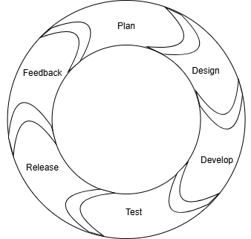

**Fig: Agile Methodology**

## FIGURES

### **Usecase Diagram**

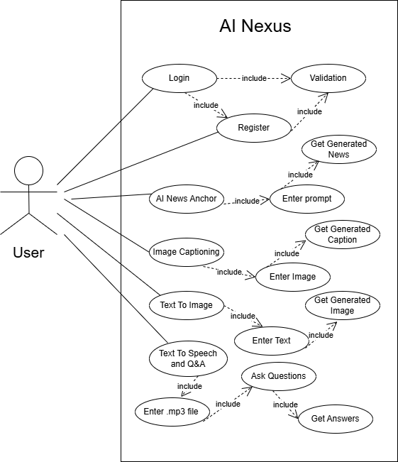

**Fig : Usecase Diagram of AI Nexus**

### **PINECONE DATABASE**

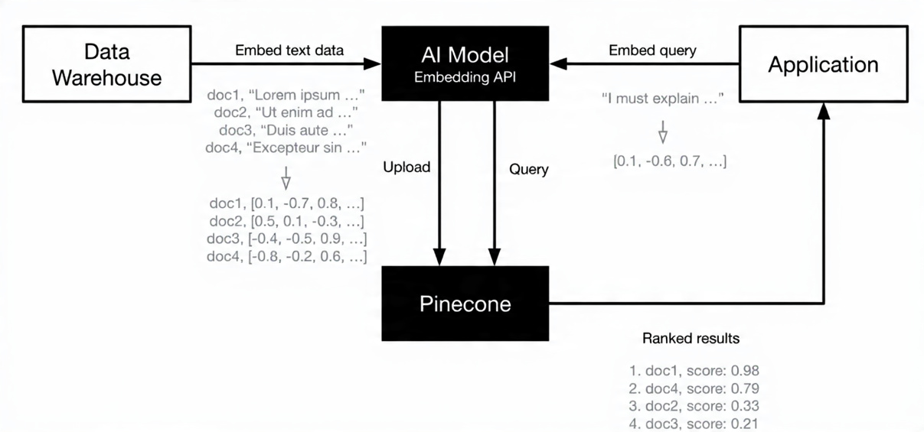

**Fig : PINECONE DATABASE**

### **RAG (Retrieval Augmented Generation)**

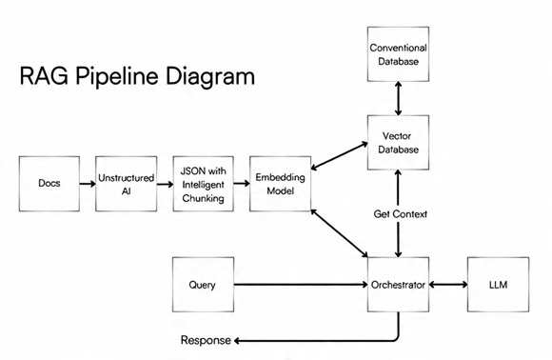

**FIG: RAG (Retrieval Augmented Generation)**

### **ER DIAGRAM**

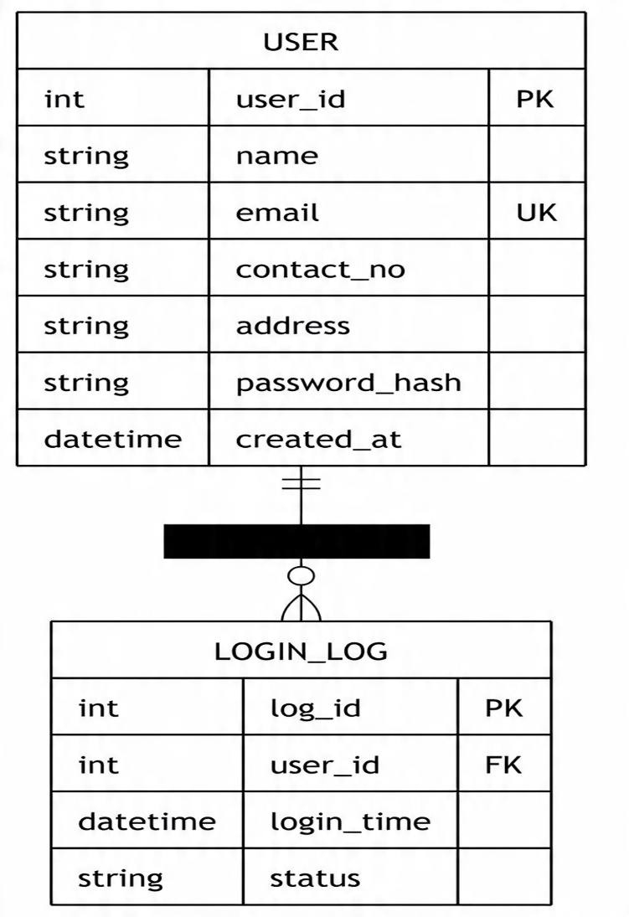

**Fig: ER DIAGRAM OF AI NEXUS**

# 8.TASK DONE SO FAR

## Module 1:

### **Model 1: Image Captioning using BLIP (Bootstrapped Language–Image Pretraining)**

**Technical Description**

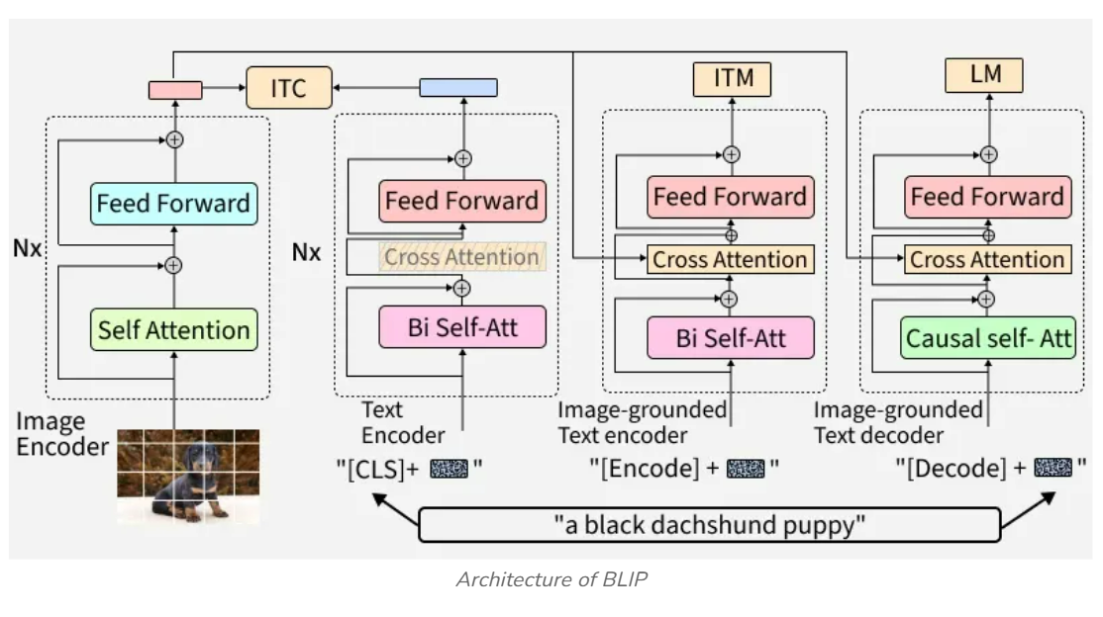

**FIG: BLIP (Bootstrapped Language–Image Pretraining)**

**Introduction**

Image captioning is a multimodal learning task that aims to generate a natural language description for a given image. It lies at the intersection of computer vision and natural language processing (NLP).

This module implements an image captioning backend service using FastAPI and the BLIP (Bootstrapped Language–Image Pretraining) model developed by Salesforce. The system accepts an image as input and generates a semantically meaningful caption describing the visual content.

**System Overview**

The system follows a server-based inference architecture:

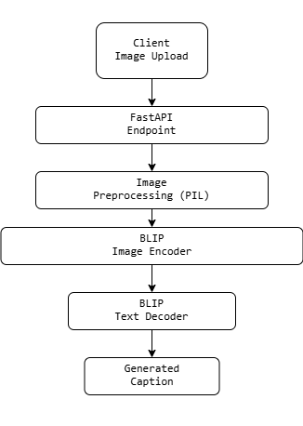

**FIG: SYSTEM ARCHITECTURE**

The BLIP model is loaded once at application startup to ensure low-latency inference.

**BLIP Model Overview**

BLIP stands for Bootstrapped Language–Image Pretraining. It is a vision–language model (VLM) designed to learn joint representations of images and text.

BLIP is capable of:

1.Image Captioning

2.Image–Text Retrieval

3.Visual Question Answering (VQA)

In this module, BLIP is used in image-to-text generation mode.

**Model Architecture**

BLIP consists of three major components:

Image → Vision Encoder → Multimodal Fusion → Text Decoder → Caption

**Vision Encoder**

The vision encoder is a Vision Transformer (ViT) that converts an image into a sequence of visual embeddings.

**Multimodal Transformer**

A transformer-based fusion module aligns visual embeddings with textual representations.

**Text Decoder**

A language model decoder generates captions autoregressively, token by token.

**Image Encoding (Vision Transformer)**

**Image Patch Embedding**

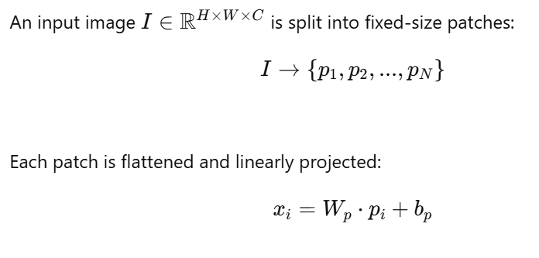

Positional embeddings are added to retain spatial information.

**Self-Attention Mechanism**

The Vision Transformer and language decoder both rely on scaled dot-product attention:

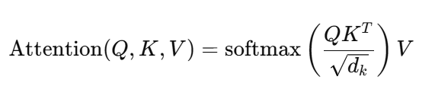

Where:

(Q) = Query matrix

(K) = Key matrix

(V) = Value matrix

(d\_k) = Key dimension

This allows the model to focus on relevant regions of the image while generating words.

**Multimodal Alignment**

BLIP aligns image and text embeddings into a shared latent space:

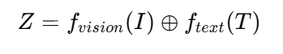

This alignment enables the model to associate visual features with linguistic concepts such as objects, actions, and attributes.

**Text Generation Process**

The caption is generated autoregressively:

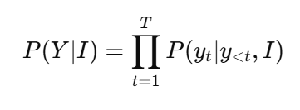

At each time step:

1.Previous tokens are fed into the decoder

2.Cross-attention attends to image embeddings

3.Next token probability is computed

**Decoder Output and Softmax**

The decoder outputs logits (z), which are converted to probabilities using softmax:

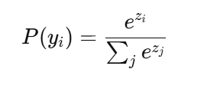

The token with the highest probability is selected during greedy decoding.

**Training Objective (Conceptual)**

BLIP is trained using cross-entropy loss for caption generation:

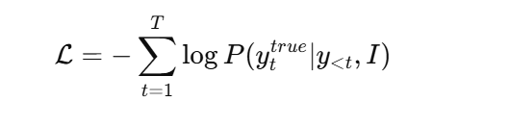

Additional pretraining objectives include:

Image–Text Contrastive Learning (ITC)

Image–Text Matching (ITM)

These objectives improve multimodal understanding.

**Inference in This Application**

**Processing Steps**

1.Uploaded image is converted to RGB format

2.BLIP processor normalizes and tokenizes input

3.Model generates token sequence

4.Tokens are decoded into a caption string

The entire process runs on pretrained weights without fine-tuning.

**FastAPI Integration**

The backend uses FastAPI to expose a REST endpoint:

POST /generate-caption/

Input: Image file

Output: JSON with generated caption

The model is loaded once to avoid repeated initialization overhead.

**Performance Considerations**

1.GPU acceleration significantly improves latency

2.Batch size is set to 1 for real-time inference

3.Model size is optimized for deployment

**Advantages of BLIP**

1.Strong vision–language alignment

2.Pretrained on large-scale image–text data

3.High-quality captions with semantic richness

4.Flexible for multiple multimodal tasks

**Conclusion**

This project demonstrates a complete image captioning pipeline using the BLIP model. By combining Vision Transformers, multimodal attention, and autoregressive text generation, the system produces accurate and descriptive captions from images. The FastAPI-based backend enables easy integration into real-world applications.

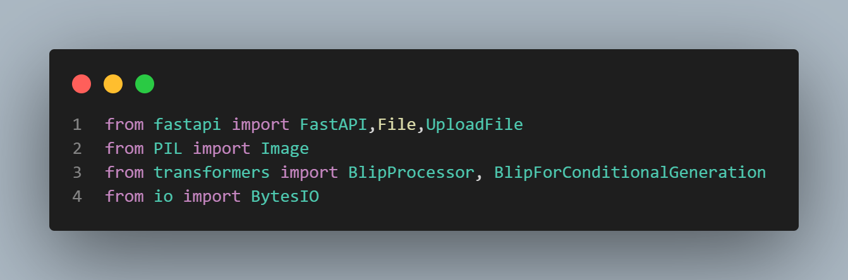

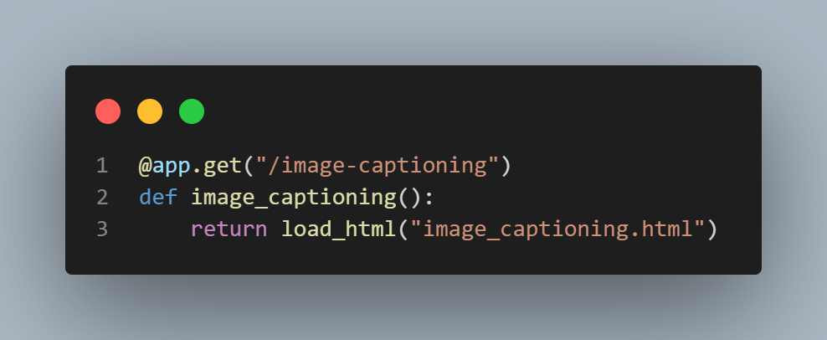

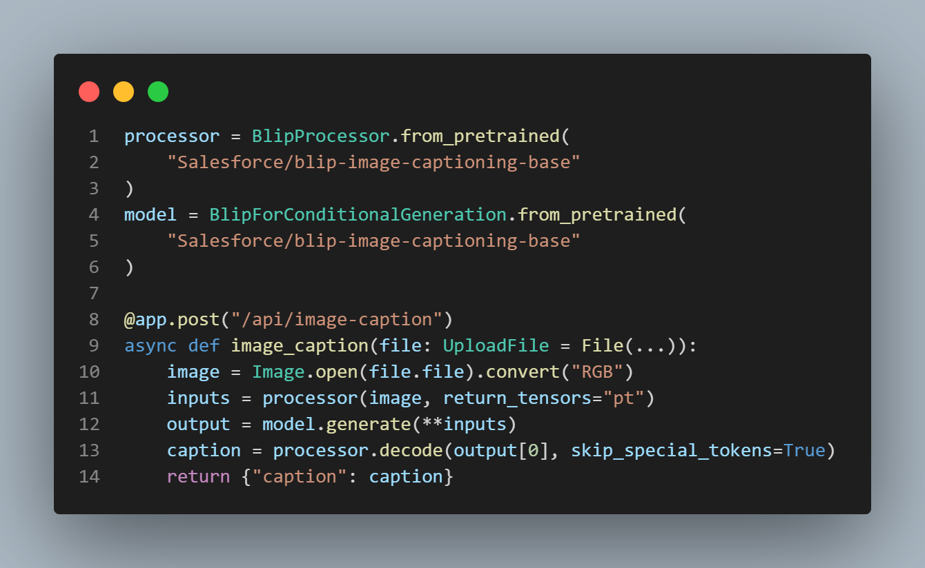

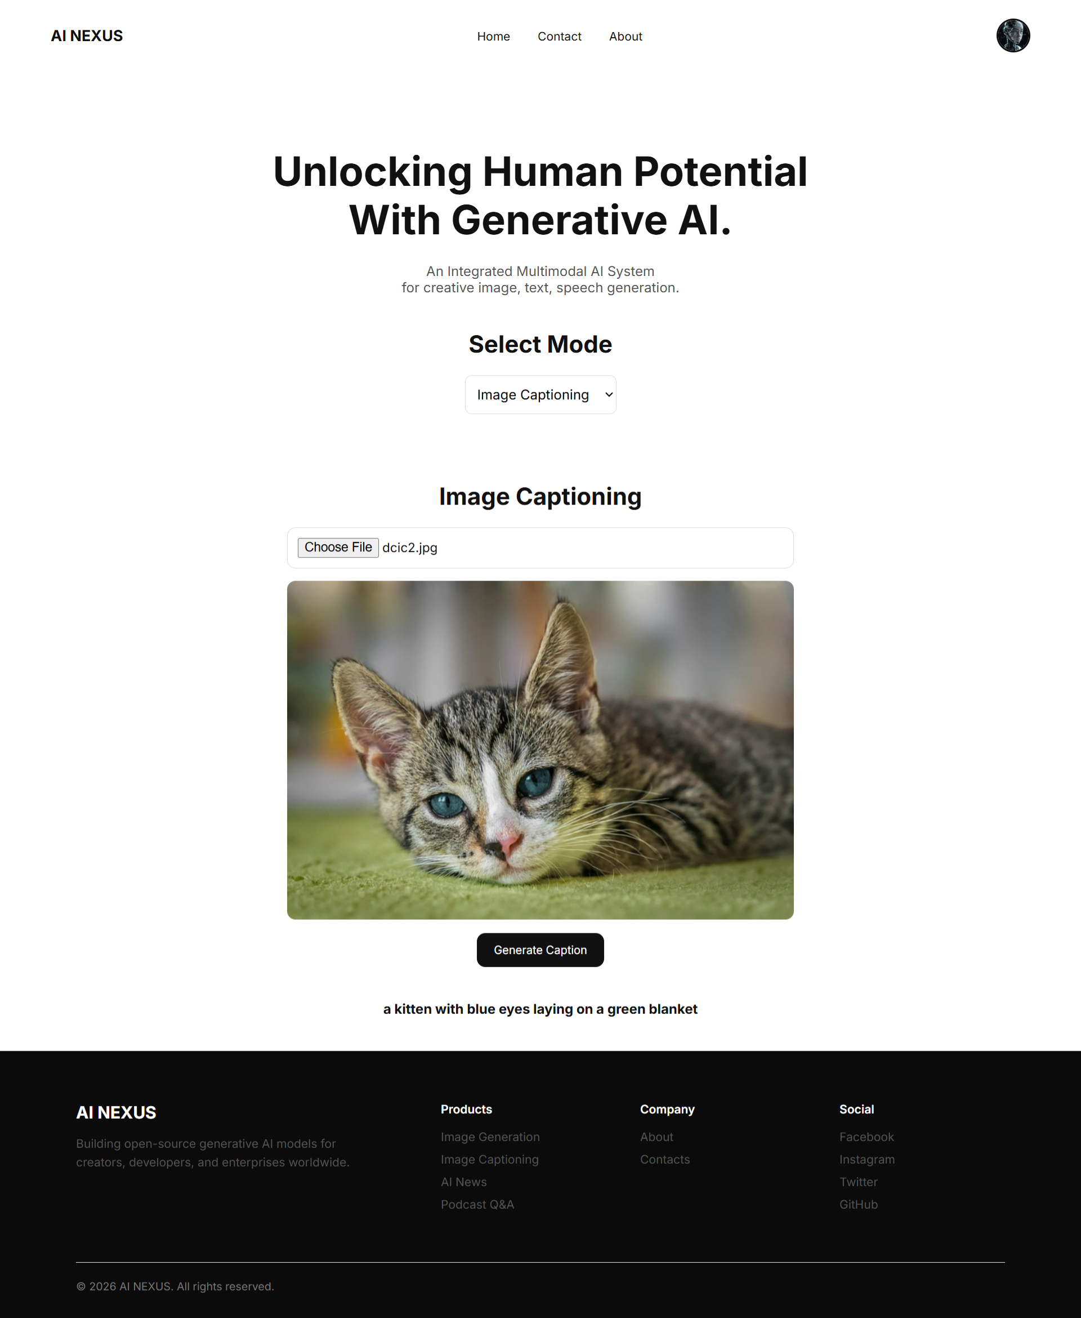

### **Model 2: Cat vs Dog Image Classification using ImageNet CNNs**

**Technical description**

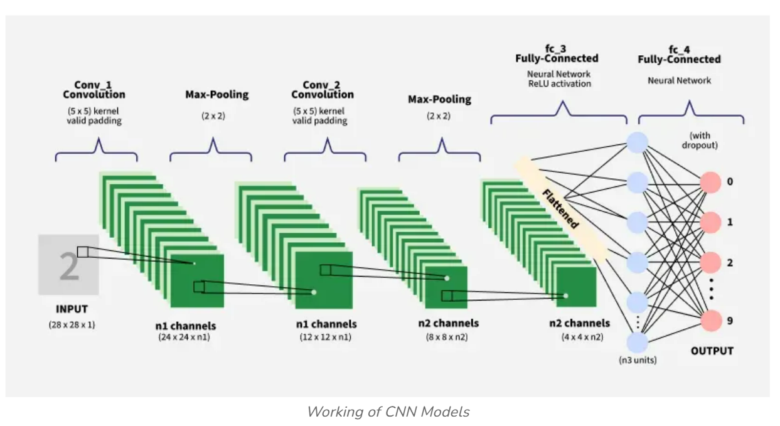

**FIG: WORKING OF CNN MODELS**

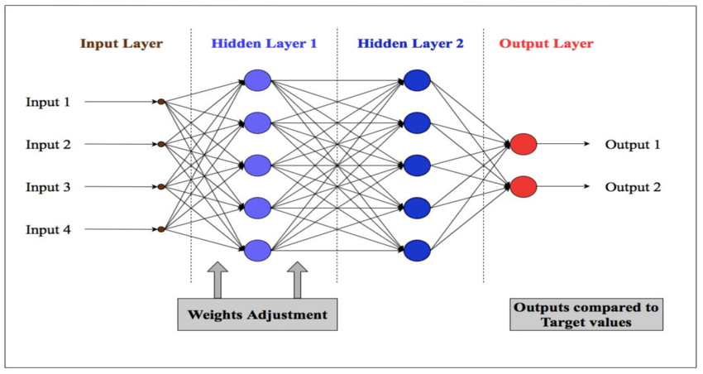

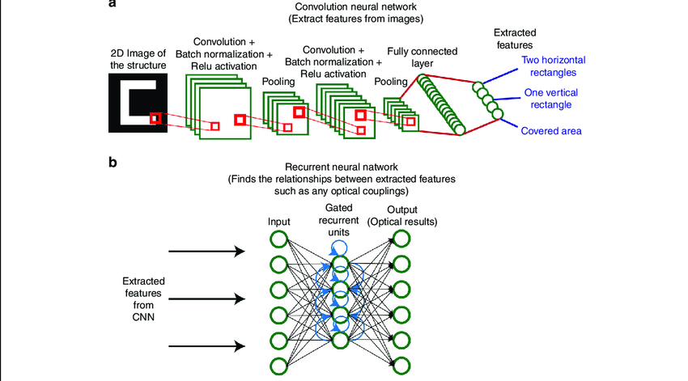

**FIG: IMAGENET ARCHITECTURE**

**Introduction**

Image classification is a core problem in computer vision where the goal is to assign a label to an image based on its visual content. This project focuses on binary image classification, specifically distinguishing between cats and dogs, using deep learning and transfer learning techniques.

Instead of training a convolutional neural network (CNN) from scratch, this project leverages ImageNet-pretrained models to improve performance, reduce training time, and handle limited data efficiently.

**Dataset Description**

The dataset consists of labeled images of cats and dogs organized in a directory structure compatible with Keras:

Dataset/

├── train/

│ ├── cats/

│ └── dogs/

├── validation/

│ ├── cats/

│ └── dogs/

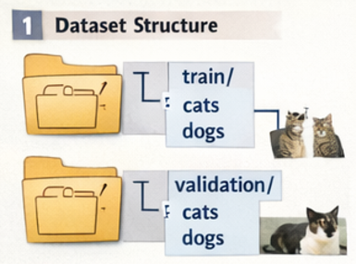

**Key Properties**

RGB images

Varying resolutions

Binary labels (Cat = 0, Dog = 1)

This folder-based organization allows automatic label inference by Keras data loaders.

**Data Preprocessing**

**Image Resizing**

All images are resized to **224 × 224 × 3**, which is the required input size for most ImageNet models (e.g., VGG16).

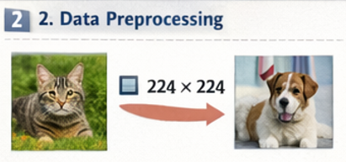

**Normalization**

Pixel values are rescaled from [0, 255] to [0, 1]:

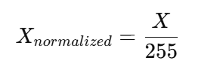

Normalization improves numerical stability and accelerates gradient-based optimization.

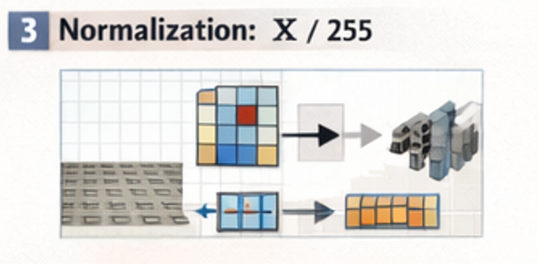

**Data Augmentation**

To reduce overfitting and improve generalization, data augmentation is applied to training images.

**Augmentation Techniques**

| **Technique** | **Mathematical Effect** |
| --- | --- |
| Rotation | ( R(theta)X ) |
| Zoom | ( sX ) |
| Horizontal Flip | ( X' = X[:, ::-1] ) |
| Rescaling | ( X / 255 ) |

These transformations create new training samples without increasing dataset size.

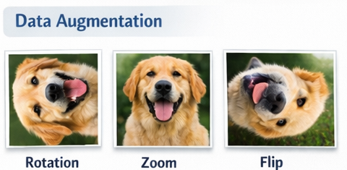

**Convolutional Neural Networks (CNNs)**

CNNs are specialized neural networks designed for image data. They exploit local spatial correlations and parameter sharing.

**Convolution Operation**

A convolution layer computes:

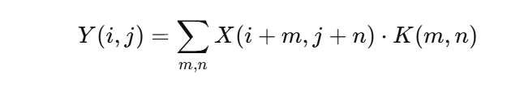

Where:

(X) = Input image

(K) = Kernel (filter)

(Y) = Feature map

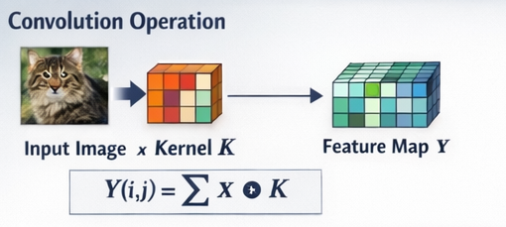

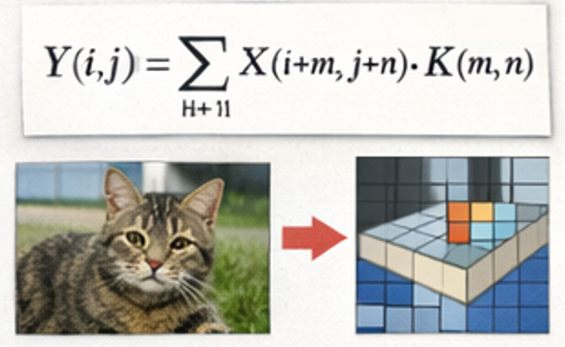

**Pooling**

Max-pooling reduces spatial dimensions:

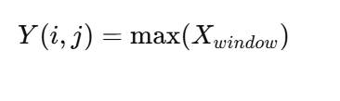

This provides translation invariance and reduces computation.

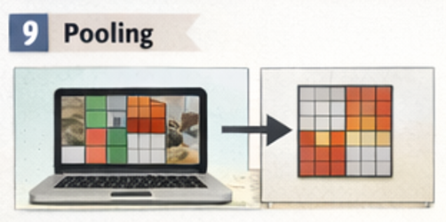

**Transfer Learning**

**Concept**

Transfer learning reuses knowledge from a model trained on a large dataset (ImageNet) and applies it to a new task.

ImageNet contains 14+ million images across 1000 classes, enabling models to learn universal visual features such as edges, textures, and shapes.

**Feature Extraction**

Pretrained convolutional layers are frozen and used as fixed feature extractors:

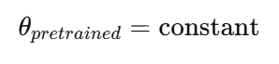

Only newly added layers are trained.

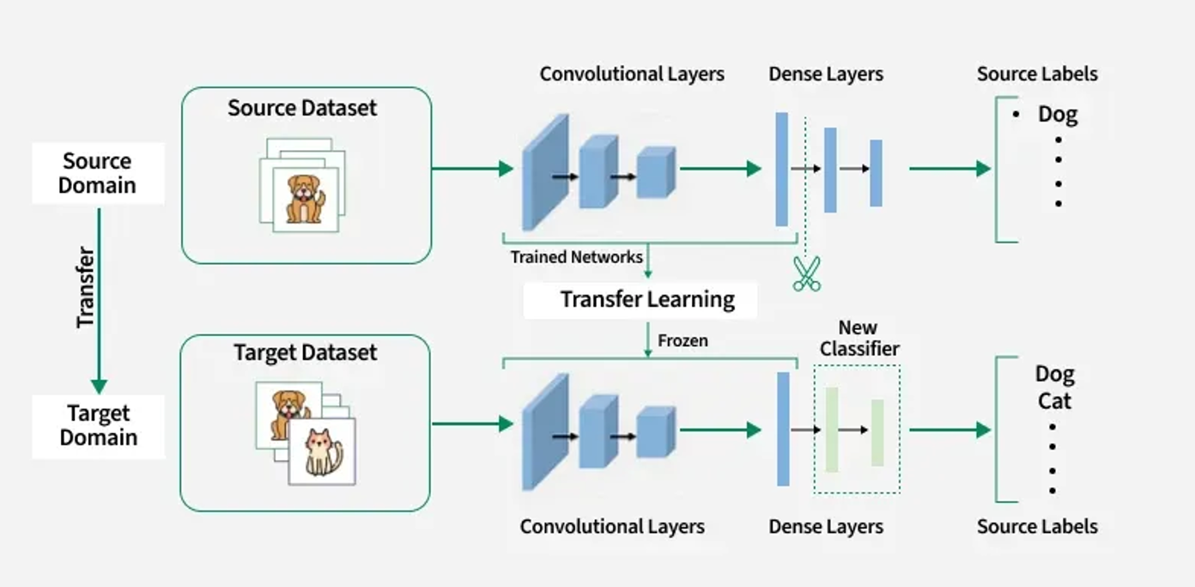

**FIG: TRANSFER LEARNING ARCHITECTURE**

**Model Architecture**

**Base Model (VGG16)**

VGG16 consists of stacked convolution blocks:

[Conv → ReLU → Conv → ReLU → MaxPool] × N

These layers capture increasingly abstract visual features.

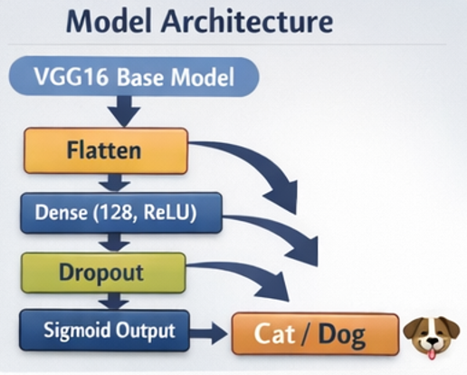

**Custom Classification Head**

Flatten

↓

Dense (128, ReLU)

↓

Dropout (0.5)

↓

Dense (1, Sigmoid)

**Layer Functions**

**Flatten**: Converts 3D feature maps to 1D vector

**Dense**: Learns task-specific patterns

**Dropout**: Prevents overfitting

**Sigmoid**: Outputs probability

**Mathematical Formulation of the Model**

**Dense Layer**

Z=W^TX+b

**Activation Functions**

**ReLU:**  
  
f(x)=max(0,x)

**Sigmoid:**  
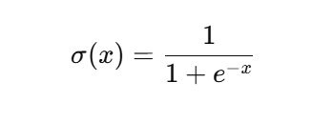

**Loss Function**

Binary Cross-Entropy is used:

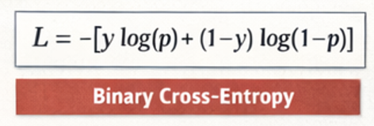

Where:

(y) = True label

(p) = Predicted probability

This loss penalizes confident wrong predictions heavily.

**Optimization**

**Adam Optimizer**

Adam combines momentum and adaptive learning rates:

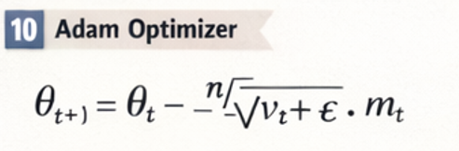

Where:

(m\_t) = First moment estimate

(v\_t) = Second moment estimate

Adam provides fast convergence and robustness.

**Training Process**

For each epoch:

1.Load batch of images

2.Forward propagation

3.Loss computation

4.Backpropagation

5.Weight update

Frozen layers remain unchanged; only custom layers are updated.

**Model Evaluation**

Performance is measured using:

Training Accuracy

Validation Accuracy

Loss Curves

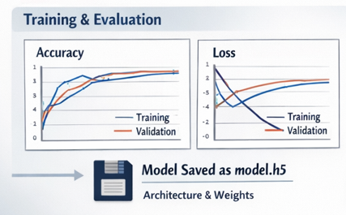

**Overfitting Detection**

If validation loss increases while training loss decreases, overfitting is occurring.

**Prediction Pipeline**

Input Image

→ Resize (224×224)

→ Normalize

→ CNN Feature Extraction

→ Dense Layers

→ Sigmoid Output

→ Cat / Dog

A threshold of 0.5 is used for binary decision making.

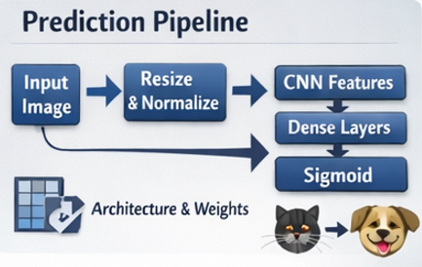

**Model Persistence**

The trained model is saved in .h5 format, which stores:

Model architecture

Weights

Optimizer state

This allows reuse without retraining.

**Conclusion**

This model demonstrates a complete, production-ready deep learning pipeline for image classification using:

Transfer learning

CNN architectures

Mathematical optimization

Regularization techniques

By leveraging ImageNet pretrained models, high accuracy is achieved with limited data and reduced computational cost.

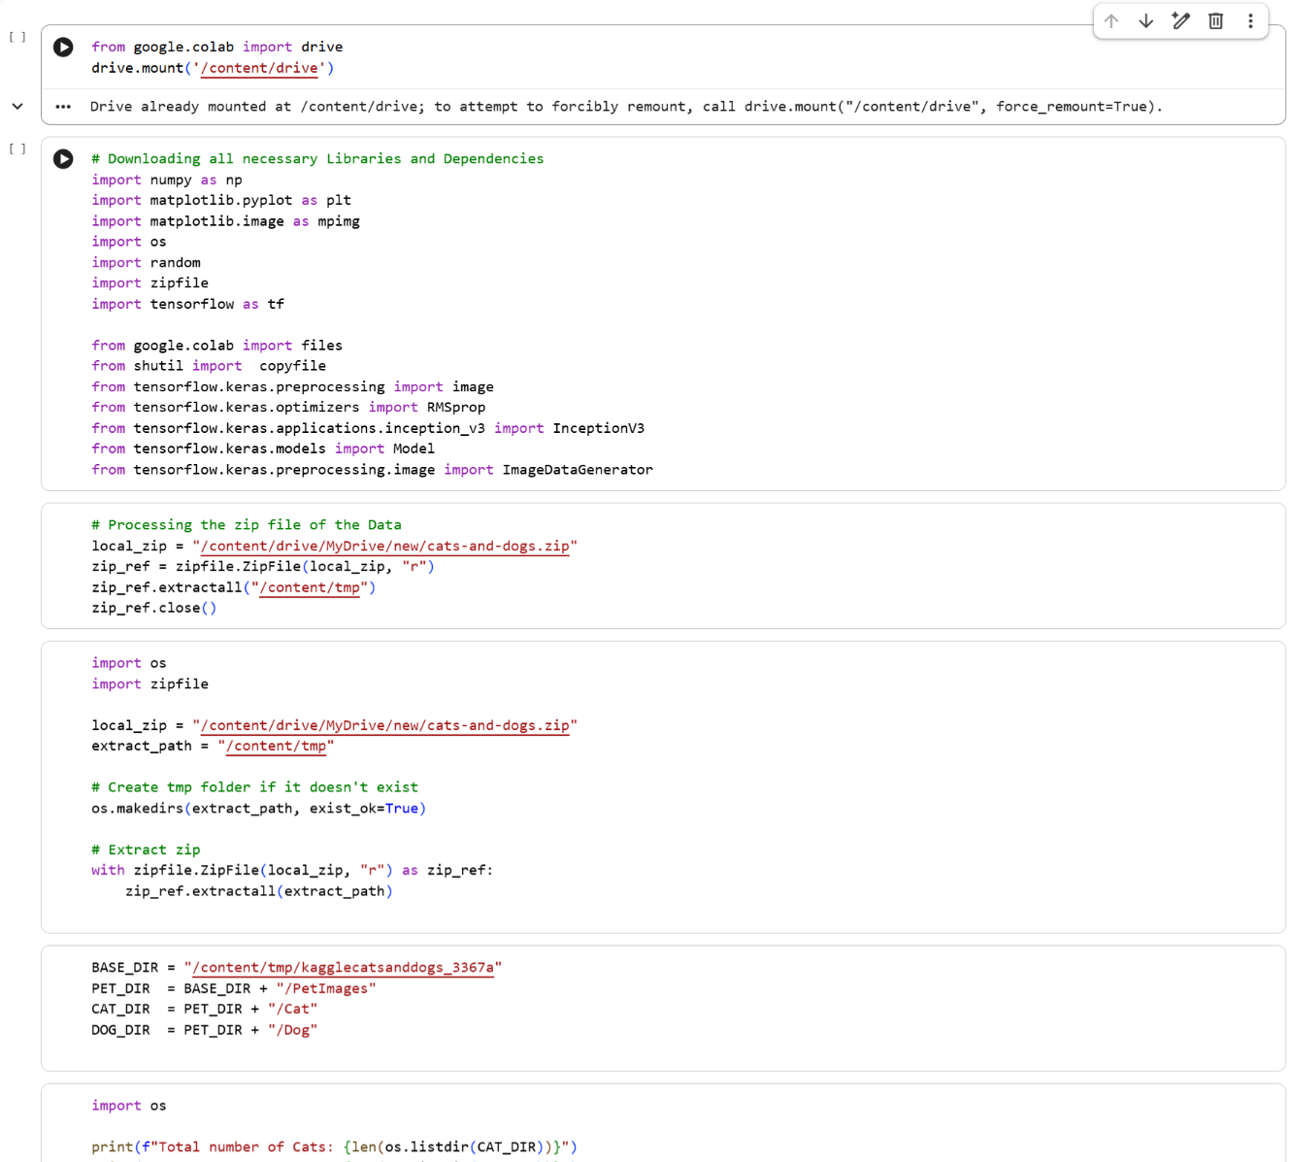

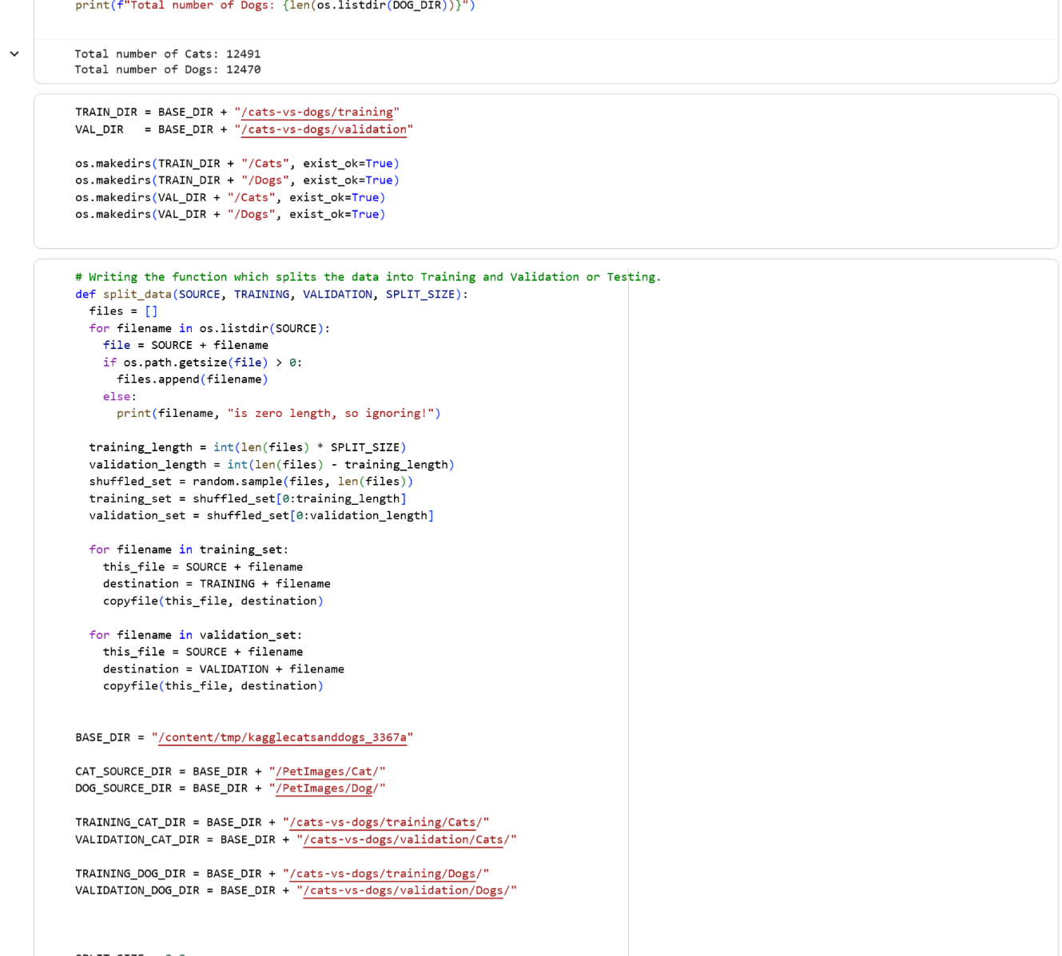

**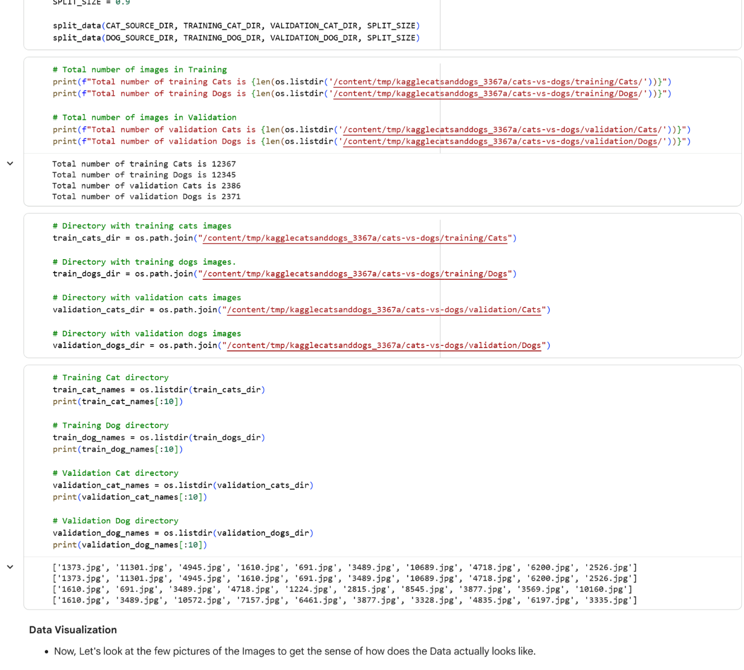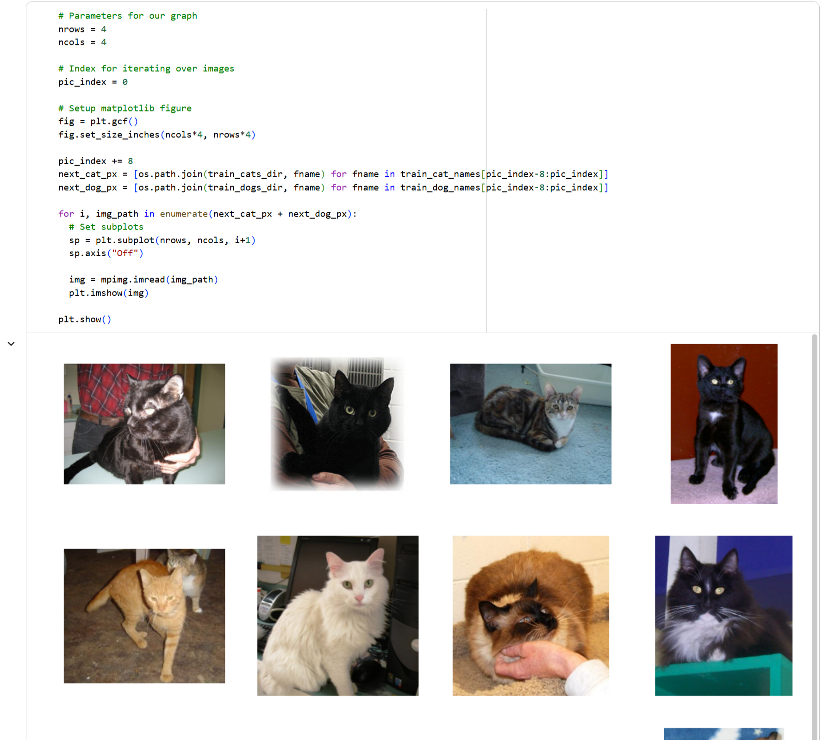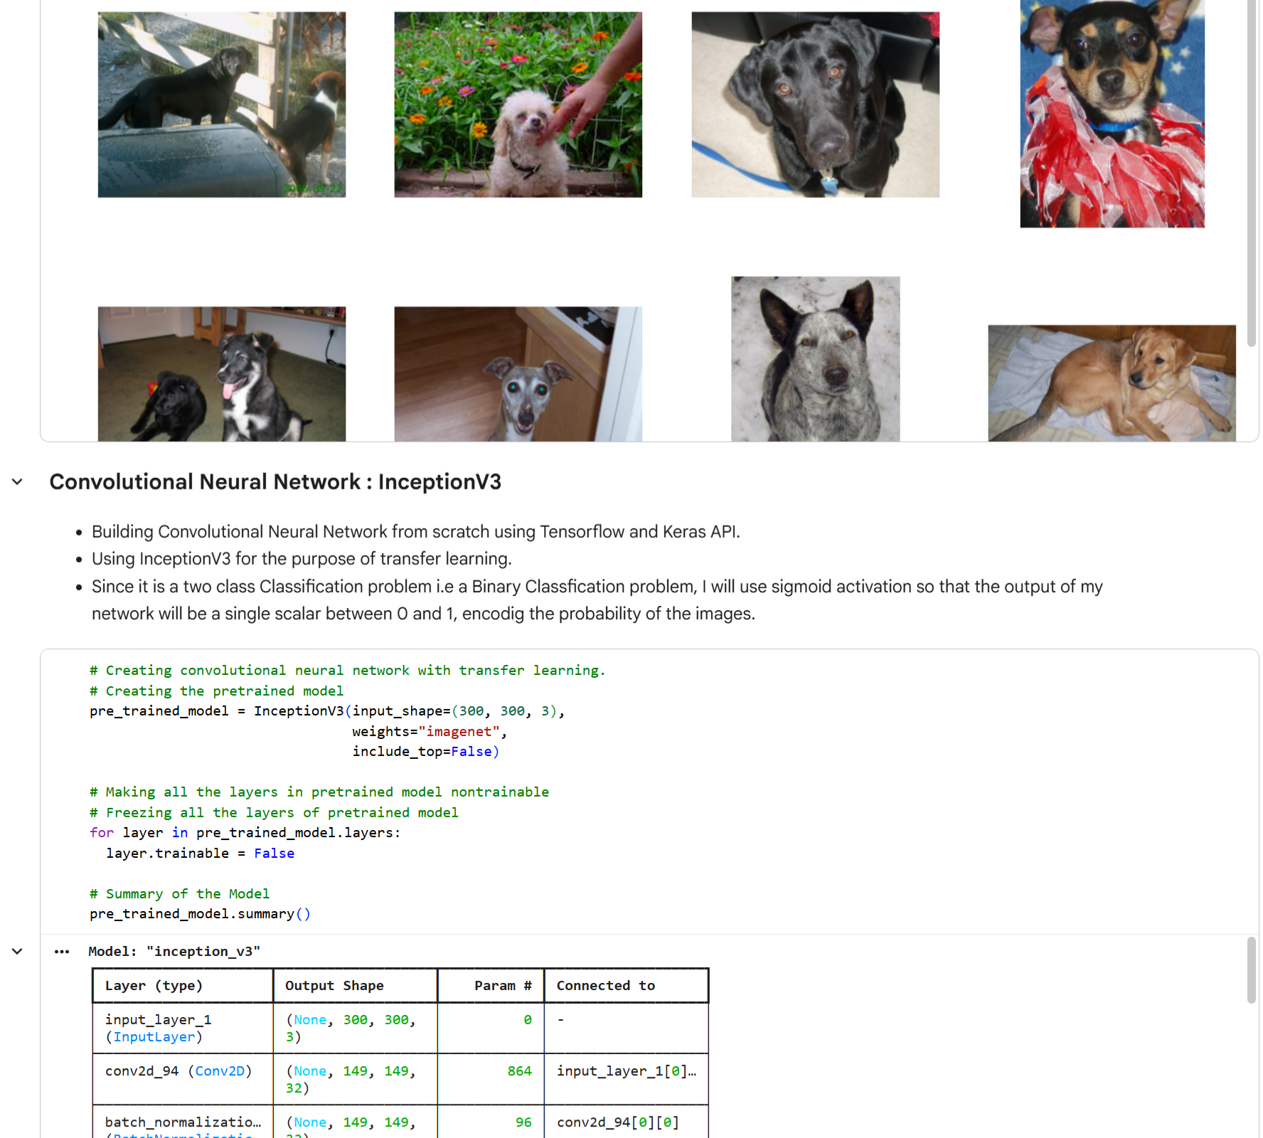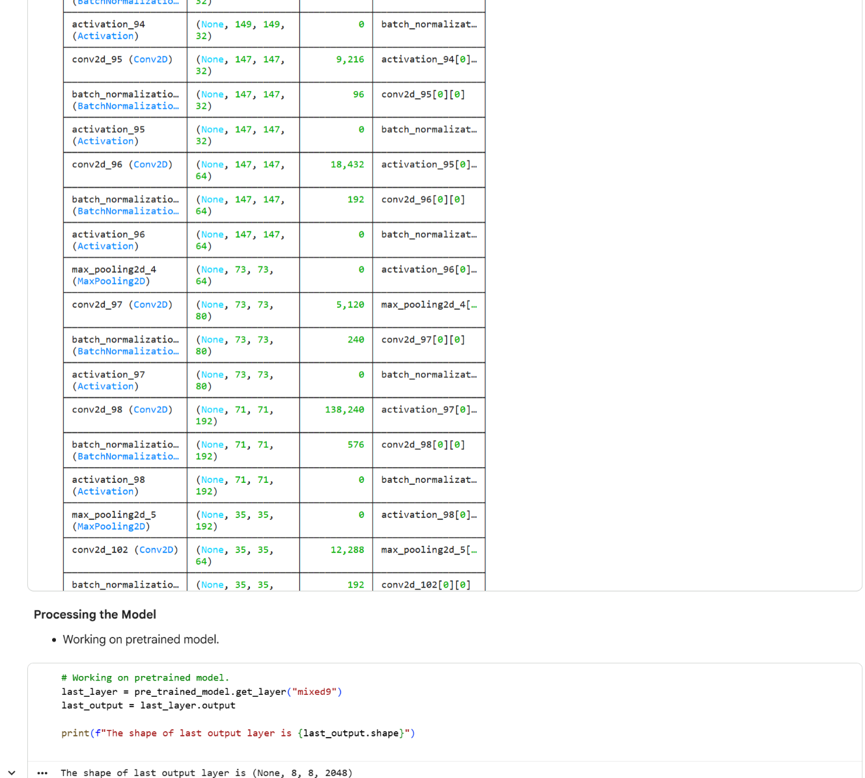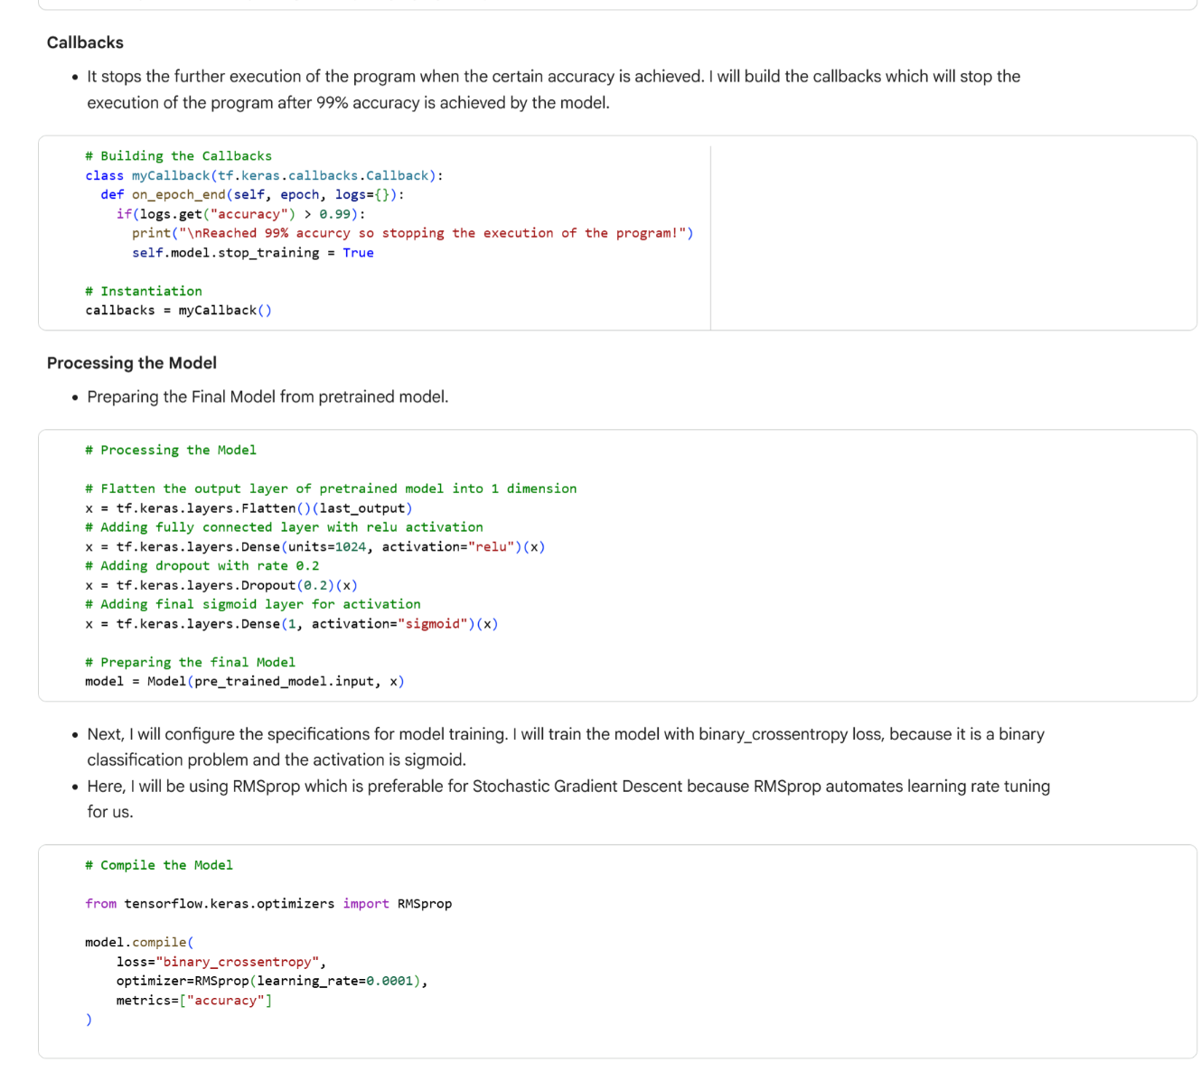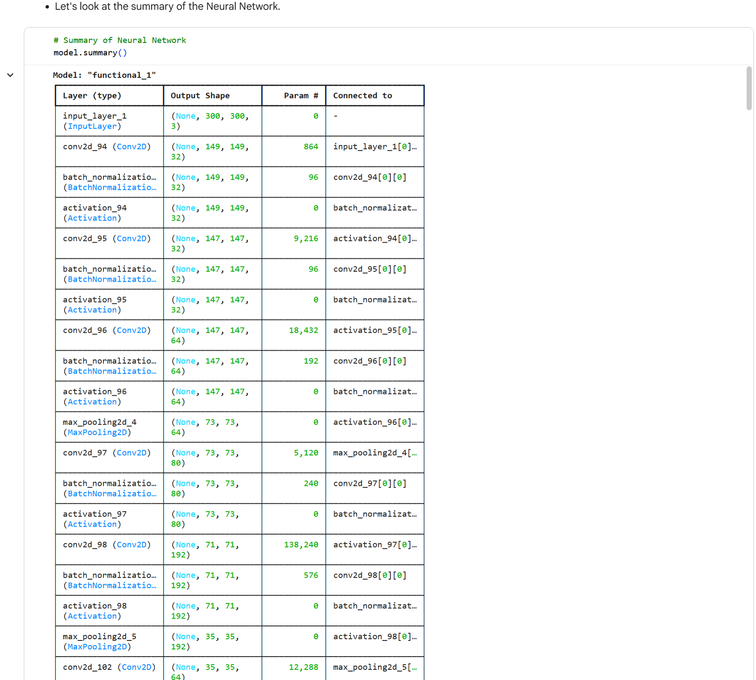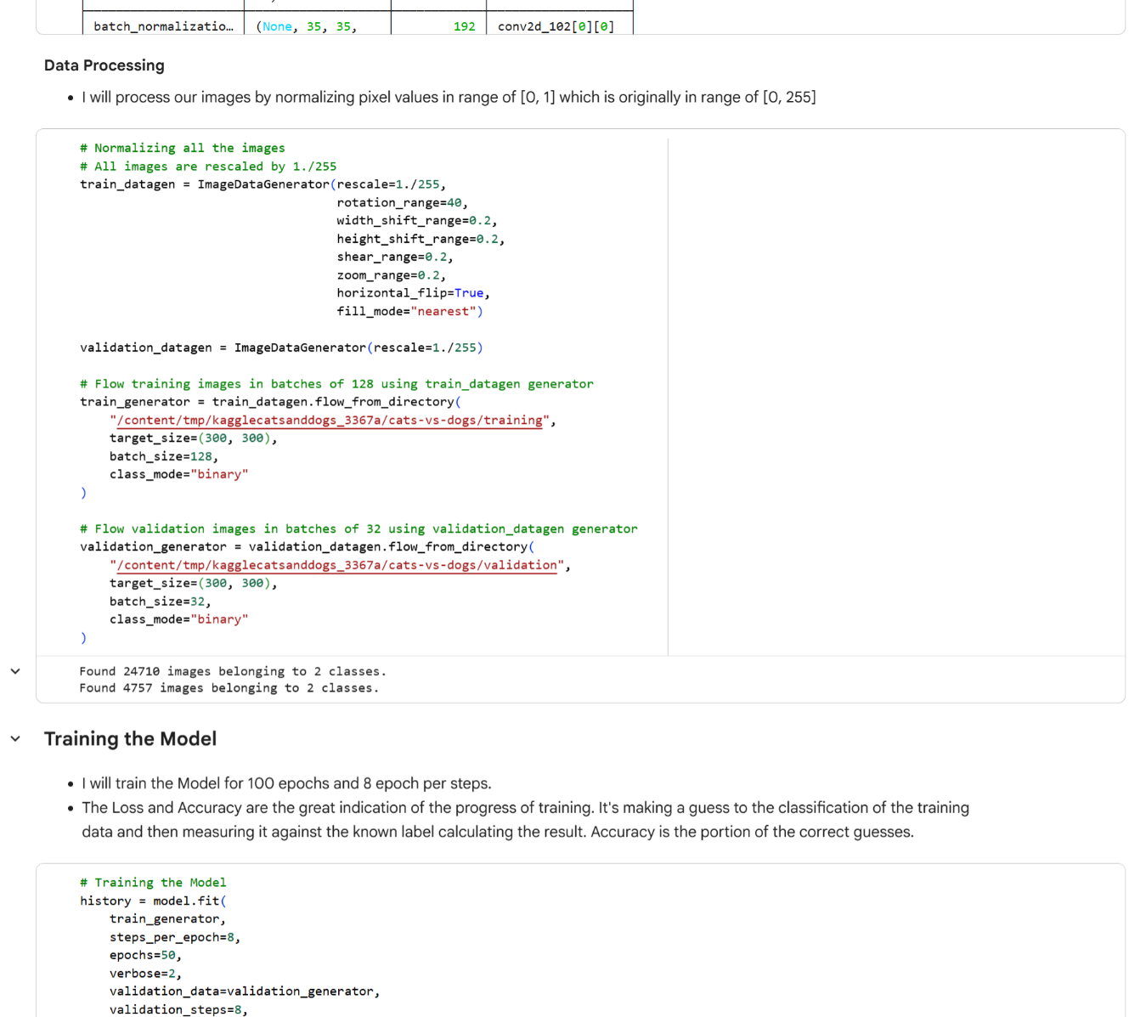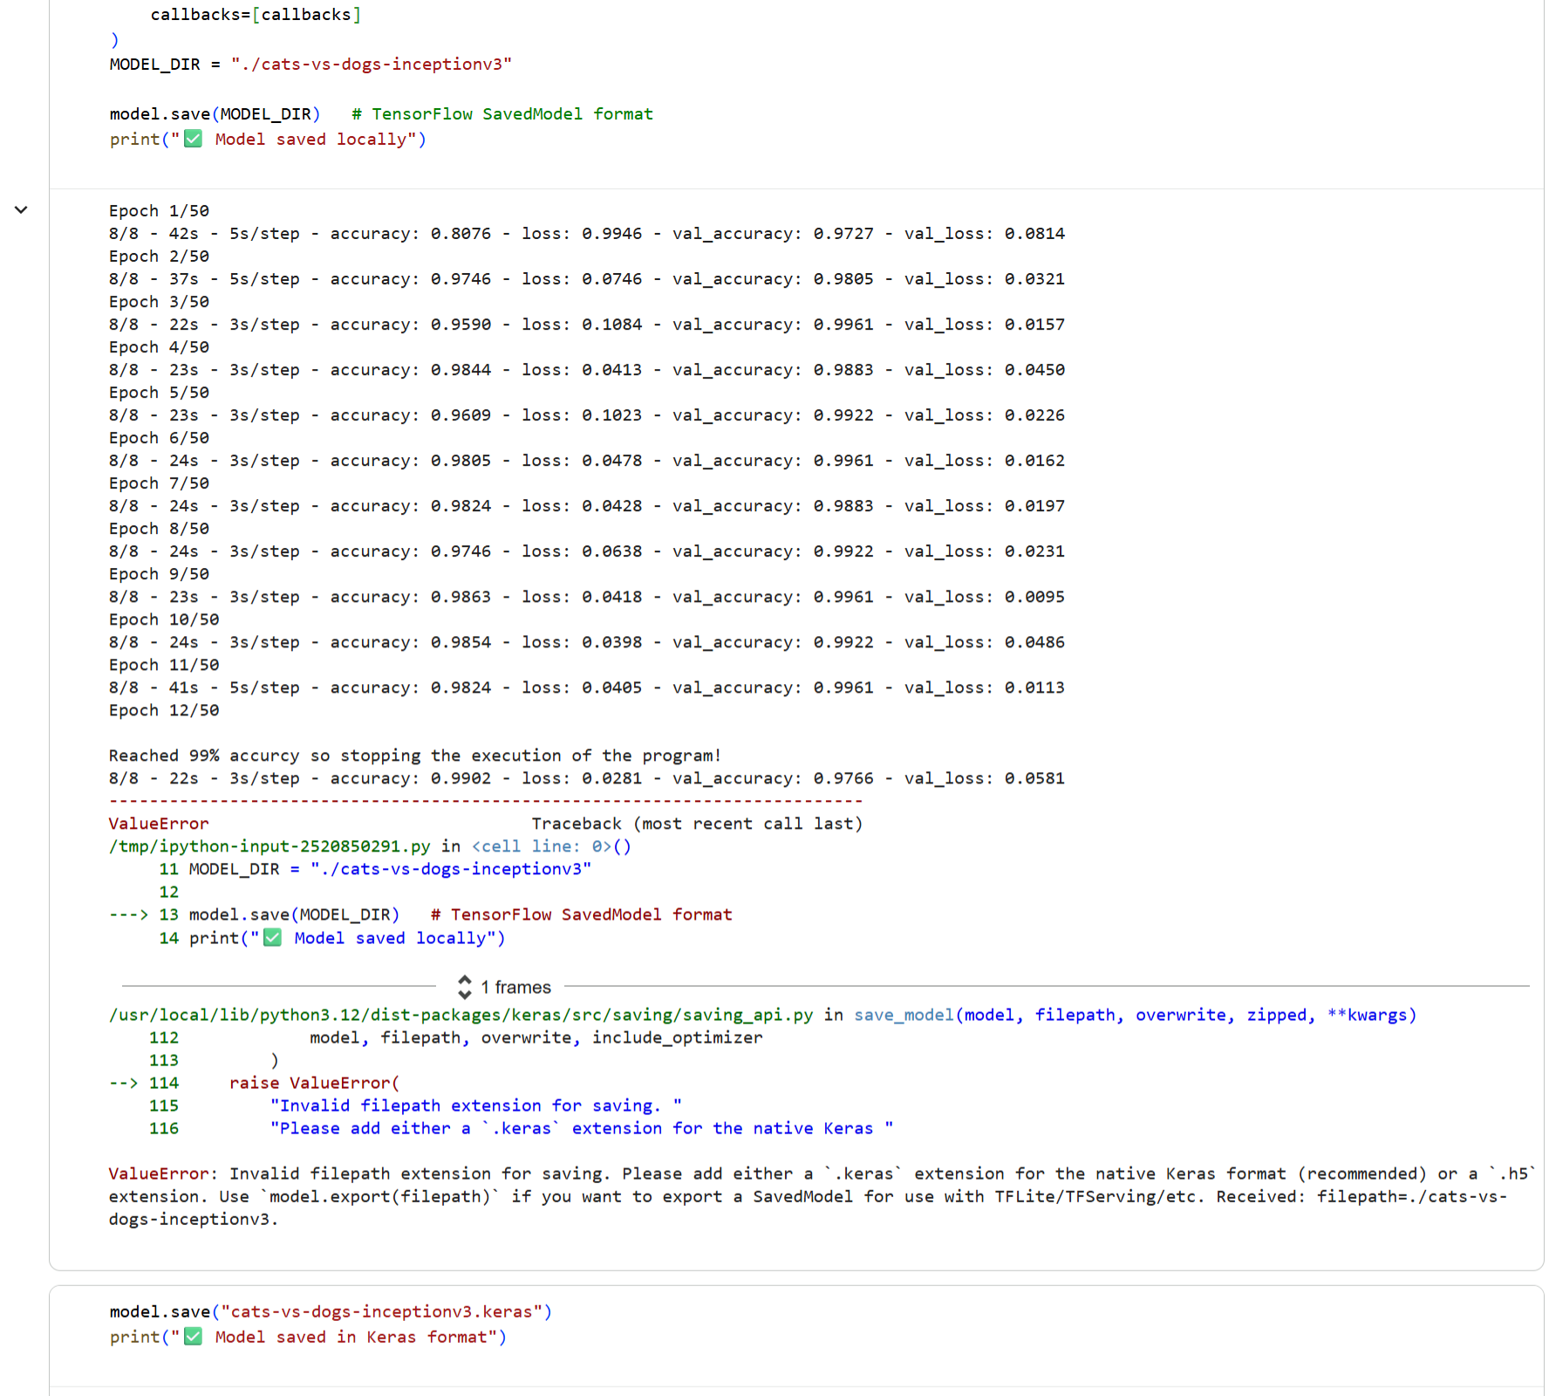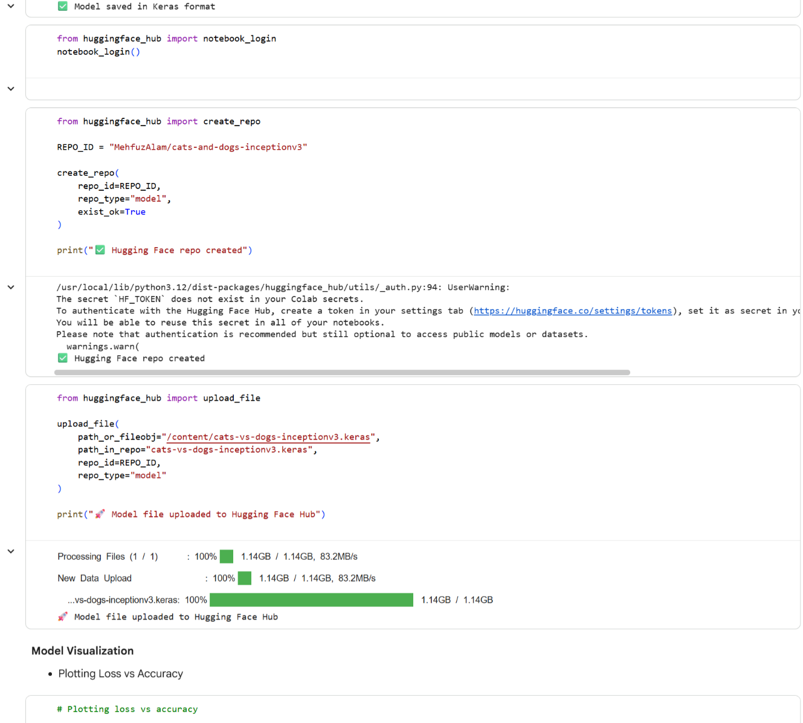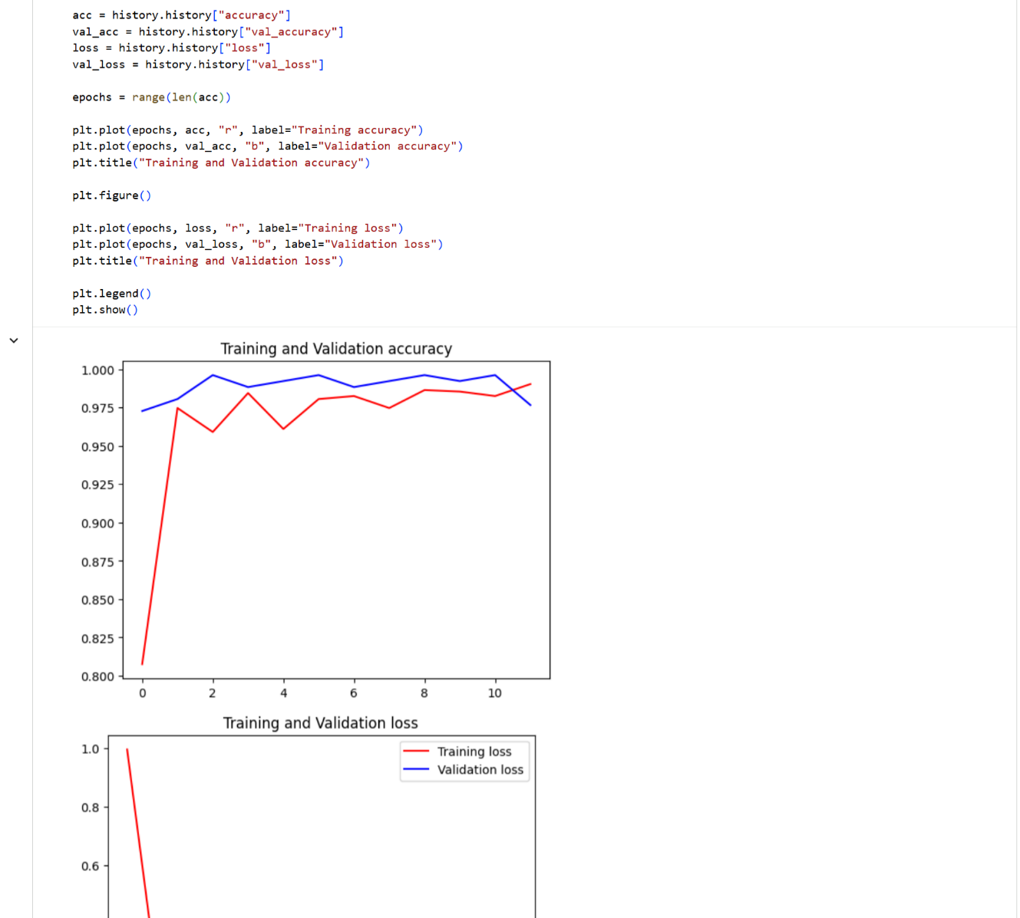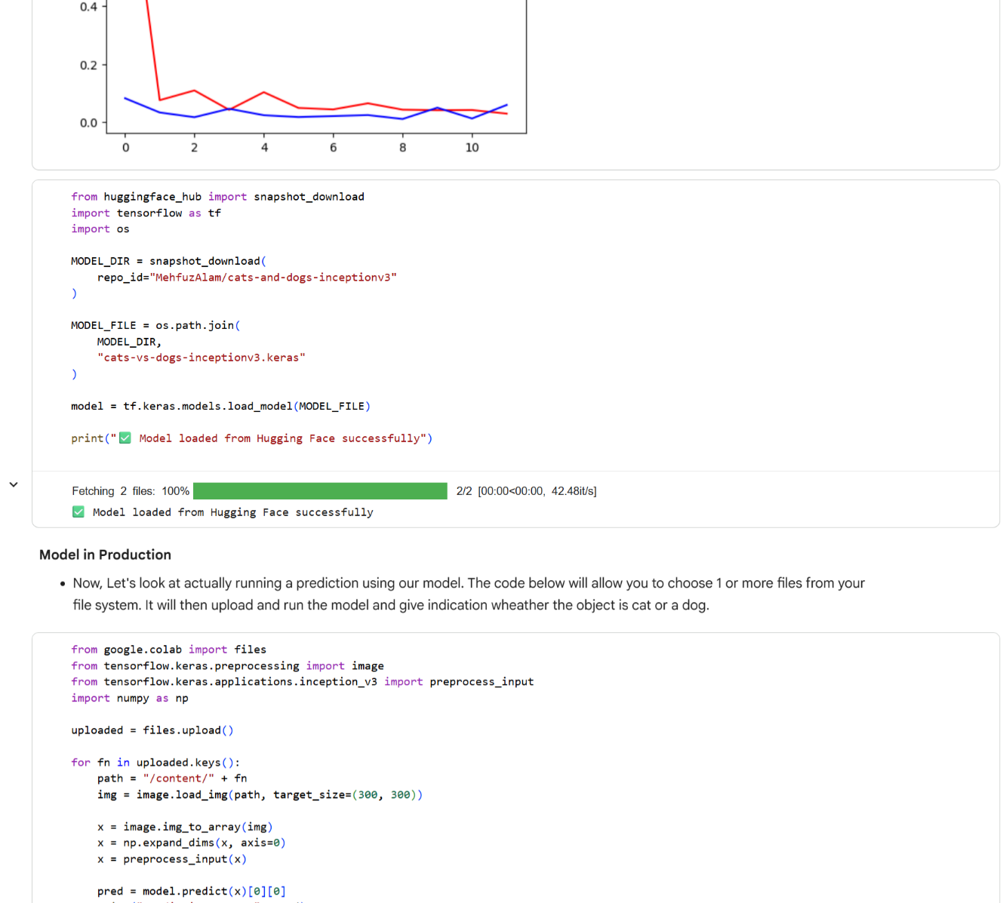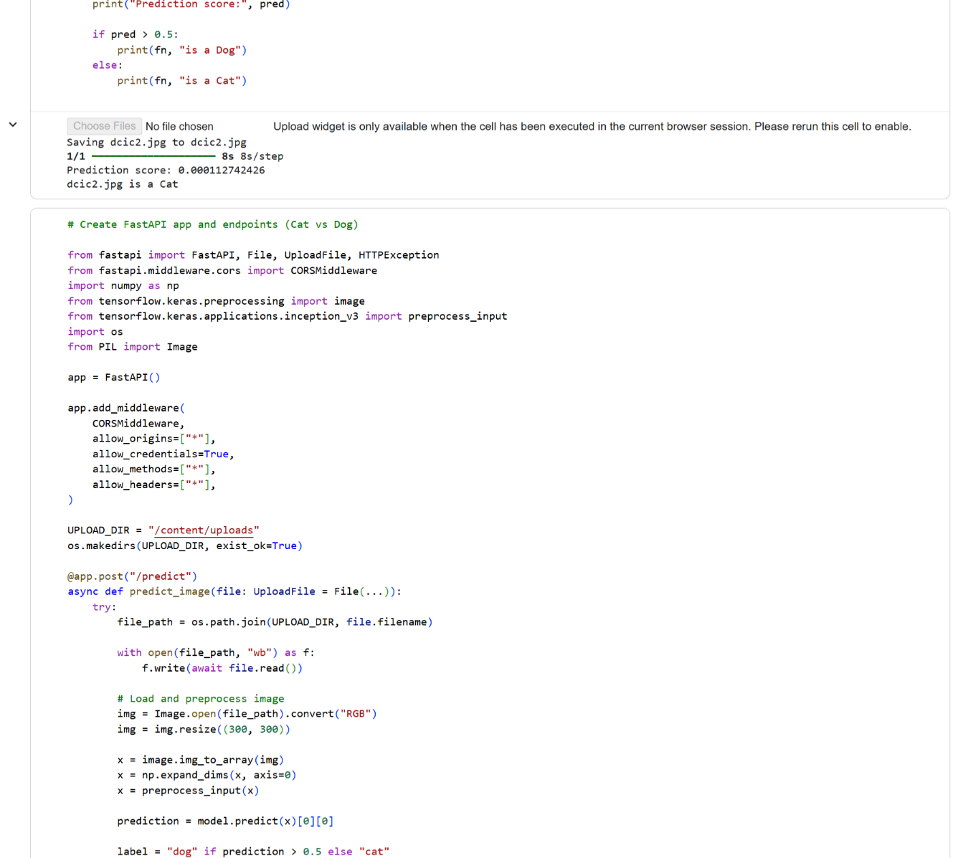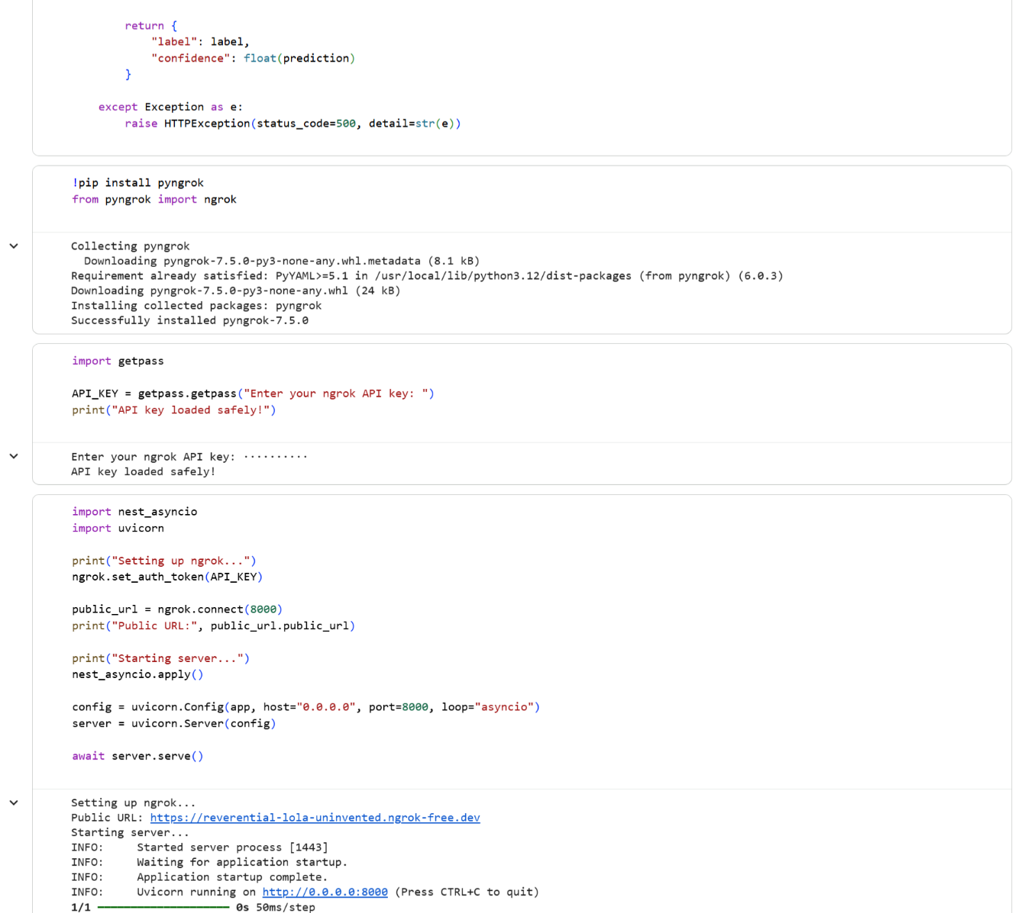**

**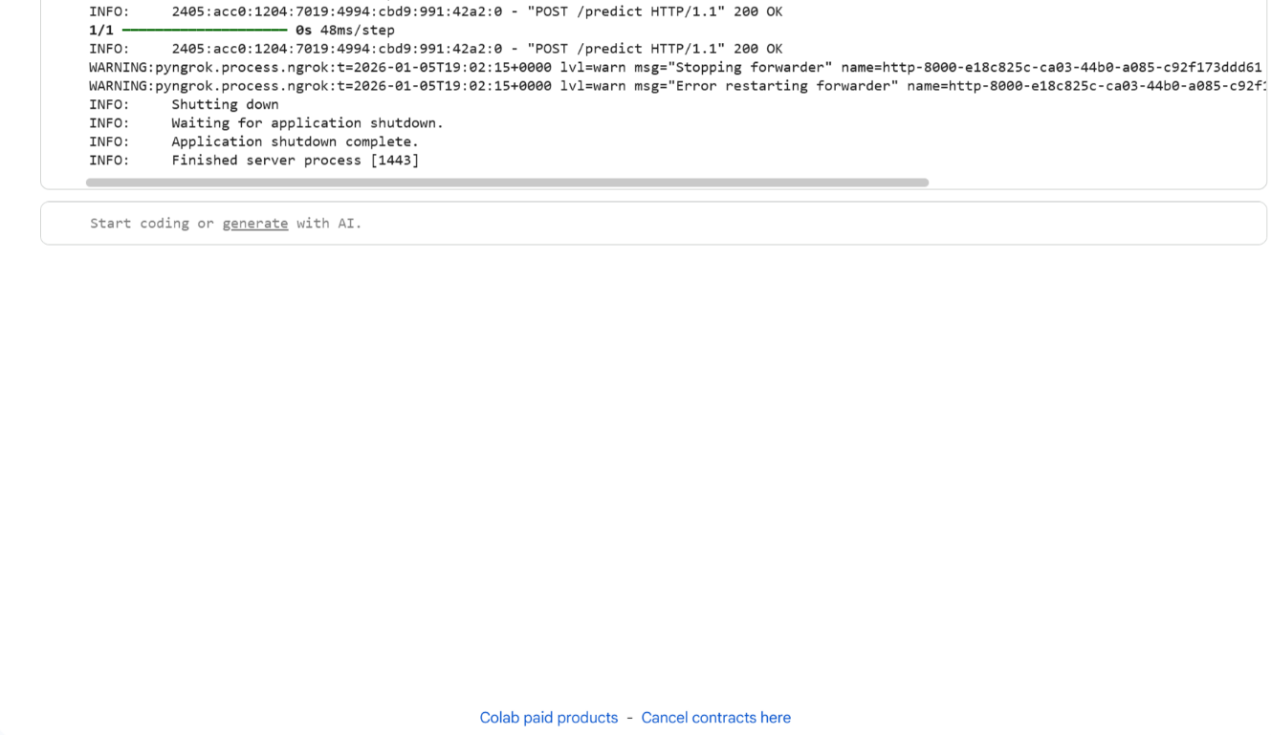**

**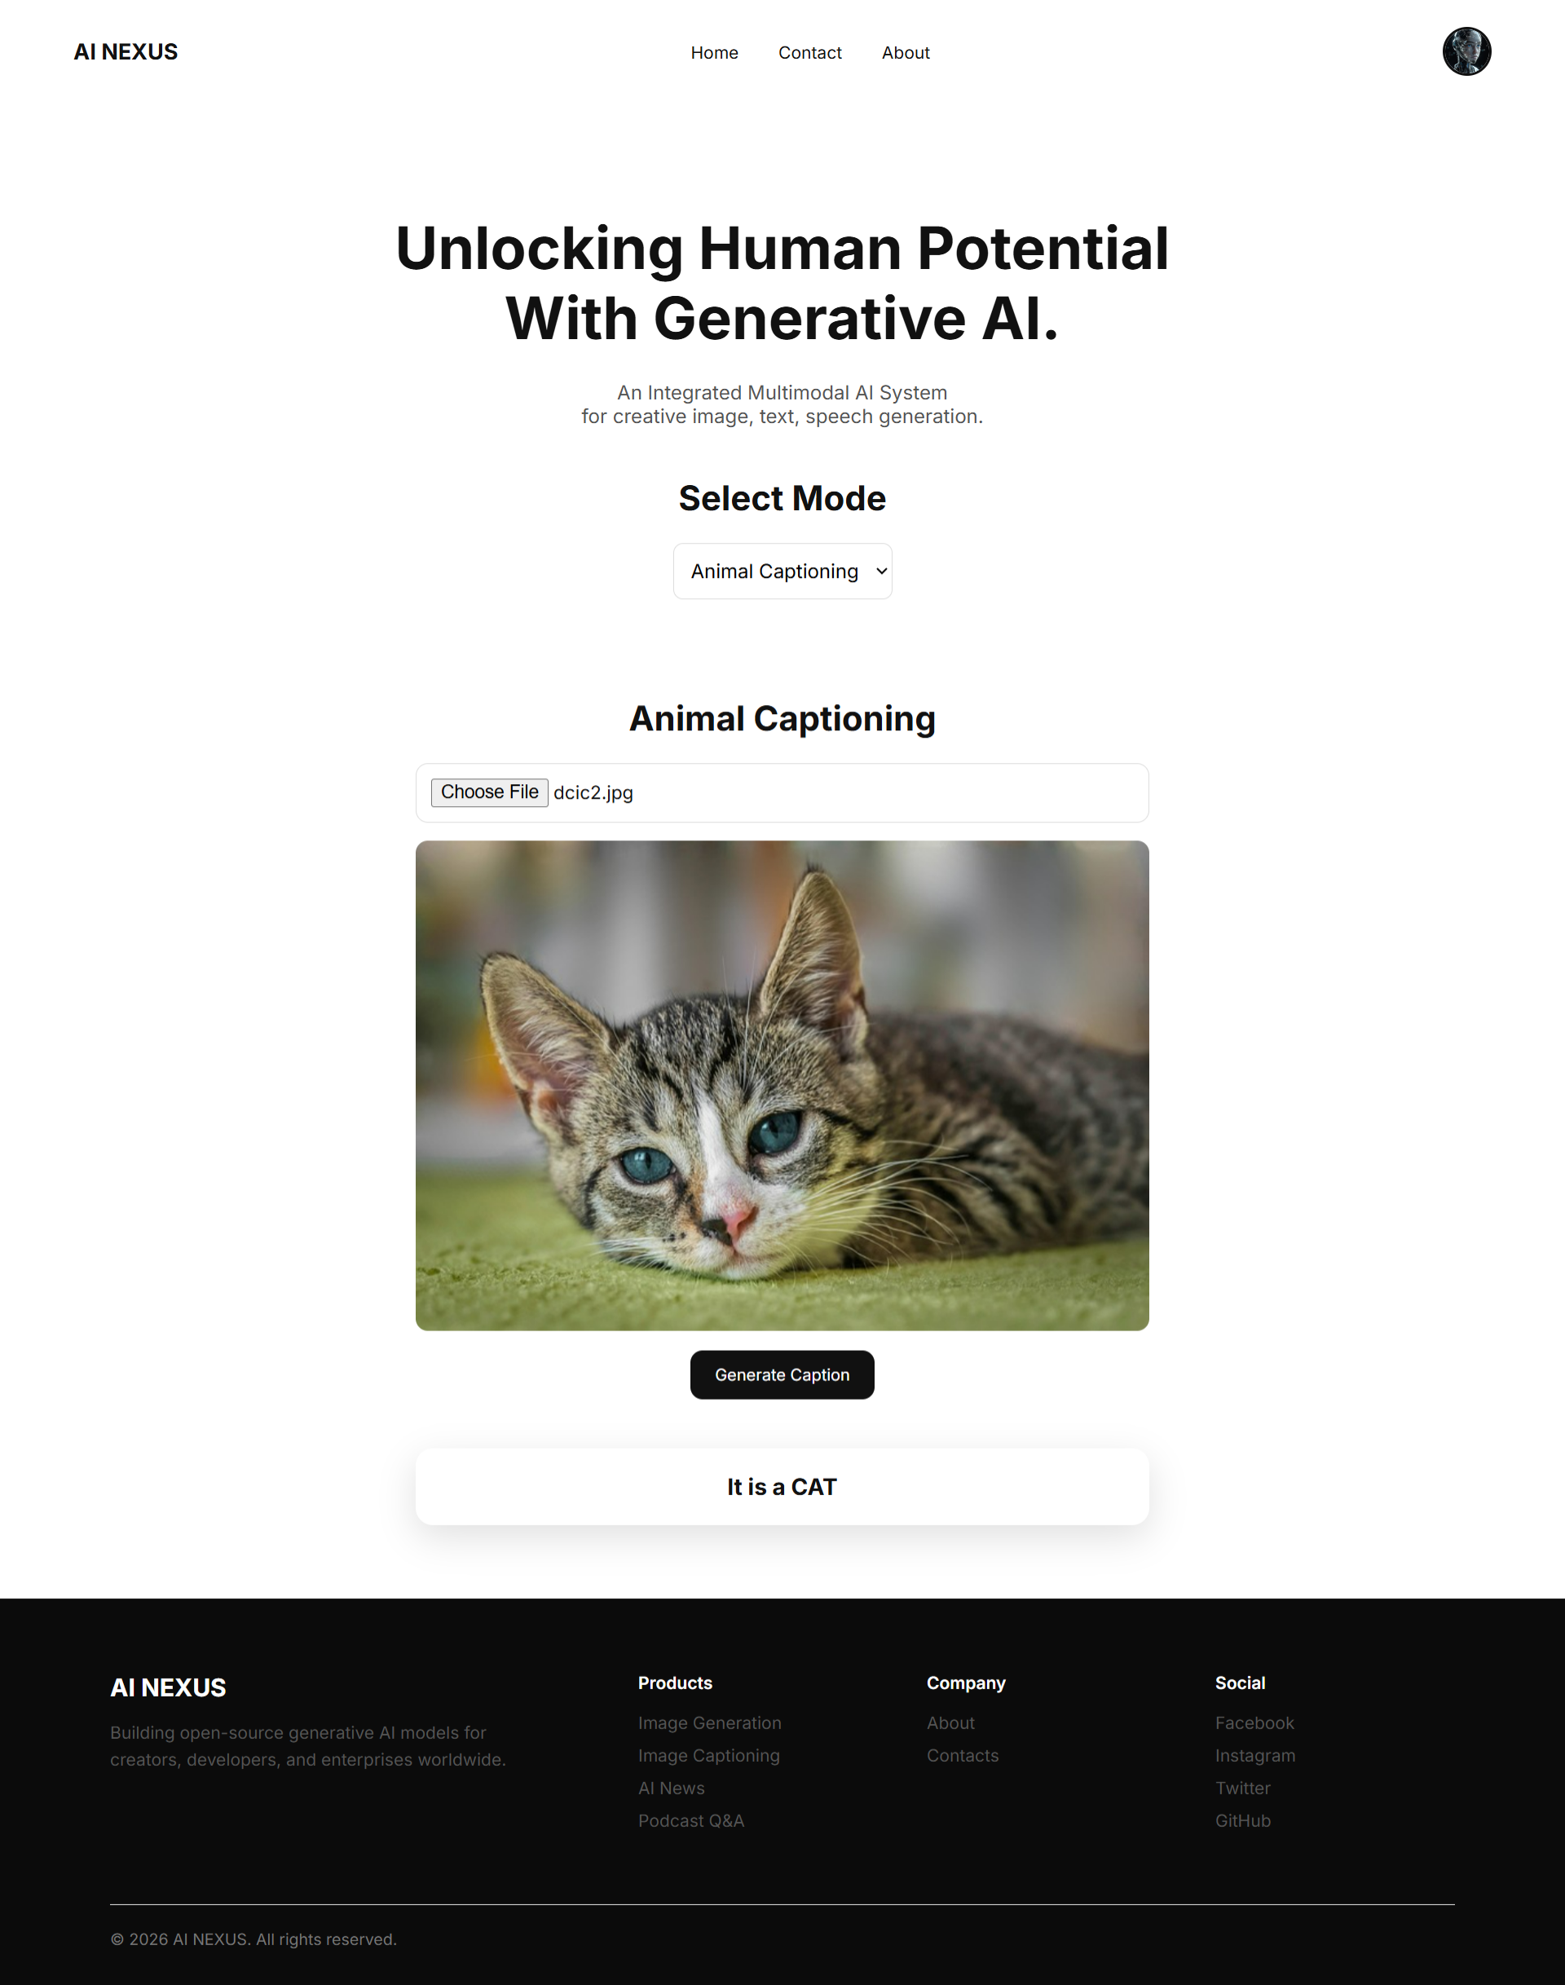**

## Module 2:

### **Model 1: Text-to-Image Generation using STABLE DIFFUSION Deep Learning**

**Technical DESCRIPTION**

**Introduction**

Text-to-Image (TTI) generation is a cutting-edge task in **multimodal artificial intelligence** where a model generates realistic images from natural language descriptions. This module implements a **backend system for text-to-image generation**, integrating deep learning models, API-based inference, and image post-processing.

This module is done in notebook and it focuses on building a **server-side (backend) pipeline** capable of receiving text prompts, generating images using pretrained diffusion-based or transformer-based models, and returning the generated images programmatically.

**Problem Statement**

Given a natural language prompt such as:

"A futuristic city at sunset with flying cars"

The system should generate a visually coherent image that semantically aligns with the prompt.

This requires understanding:

1.Natural Language Processing (NLP)

2.Vision-language alignment

3.Probabilistic generative modeling

**System Architecture Overview**

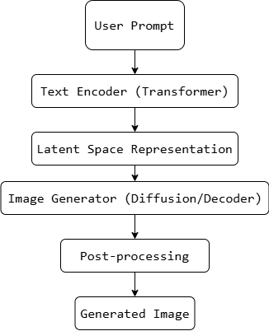

**FIG: System Architecture**

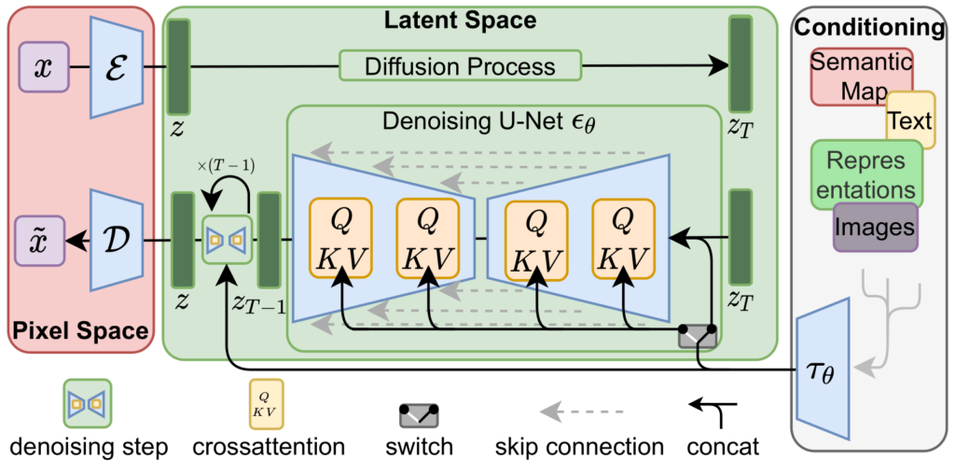

**FIG: STABLE DIFFUSION MODEL ARCHITECTURE**

**Environment Setup and Dependencies**

**Libraries Used**

1.Python

2.PyTorch / TensorFlow

3.Hugging Face Transformers

4.Diffusers

5.PIL (Python Imaging Library)

6.FastAPI / Backend utilities (where applicable)

These libraries enable model loading, tensor computation, and image handling.

**Text Input Processing**

**Tokenization**

Text prompts are converted into numerical tokens using a tokenizer:

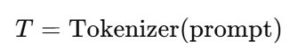

Tokenization converts raw text into discrete IDs that can be processed by transformer models.

**Text Encoder (Transformer Model)**

**Transformer Architecture**

Transformers use **self-attention** to capture contextual meaning:

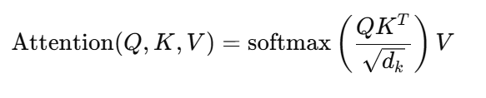

Where:

Q = Query

K = Key

V = Value

The output embedding represents the semantic meaning of the text prompt.

**Latent Space Representation**

Instead of generating images directly in pixel space, modern TTI systems operate in a **compressed latent space**.

**Benefits**

1.Faster computation

2.Lower memory usage

3.Better image quality

Mathematically:

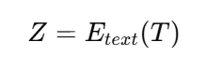

Where (Z) is a latent embedding conditioned on text.

**Image Generation Model**

**Diffusion Models (Conceptual)**

Diffusion models learn to reverse a gradual noising process:

Forward Process:

#### 

Reverse Process:

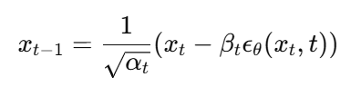

Where:

(x\_0) = original image

(epsilon) = Gaussian noise

The model iteratively denoises latent vectors into images.

**Conditioning on Text**

The generation process is **conditioned** on text embeddings:

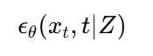

This ensures generated images align with the textual description.

**Sampling Strategy**

Common sampling strategies include:

DDPM

DDIM

PLMS

Sampling trades off between:

Speed

Image fidelity

**Image Decoding**

The final latent output is decoded into pixel space using a decoder network:

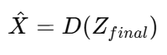

Where:

(D) = Decoder

(\hat{X}) = Generated image

**Post-processing**

Post-processing includes:

1.Clipping pixel values

2.Converting tensors to images

3.Resizing

4.Format conversion (PNG/JPEG)

This makes the output usable for downstream applications.

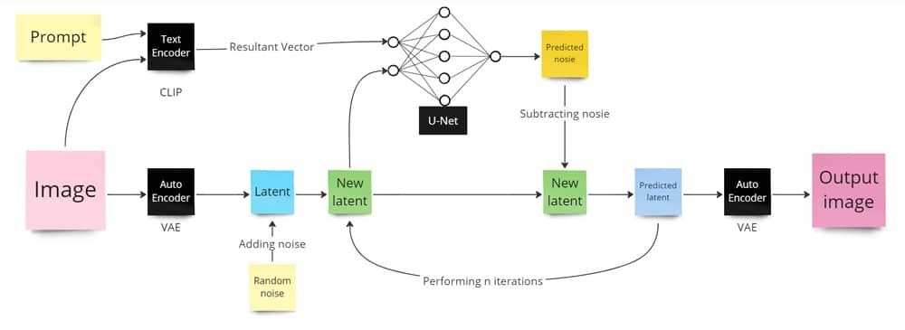

**FIG: UNET ARCHITECTURE**

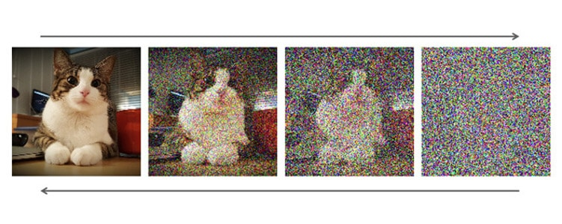

**FIG: NOISING AND DENOISING PROCESS**

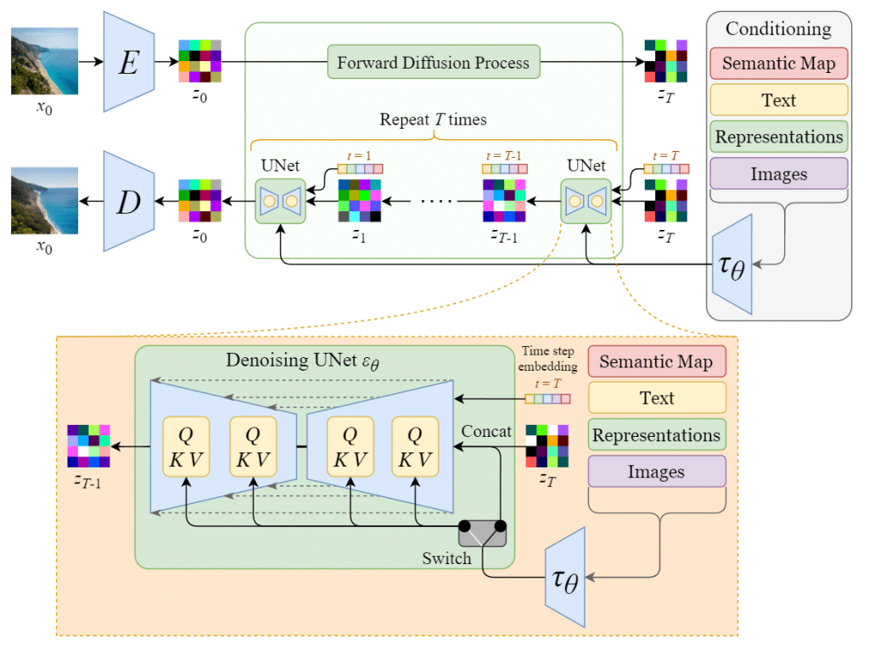

**FIG: MODEL ARCHITECTURE**

**Conclusion**

This project model demonstrates a complete backend pipeline for text-to-image generation using modern deep learning models. By combining transformers, latent diffusion models, and efficient backend design, the system enables scalable and high-quality image generation from natural language prompts.

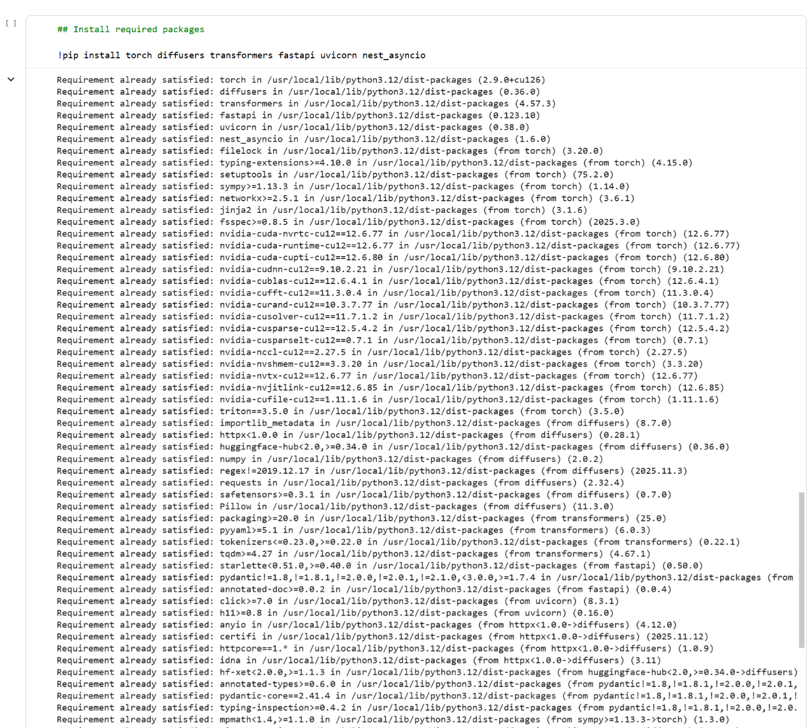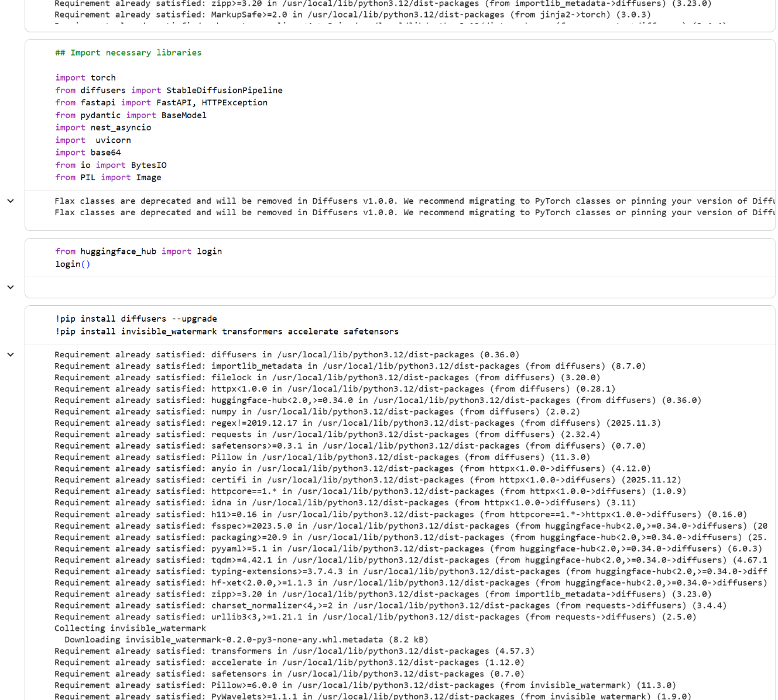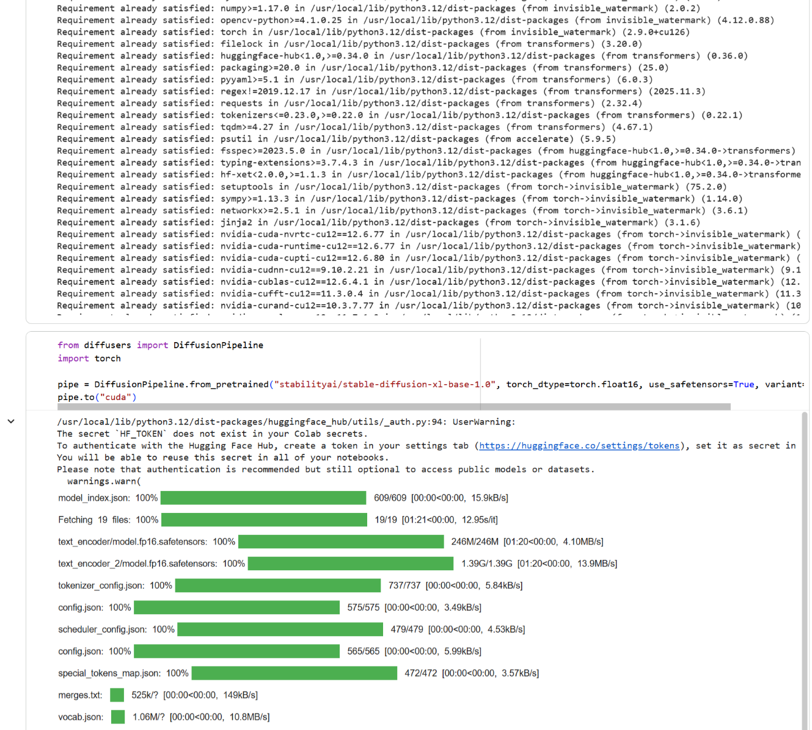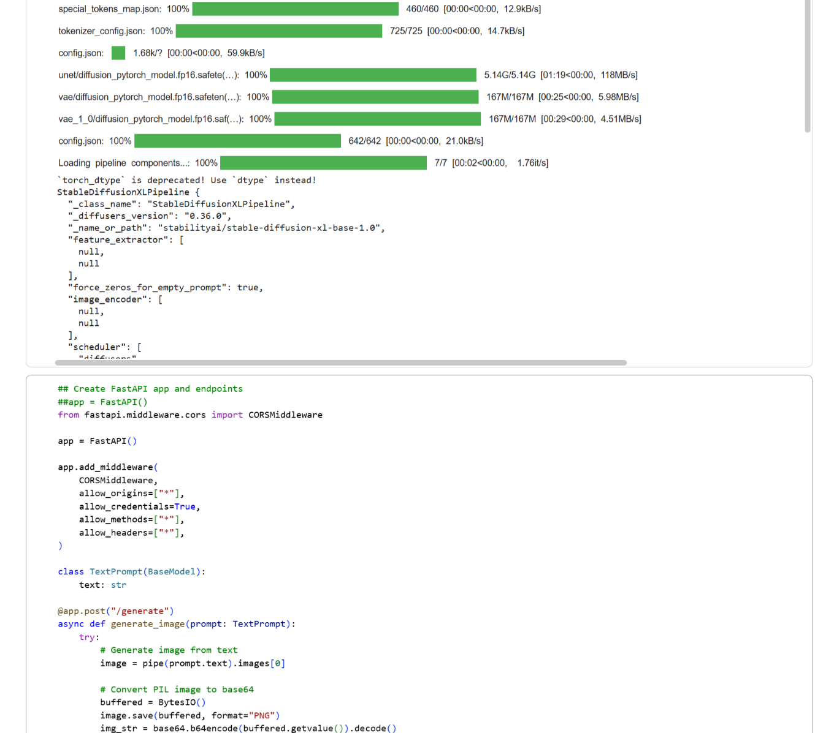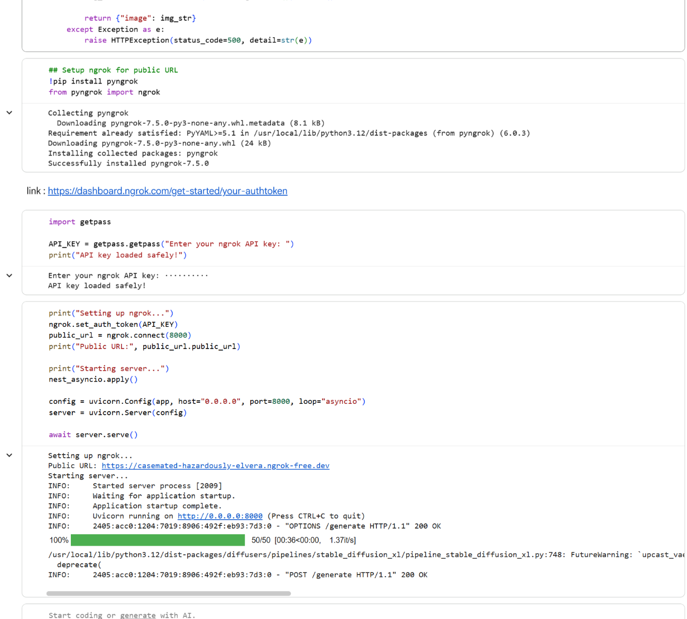

**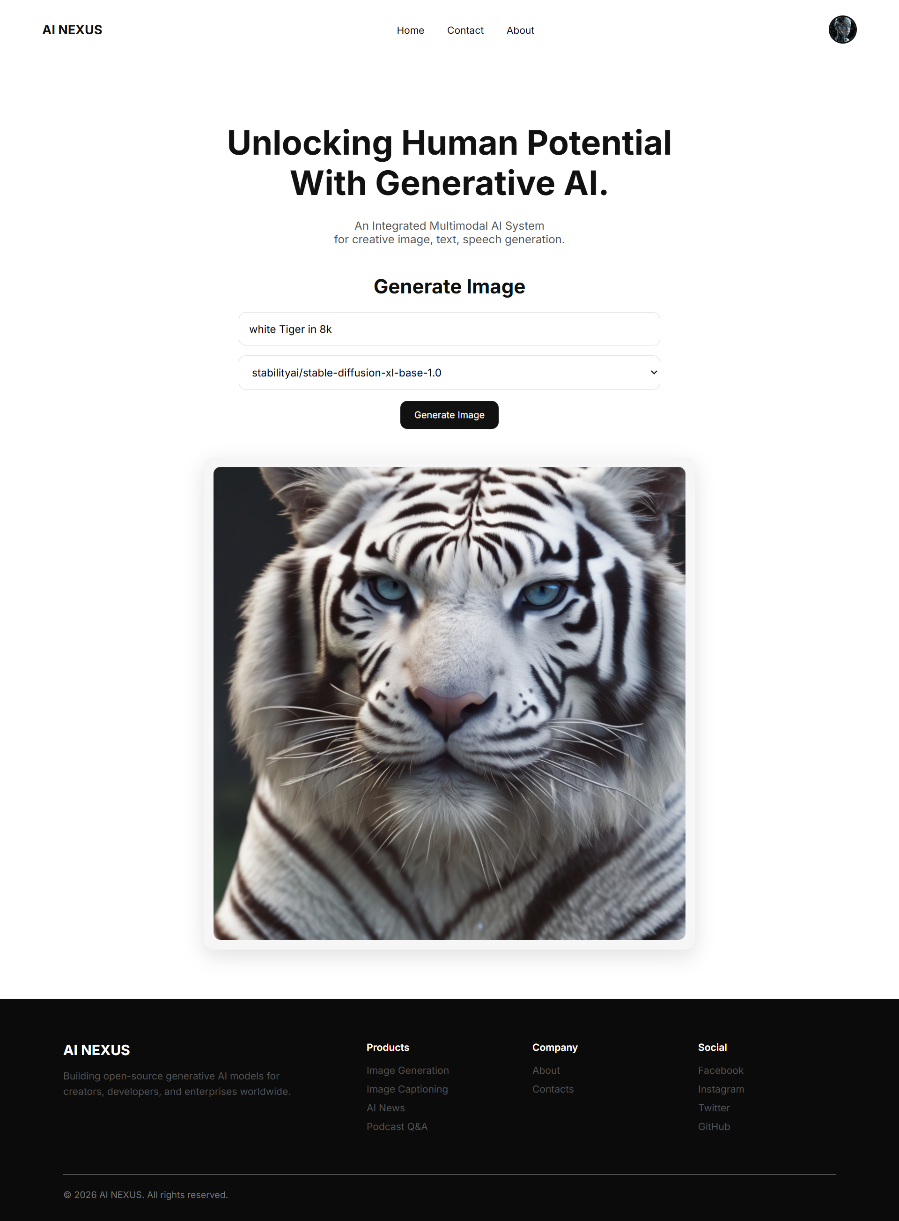**

### **Model 2: Butterfly Image Generation using Diffusion Models (DDPM)**

**Technical description**

**Introduction**

Image generation is a fundamental problem in generative modeling, where the objective is to learn the underlying data distribution and generate new, realistic images. Unlike image classification, generative tasks do not predict labels; instead, they synthesize data.

This project focuses on training and deploying a diffusion-based generative model to generate butterfly images, using Denoising Diffusion Probabilistic Models (DDPMs) implemented via the Hugging Face Diffusers library.

The work combines:

1.Model training and fine-tuning using Diffusers and Accelerate

2.Model inference and deployment using FastAPI and ngrok

The final system enables on-demand butterfly image generation via an API.

**Dataset Description**

The dataset consists of butterfly images, used to train a generative model that learns the visual distribution of butterflies.

**Dataset Characteristics**

RGB images

Natural variations in:

Wing shapes

Color patterns

Textures

Backgrounds

Unlabeled (unsupervised learning)

Unlike classification datasets, no class labels are required. The model learns directly from pixel distributions.

**Diffusion Models Overview**

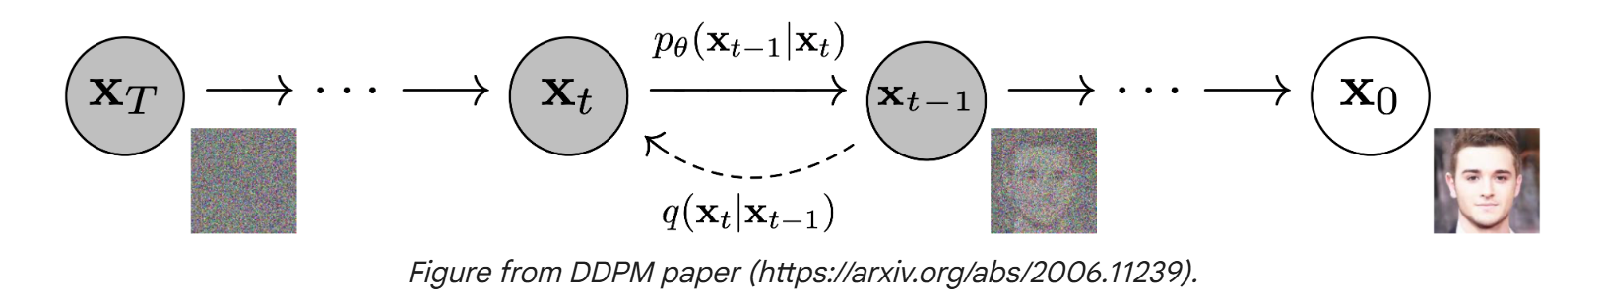

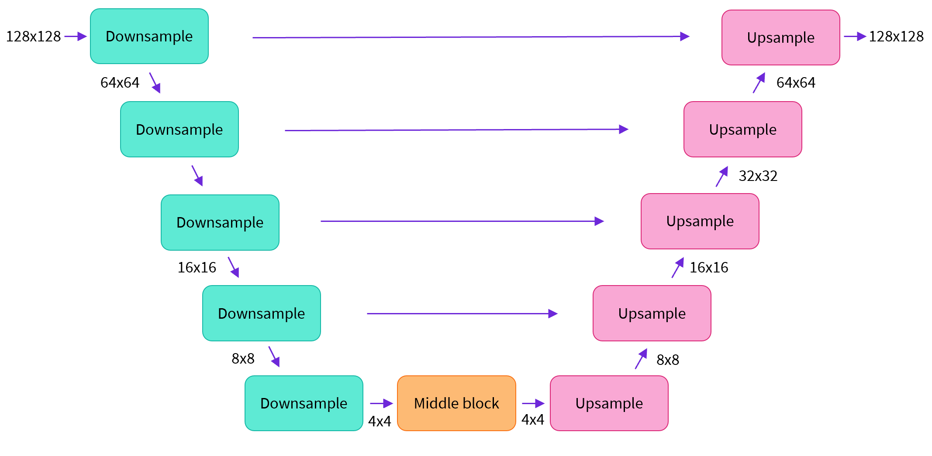

**FIG: DIFFUSION MODEL**

**Generative Modeling Paradigm**

Diffusion models generate images by learning to reverse a gradual noising process. Instead of generating images in a single step, they refine noise over many steps.

**Mathematical Foundation of Diffusion Models**

**Forward Diffusion Process**

Noise is gradually added to an image over T timesteps:

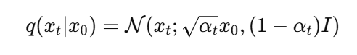

Where:

x0x\_0x0​: Original image

xtx\_txt​: Noisy image at timestep ttt

αt\alpha\_tαt​: Noise schedule

As t→Tt \to Tt→T, the image approaches pure Gaussian noise.

**Reverse Denoising Process**

The model learns the reverse process:

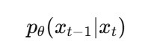

This is done by predicting the noise component added at each timestep.



**Model Architecture**

**Denoising Network (U-Net)**

The core neural network is a U-Net architecture, which consists of:

Downsampling Path → Bottleneck → Upsampling Path

Key properties:

1.Skip connections preserve spatial details

2.Time embeddings condition the network on diffusion step

3.Convolutions learn hierarchical visual features

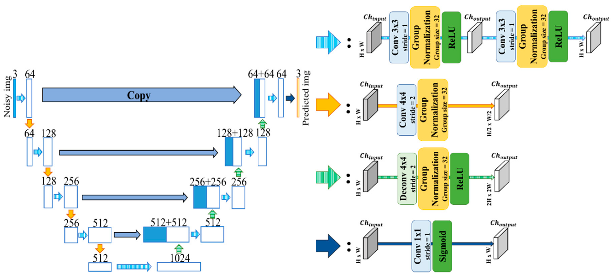

**FIG: U-NET ARCHITECTURE**

**Parameterization**

The model predicts noise ϵθ(xt,t)\epsilon\_\theta(x\_t, t)ϵθ​(xt​,t) rather than the clean image directly, improving training stability.

**Loss Function**

The training objective minimizes Mean Squared Error (MSE) between true noise and predicted noise:

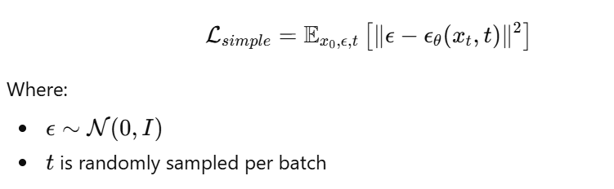

**Training Pipeline**

**Frameworks and Libraries**

1.Diffusers

2.Accelerate

3.PyTorch

4.TorchVision

**Training Configuration**

Key training parameters include:

1.Batch size

2.Image resolution

3.Learning rate

4.Number of diffusion steps

5.Mixed precision (fp16)

Accelerate enables multi-GPU and mixed-precision training for efficiency.

**Training Loop**

For each iteration:

1.Sample image x0x\_0x0​

2.Add noise → obtain xtx\_txt​

3.Predict noise ϵθ\epsilon\_\thetaϵθ​

4.Compute MSE loss

5.Backpropagation

6.Optimizer step

**Model Checkpointing and Versioning**

The trained model is:

1.Saved as Diffusers pipeline

2.Uploaded to Hugging Face Hub

3.Version-controlled using Git-LFS

This enables:

1.Reproducibility

2.Public or private sharing

3.Easy loading for inference

**Image Generation (Inference)**

**Sampling Process**

Image generation starts from pure noise:



The model iteratively denoises:

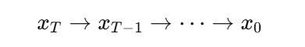

Resulting in high-quality butterfly images.

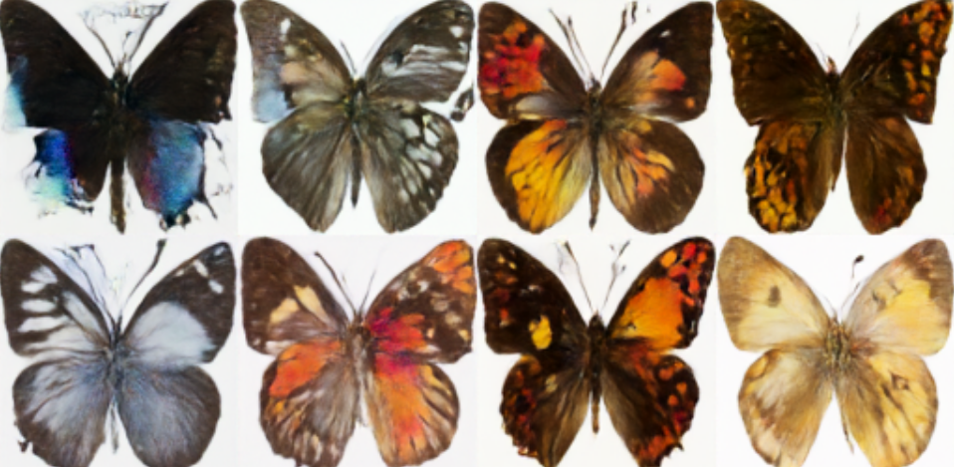

**Pipeline Usage**

pipe = DDPMPipeline.from\_pretrained(MODEL\_ID)

images = pipe(batch\_size=N).images

Generated images are converted to PIL format for visualization or API delivery.

**Deployment Architecture**

**FastAPI Backend**

The trained model is deployed using **FastAPI**, providing:

1.REST API endpoint

2.JSON-based image requests

3.Base64-encoded image responses

**API Workflow**

Client Request

→ FastAPI Endpoint

→ Diffusion Pipeline

→ Image Generation

→ Base64 Encoding

→ JSON Response

**Performance Considerations**

1.GPU acceleration (cuda)

2.FP16 inference reduces memory usage

3.Batch inference supported

**Conclusion**

This project demonstrates an end-to-end generative AI system for butterfly image generation using diffusion models:

Mathematical rigor via DDPM formulation

Scalable training with Accelerate

High-quality image synthesis

Production-ready deployment using FastAPI

The system successfully transforms random noise into realistic butterfly images, showcasing the power of modern diffusion-based generative modeling.

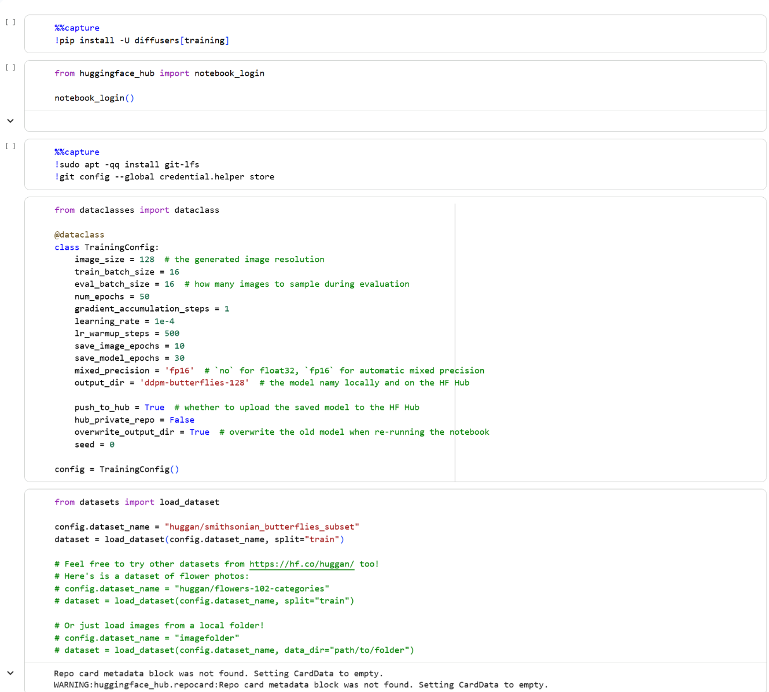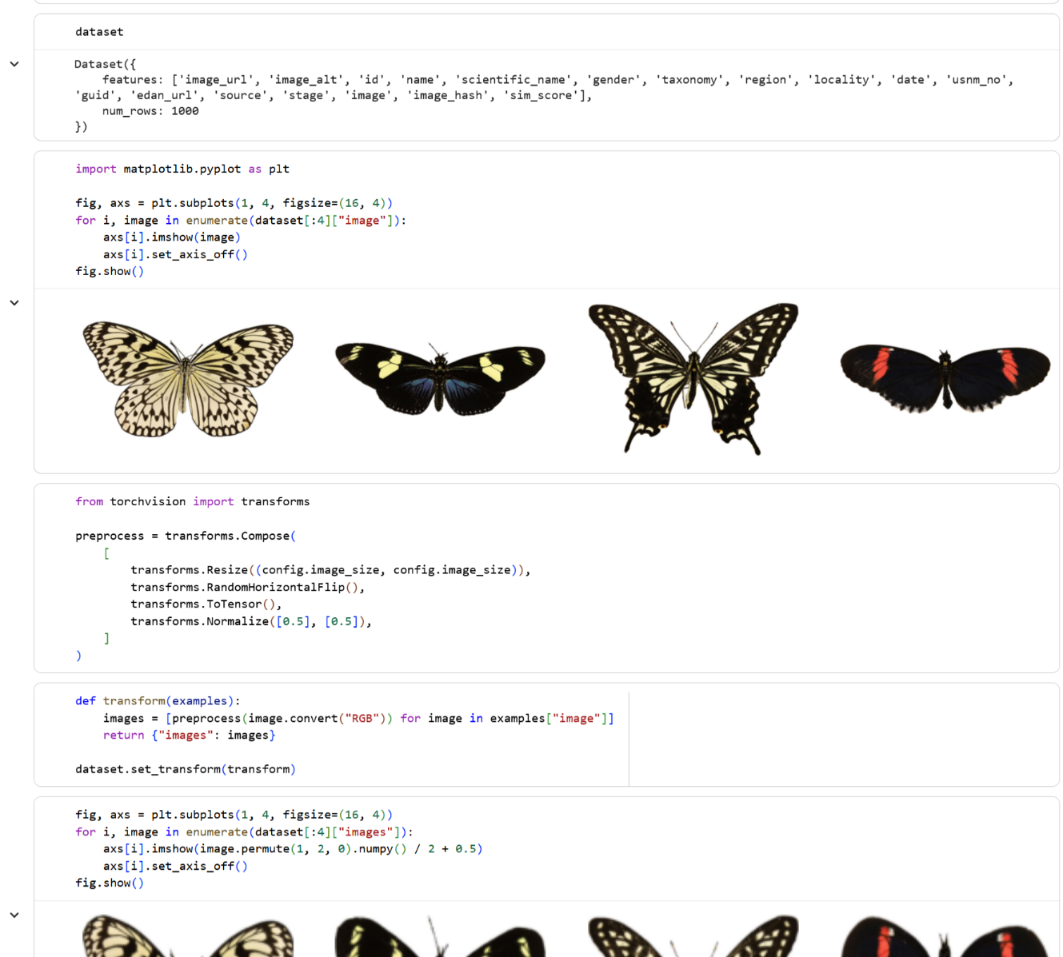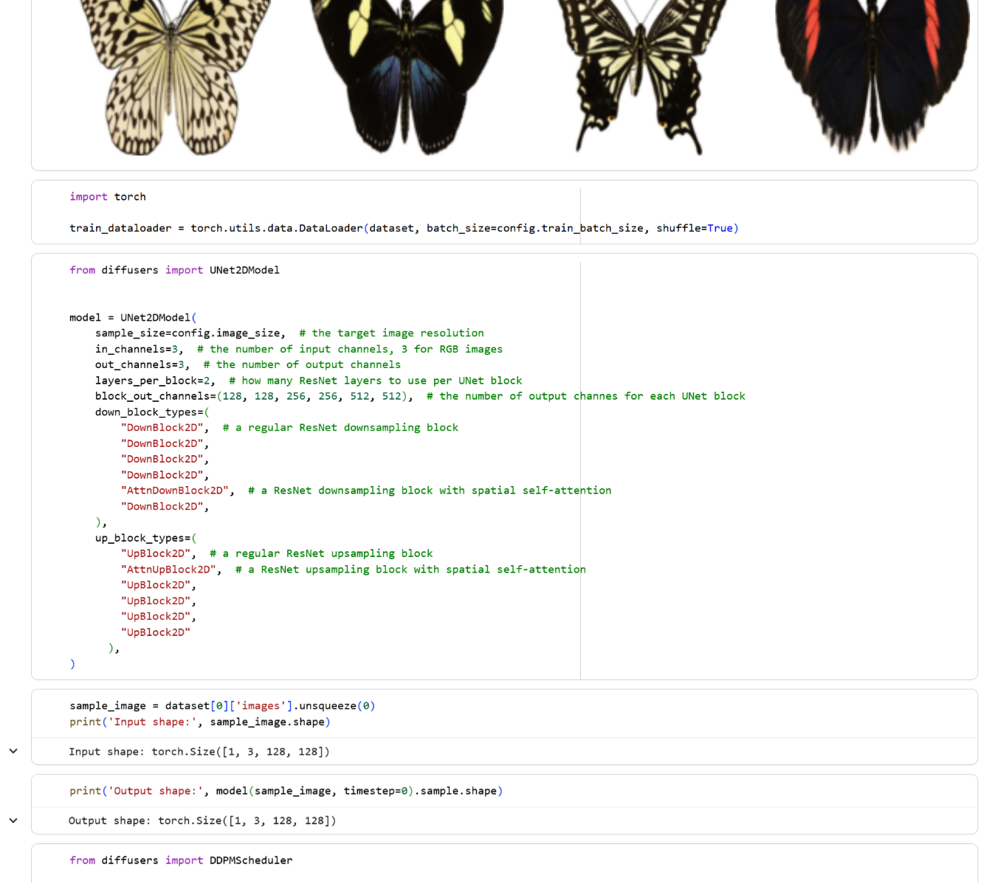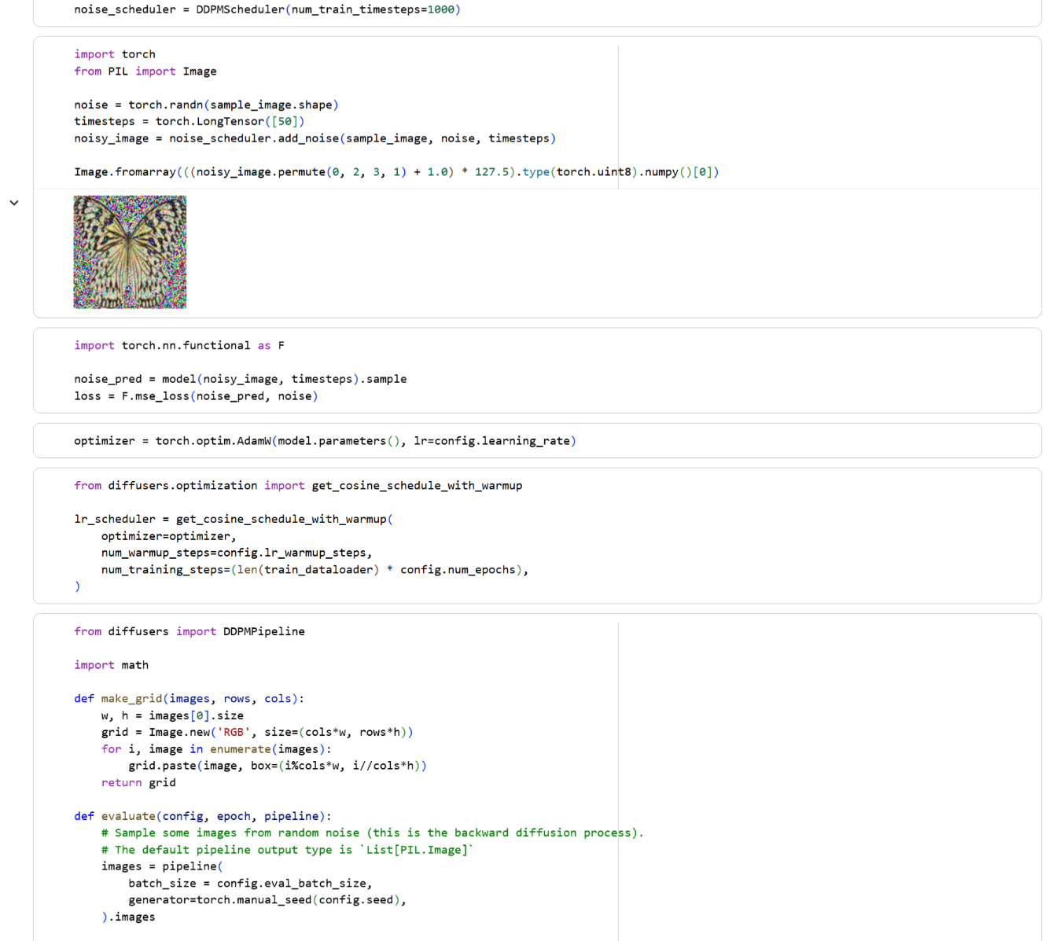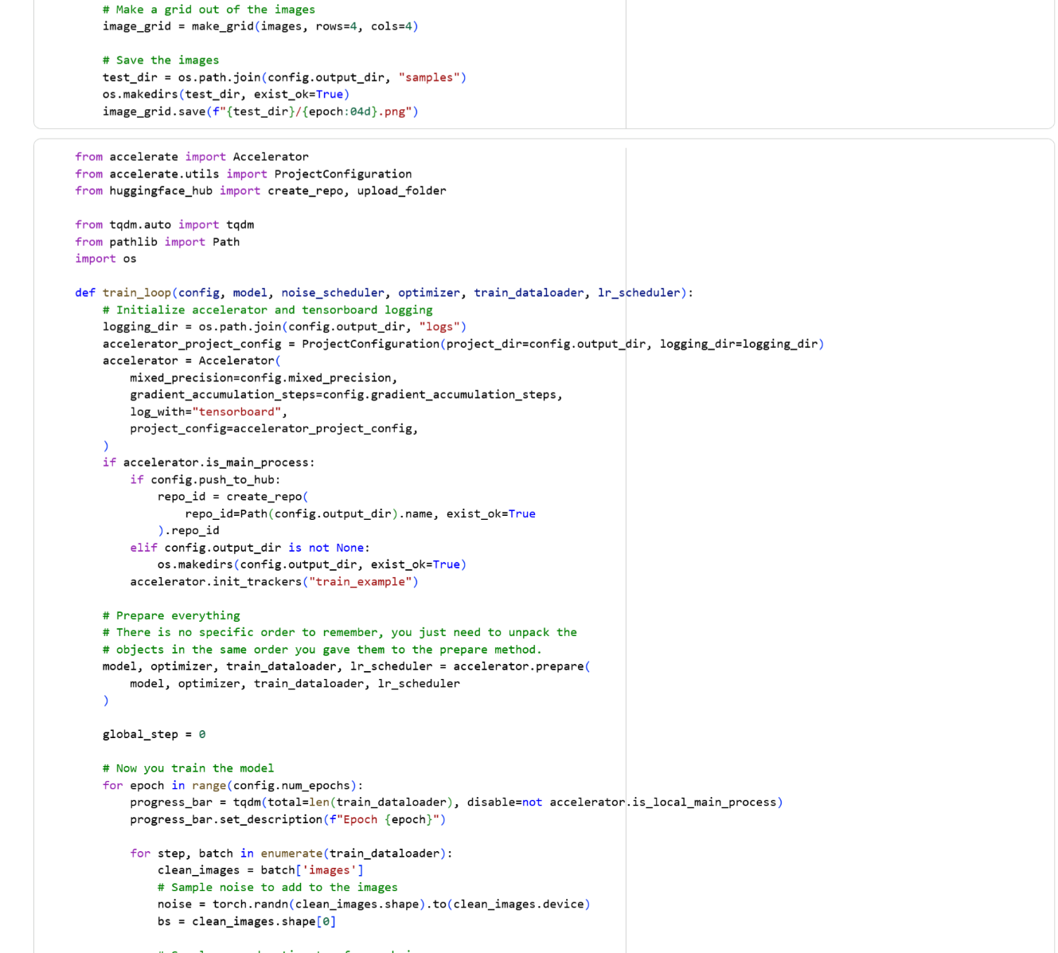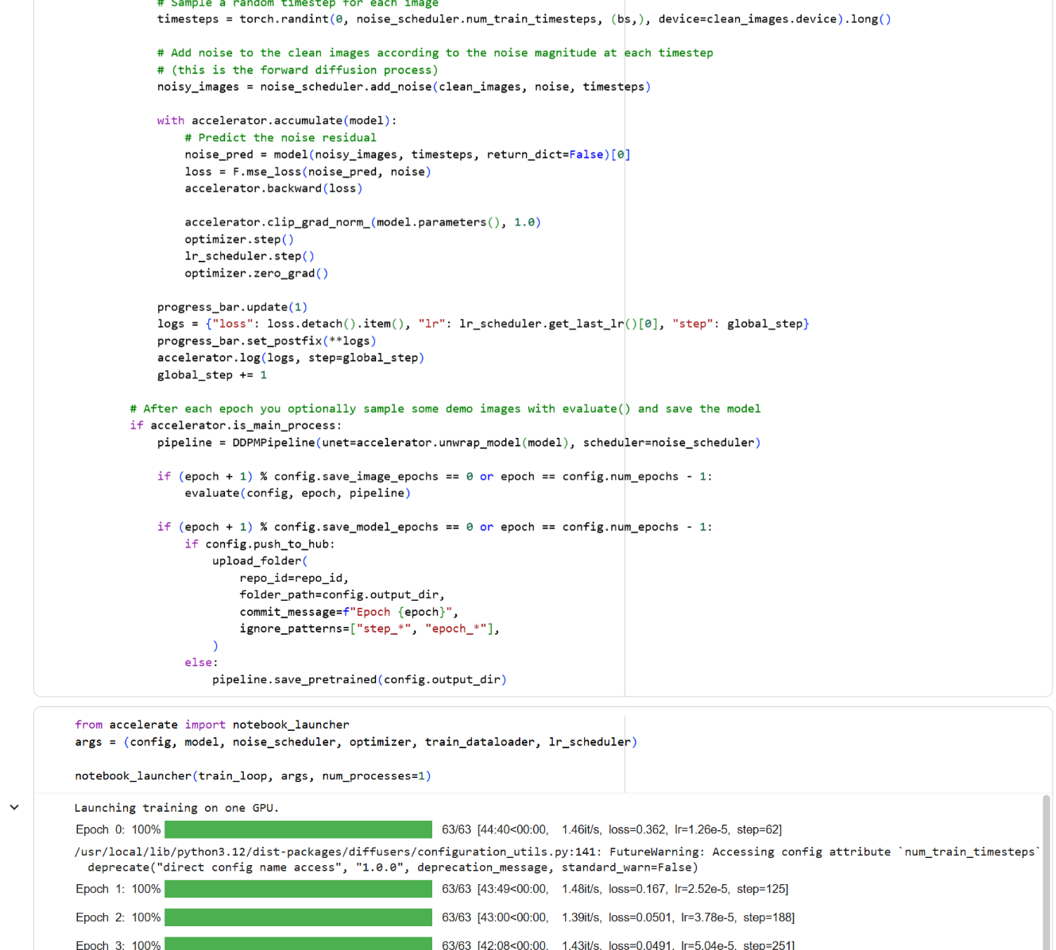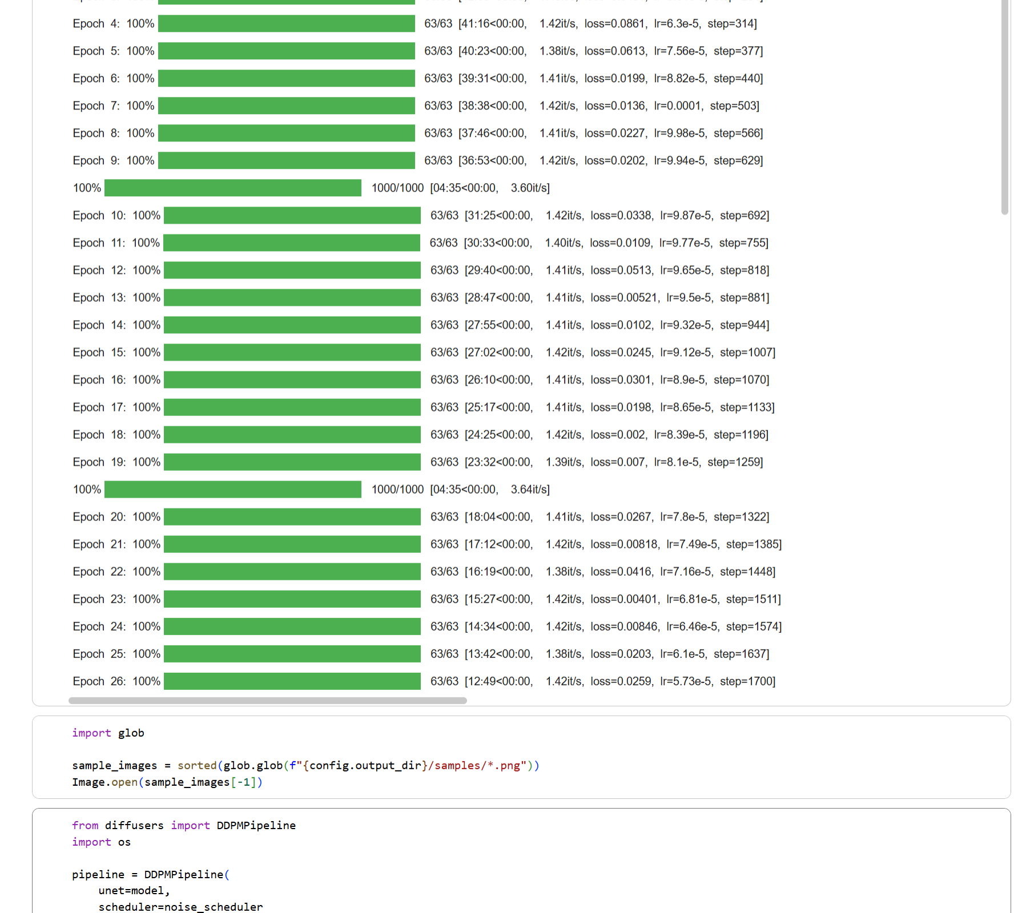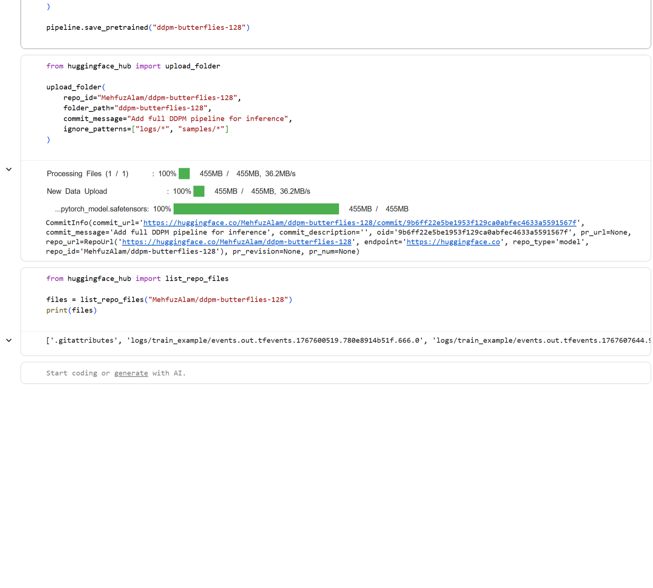

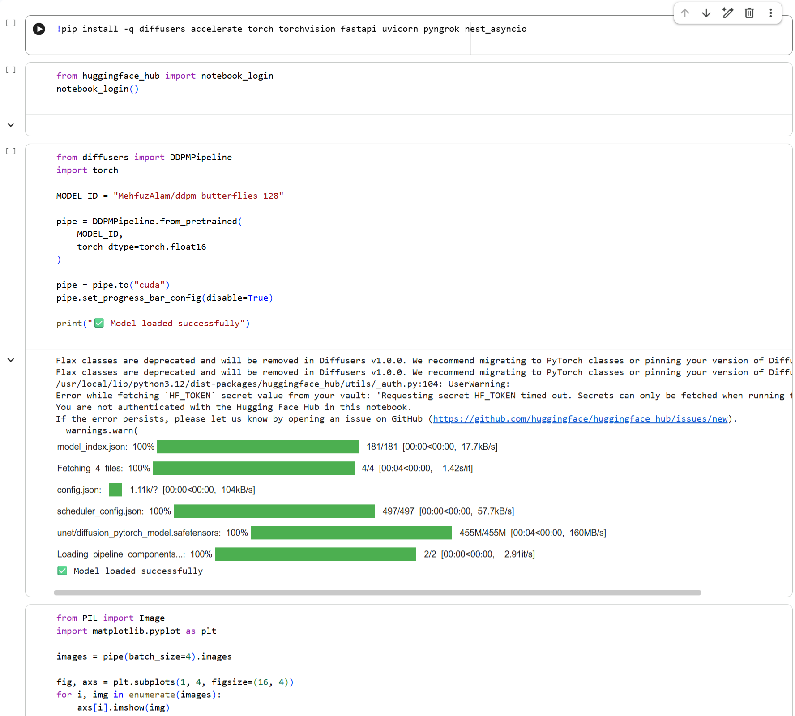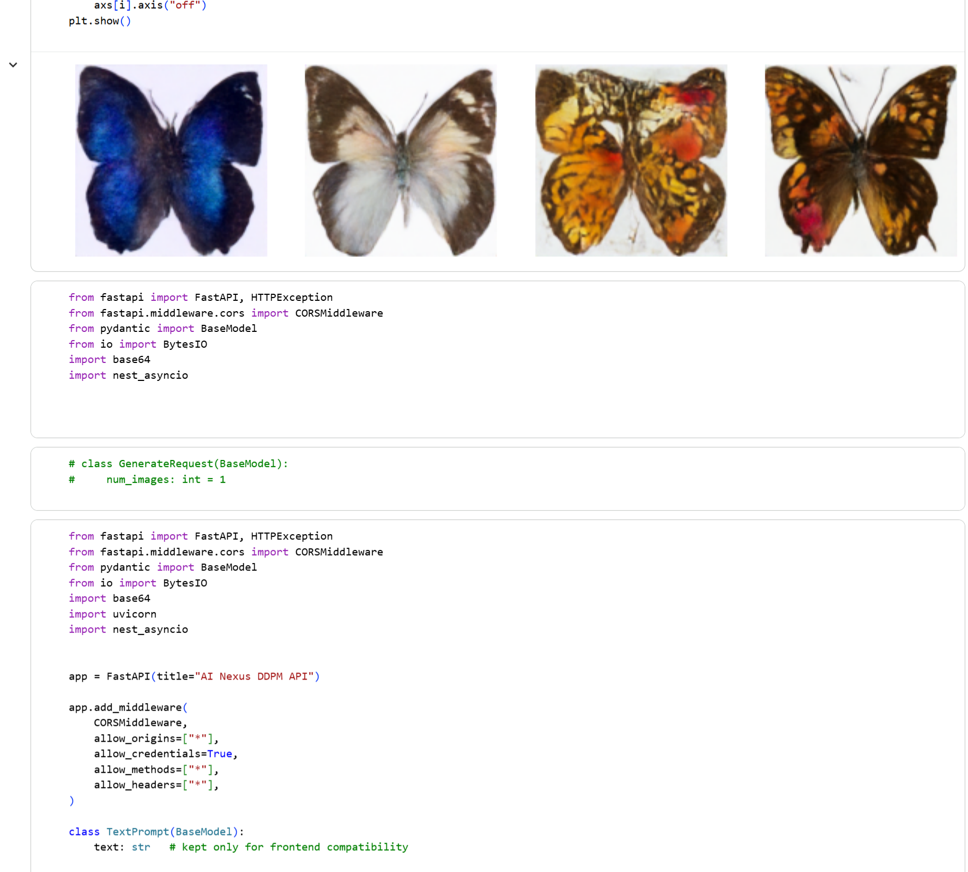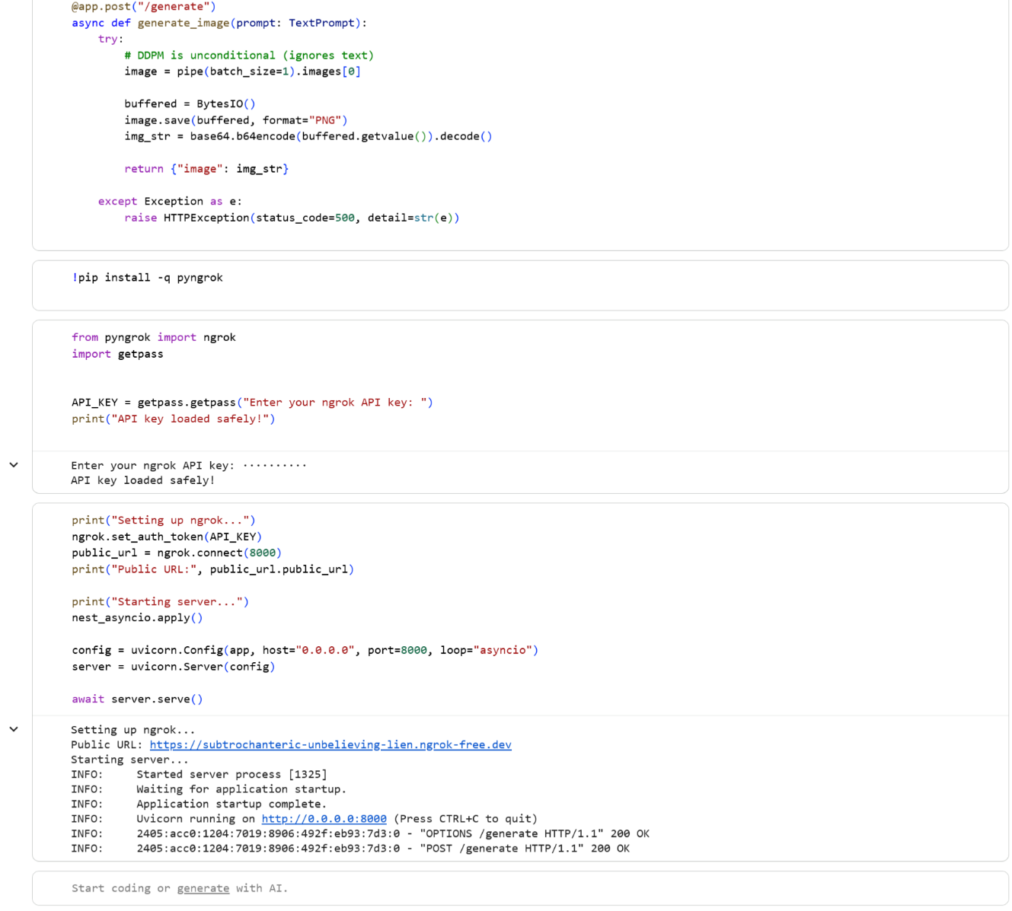



## Module 3: AI News Generation System using LLM Agents, Web Tools, TTS, and Video Synthesis

**Technical DESCRIPTION**

**Introduction**

This module implements an AI-powered news generation system that autonomously produces news content using Large Language Models (LLMs), enriches it with real-time web information, and optionally converts the news into audio and video media suitable for social platforms.

The system is built using:

1.Agent-based LLM orchestration (Agno)

2.Web search tools (DuckDuckGo)

3.FastAPI backend

4.Text-to-Speech (gTTS)

5.Video synthesis (MoviePy)

The result is a full multimodal AI news pipeline.

**High-Level System Architecture**

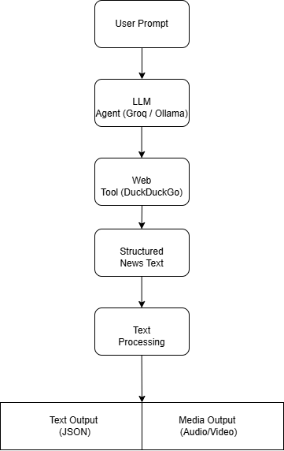

**FIG: System Architecture**

**Agent-Based Design**

What is an Agent?

An LLM agent is an autonomous entity that:

1.Receives a goal (prompt)

2.Decides whether to use tools

3.Gathers external information

4.Produces a final response

In this system, the agent behaves as a news reporter, combining language generation with real-time search.

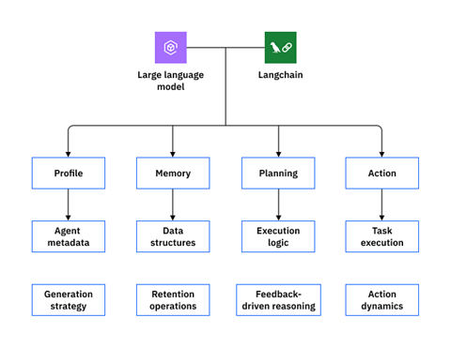

**FIG: Agent-based LLM orchestration (Agno)**

**LLM Model Selection**

Groq-hosted Model

model = Groq(id="openai/gpt-oss-120b")

1.120B parameter open-source-grade model

2.High reasoning and summarization ability

3.Optimized inference via Groq hardware

**Alternative Local Model (Ollama)**

Ollama(id="deepseek-r1:1.5b")

Allows offline or low-resource inference.

**Tool Integration (Web Search)**

**DuckDuckGoTools**

The agent is equipped with a search tool:

tools=[DuckDuckGoTools()]

This enables:

Real-time news retrieval

Fact grounding

Reduced hallucination

The agent dynamically decides when to call the tool.

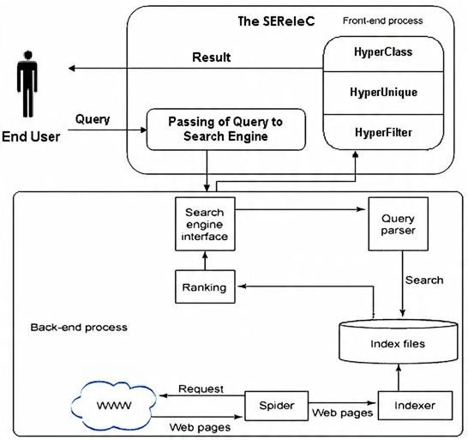

**FIG: DUCKDUCKGO WEB SEARCH**

**Agent Configuration Parameters**

| **Parameter** | **Purpose** |
| --- | --- |
| description | Defines agent persona |
| tools | Enables external actions |
| parse\_response | Structured parsing |
| structured\_outputs | JSON-like outputs |
| markdown | Readable formatting |

These parameters control behavior, reliability, and output quality.

**Prompt-to-News Generation Flow**

**Mathematical Abstraction**

The agent computes:



Where:

(X) = user prompt

(T) = external tool results

(Y) = generated news content

The model performs conditional text generation:

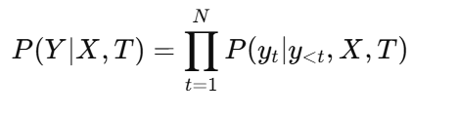

**FastAPI Integration**

**API Endpoint: Generate News**

POST /api/generate-news

Input: prompt

Output: structured news text

The API acts as a stateless interface over a stateful agent instance.

**News Text Post-Processing**

**Emoji Removal**

Regular expressions remove emojis to ensure:

TTS compatibility

Professional tone

**Markdown & Noise Cleaning**

Markdown symbols and timestamps are stripped for clean narration.

**News Structuring Logic**

The generated text is parsed into:

Headline

Bullet points

Speech-friendly paragraph

This enables reuse across text, audio, and video modalities.

**Text-to-Speech (TTS)**

**gTTS Engine**

Text is converted into speech:

Audio=TTS(Text)

Uses Google neural voices

Outputs MP3 format

Language-agnostic support

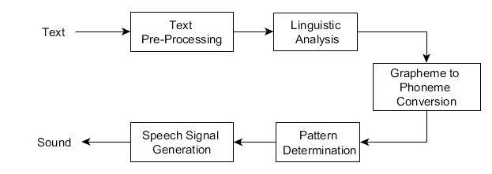

**FIG: gTTS ARCHITECTURE**

**Audio–Video Synchronization**

**Video Looping Strategy**

Given:

Video duration = (D\_v)

Audio duration = (D\_a)

Required loops:

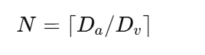

The anchor video is looped to match narration length.

**Video Composition**

Using MoviePy:

Loop video

Trim excess

Attach audio

Encode with H.264 + AAC

This produces a broadcast-ready news video.

**Media API Endpoint**

POST /api/news-with-media

**Response Includes**

Headline

Bullet points

Audio URL

Video URL

This endpoint enables end-to-end AI news generation.

File System Design

**media/**

├── audio/

│ └── uuid.mp3

└── video/

└── uuid.mp4

UUIDs ensure collision-free, scalable storage.

**Scalability Considerations**

1.Agent loaded once in memory

2.Stateless HTTP requests

3.Media generation offloaded to disk

4.GPU optional for LLM inference

**Advantages**

1.Real-time news grounding

2.Multimodal output

3.Modular agent design

4.Easy model swapping

**Conclusion**

This module demonstrates a state-of-the-art AI news generation pipeline combining LLM agents, real-time web tools, and multimodal media synthesis. It reflects modern AI system design principles and is suitable for real-world deployment in digital journalism, content automation, and media platforms.

**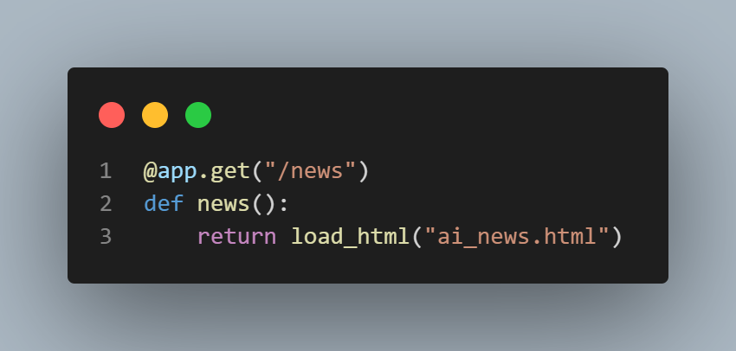**

**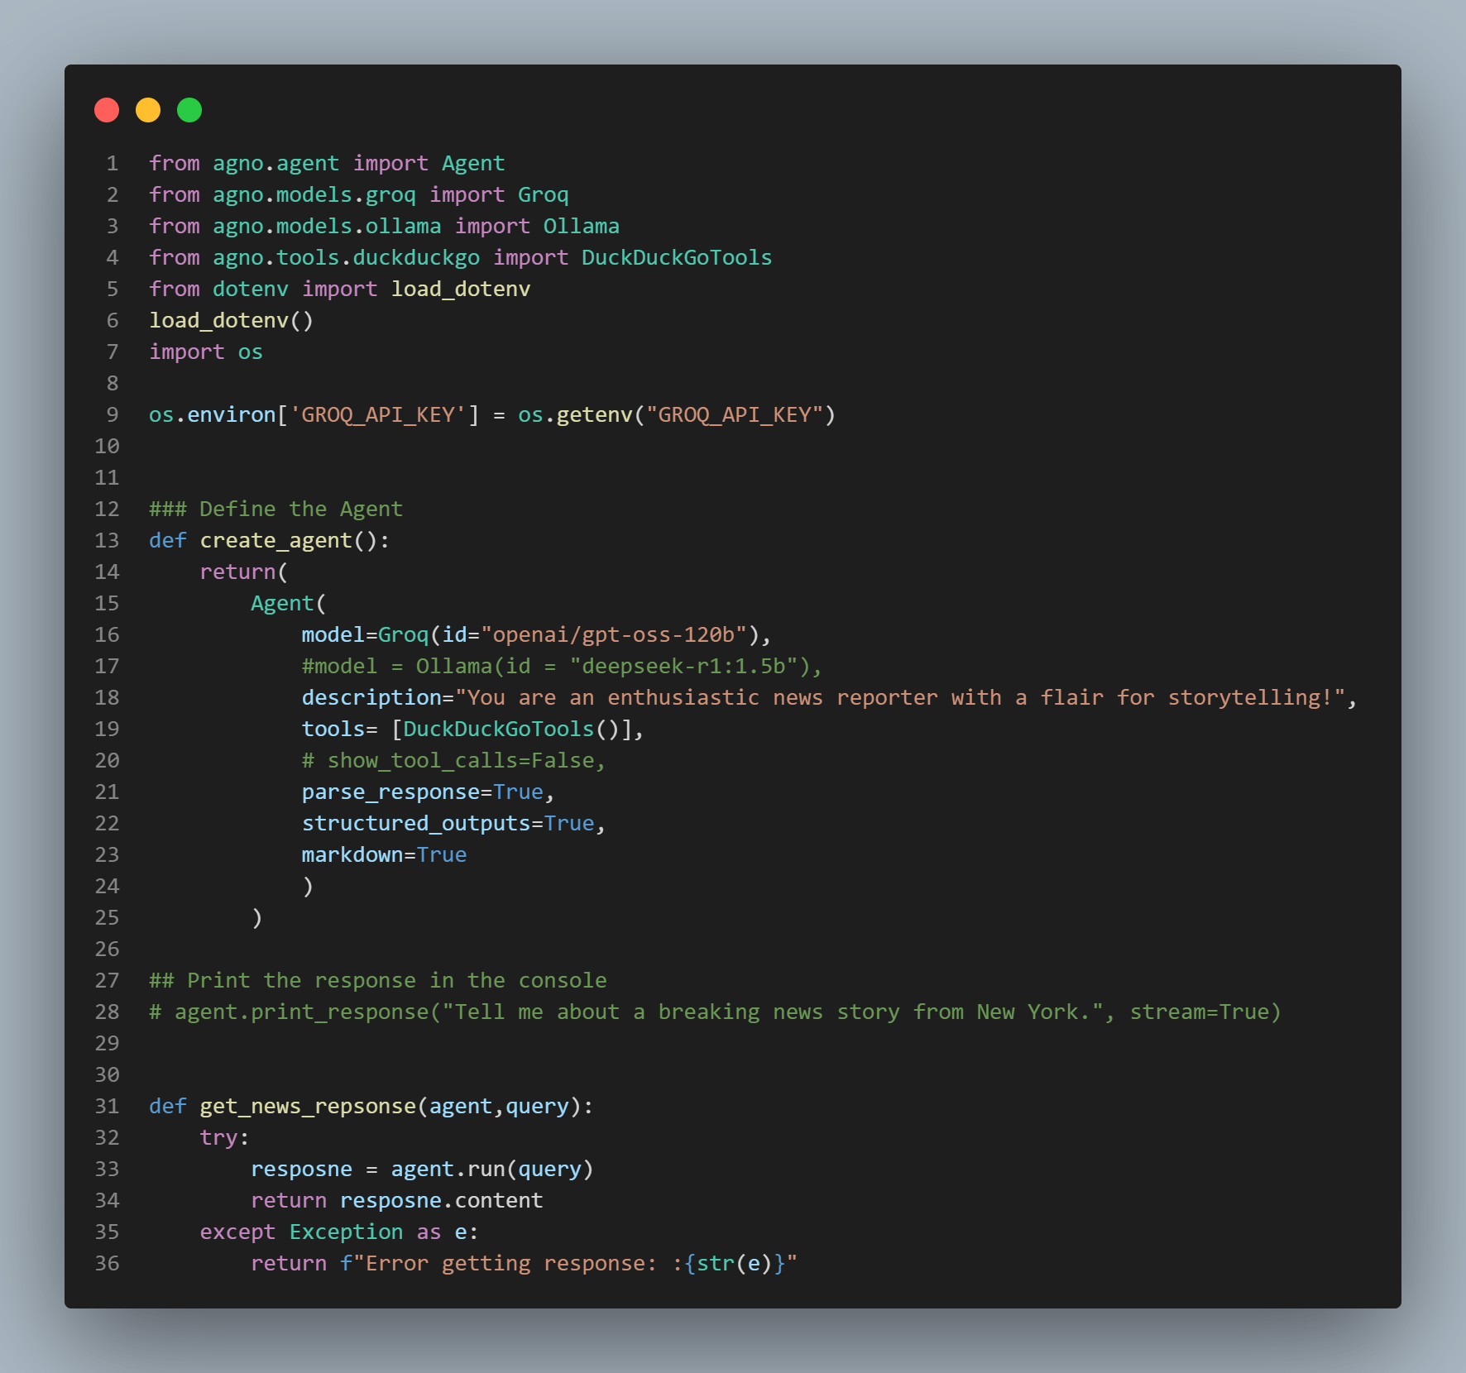**

agent = create\_agent()

class NewsRequest(BaseModel):

    prompt: str

@app.post("/api/generate-news")

def generate\_news(req: NewsRequest):

    news = get\_news\_repsonse(agent, req.prompt)

    return {"news": news}

import re

import uuid

import math

from pathlib import Path

from gtts import gTTS

from pydantic import BaseModel

from moviepy.editor import (

    VideoFileClip,

    AudioFileClip,

    concatenate\_videoclips

)

VIDEO\_TEMPLATE = BASE\_DIR / "news.mp4"

AUDIO\_DIR = BASE\_DIR / "media/audio"

VIDEO\_DIR = BASE\_DIR / "media/video"

AUDIO\_DIR.mkdir(parents=True, exist\_ok=True)

VIDEO\_DIR.mkdir(parents=True, exist\_ok=True)

class NewsMediaRequest(BaseModel):

    prompt: str

def remove\_emojis(text: str) -> str:

    emoji\_pattern = re.compile(

        "["

        "\U0001F600-\U0001F64F"  # emoticons

        "\U0001F300-\U0001F5FF"  # symbols & pictographs

        "\U0001F680-\U0001F6FF"  # transport & map

        "\U0001F700-\U0001F77F"

        "\U0001F780-\U0001F7FF"

        "\U0001F800-\U0001F8FF"

        "\U0001F900-\U0001F9FF"

        "\U0001FA00-\U0001FAFF"

        "\U00002702-\U000027B0"

        "\U000024C2-\U0001F251"

        "]+",

        flags=re.UNICODE

    )

    return emoji\_pattern.sub("", text)

def format\_news\_text(raw\_text: str):

    """

    Returns:

    - headline (string)

    - bullet\_points (list)

    - speech\_text (string, clean for TTS)

    """

    raw\_text = remove\_emojis(raw\_text)

    # Remove markdown symbols

    text = re.sub(r'[\*\_`#]', '', raw\_text)

    # Remove dates like (2026-01-01)

    text = re.sub(r'\(\d{4}-\d{2}-\d{2}\)', '', text)

    parts = [p.strip() for p in text.split('-') if p.strip()]

    headline = parts[0]

    bullet\_points = parts[1:]

    # Speech should be clean & natural

    speech\_text = headline + ". " + " ".join(bullet\_points)

    return headline, bullet\_points, speech\_text

@app.post("/api/news-with-media")

def generate\_news\_with\_media(req: NewsMediaRequest):

    # 1️⃣ Generate AI news

    news\_text = get\_news\_repsonse(agent, req.prompt)

    headline, bullet\_points, speech\_text = format\_news\_text(news\_text)

    uid = uuid.uuid4().hex

    # 2️⃣ Text → Speech

    audio\_path = AUDIO\_DIR / f"{uid}.mp3"

    tts = gTTS(speech\_text)

    tts.save(str(audio\_path))

    # 3️⃣ Sync audio with looping anchor video

    video = VideoFileClip(str(VIDEO\_TEMPLATE))

    audio = AudioFileClip(str(audio\_path))

    loops\_required = math.ceil(audio.duration / video.duration)

    looped\_video = concatenate\_videoclips([video] \* loops\_required)

    final\_video = looped\_video.subclip(0, audio.duration)

    final\_video = final\_video.set\_audio(audio)

    video\_path = VIDEO\_DIR / f"{uid}.mp4"

    final\_video.write\_videofile(

        str(video\_path),

        codec="libx264",

        audio\_codec="aac",

        verbose=False,

        logger=None

    )

    return {

        "headline": headline,

        "points": bullet\_points,

        "audio\_url": f"/media/audio/{uid}.mp3",

        "video\_url": f"/media/video/{uid}.mp4"

    }

**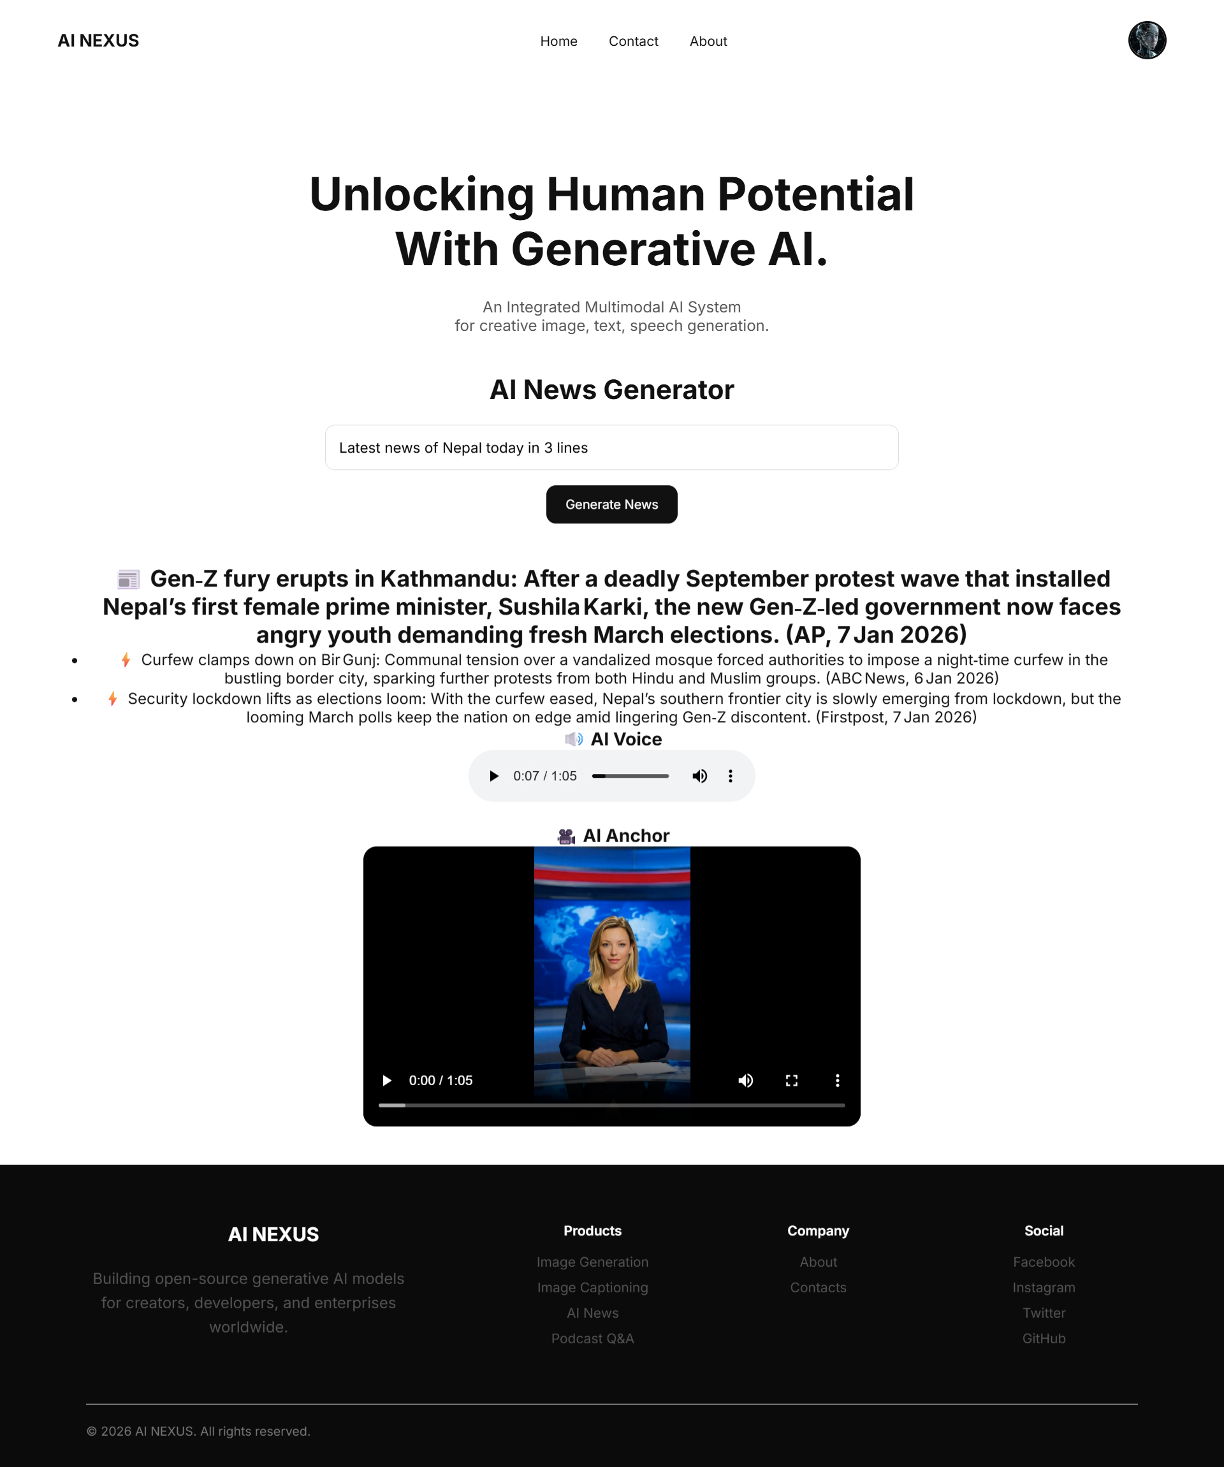**

## Module 4: NexusGPT: Enterprise-Grade Conversational AI System using LangChain and Ollama

**Technical DESCRIPTION**

**Introduction**

This module implements **NexusGPT**, an enterprise-grade conversational AI system designed for professional, structured, and documentation-quality responses. The system integrates:

**LangChain** for prompt orchestration

**Ollama** for local Large Language Model (LLM) inference

**FastAPI** for backend API exposure

**HTML, JavaScript, and Web Speech API** for frontend interaction

The primary objective is to deliver a **production-ready AI chat interface** with strict response formatting, multimodal input support, and clean UI integration.

**High-Level System Architecture**

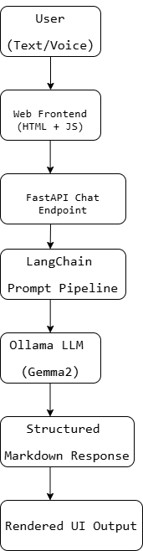

**FIG: System Architecture**

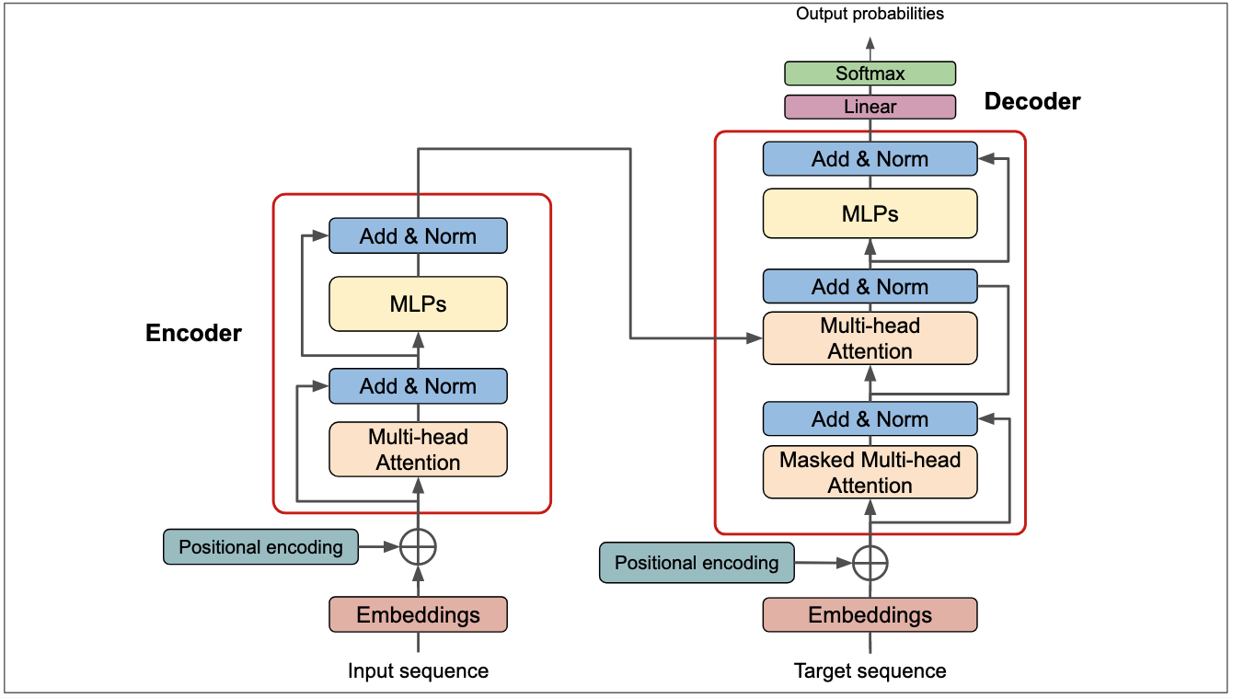

**FIG: TRANSFORMER ARCHITECTURE**

**Environment Configuration**

**LangChain Tracing**

os.environ["LANGCHAIN\_TRACING\_V2"] = "true"

Enables request-level tracing for:

Debugging

Prompt analysis

Performance monitoring

**Project and API Keys**

Environment variables ensure:

Secure credential management

Separation of configuration from code

**Prompt Engineering with ChatPromptTemplate**

**System Prompt Design**

The system prompt defines **strict behavioral constraints**:

Professional tone

Markdown-only responses

Deterministic formatting rules

Separation of code and explanation

This ensures responses resemble **official technical documentation**.

**Prompt–Response Formalization**

The conversation is modeled as:

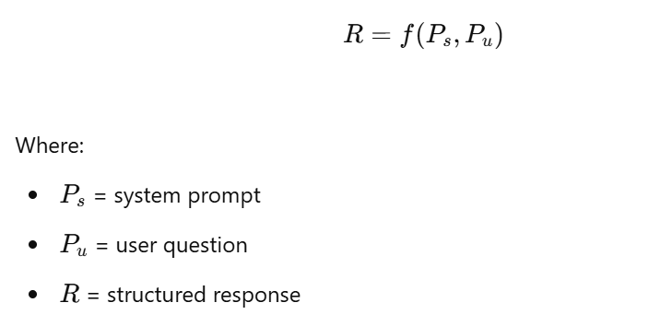

LangChain guarantees consistent prompt injection before each request.

**LLM Selection (Ollama + Gemma2)**

llm = Ollama(model="gemma2:2b")

**Model Characteristics**

2B parameters

Efficient local inference

Low latency

Privacy-preserving (no cloud calls)

This choice balances **performance, cost, and control**.

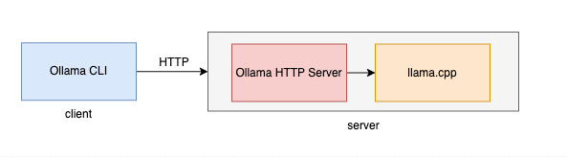

**FIG: OLLAMA ARCHITECTURE**

**LangChain Runnable Pipeline**

chain = prompt | llm | output\_parser

**Pipeline Stages**

Prompt construction

Model inference

Output parsing

This forms a **deterministic, composable execution graph**.

**Output Parsing**

**StrOutputParser**

Ensures:

Clean string output

No metadata leakage

UI-safe rendering

This is critical for frontend Markdown rendering.

**FastAPI Backend Design**

**Chat Endpoint**

POST /api/chat

Request Schema

{

"question": "string"

}

Response Schema

{

"answer": "markdown string"

}

The endpoint is:

Stateless

JSON-based

Easily scalable

**Error Handling**

If the question is missing:

HTTP 400 returned

Clear error message

This enforces API correctness.

**Frontend UI Architecture**

**Navigation Layer**

Branding header

Route-based navigation

User profile placeholder

**Hero Section**

Communicates:

Platform vision

Multimodal AI capabilities

**Chat Interface Design**

**Components**

Textarea input

Send button

Microphone button

Response container

The layout is optimized for **clarity and usability**.

**Markdown Rendering**

marked.parse(data.answer)

The marked library converts Markdown into HTML while preserving:

Code blocks

Headings

Lists

This allows LLM responses to appear as formatted documentation.

**Voice Input Integration**

**Web Speech API**

Speech recognition pipeline:

Microphone → SpeechRecognition → Text → Input Box

Configuration:

Language: en-US

Non-interim results

This enables **hands-free interaction**.

**Multimodal Interaction Model**

The system supports:

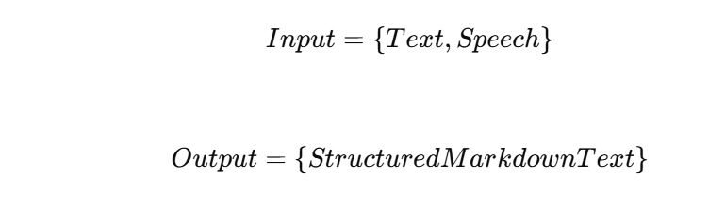

This aligns with modern conversational AI UX standards.

**Security Considerations**

No client-side API keys

Environment-based secrets

Local inference reduces data exposure

**Performance Considerations**

Lightweight 2B model

Prompt caching via LangChain

Minimal frontend JavaScript

This ensures low-latency interactions.

**Advantages of the System**

1.Enterprise-grade response formatting

2.Deterministic prompt behavior

3.Modular architecture

4.Fully offline-capable LLM

**Conclusion**

NexusGPT represents a **professional-grade conversational AI platform** built with modern LLM orchestration principles. By combining LangChain, Ollama, FastAPI, and a structured frontend, the system delivers reliable, well-formatted, and enterprise-ready AI interactions suitable for real-world deployment.

**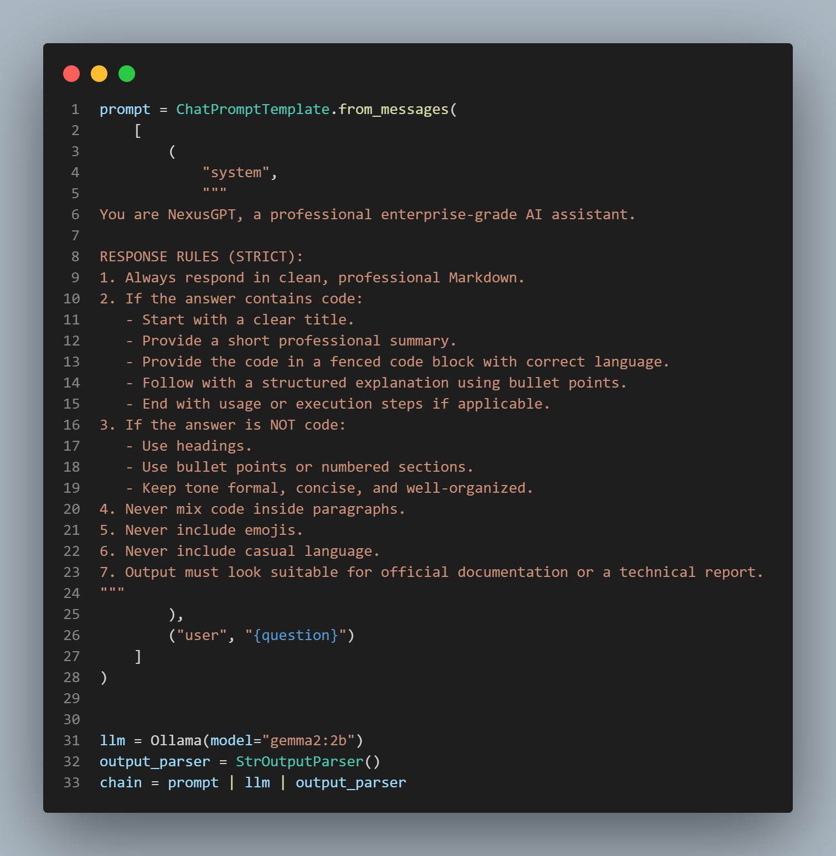**

**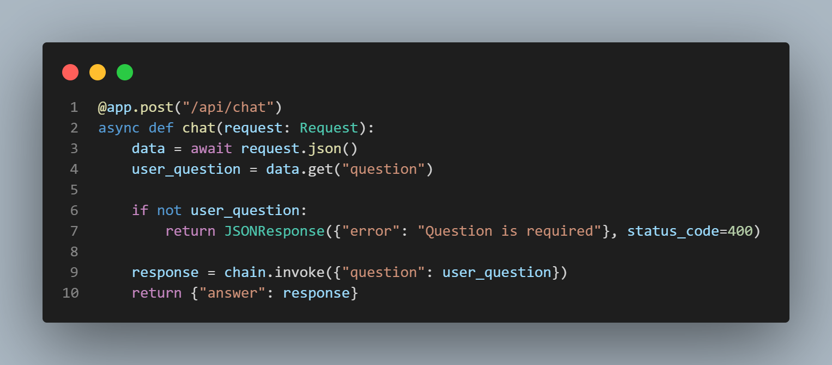**

**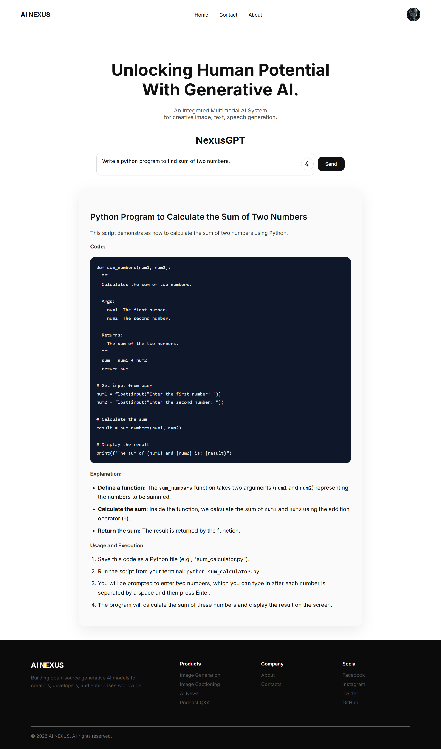**

## Module 5: Podcast Q&A System using Speech-to-Text, Vector Embeddings, and Large Language Models

**Technical DESCRIPTION**

**Introduction**

This project implements an end-to-end Podcast Question & Answering (Q&A) system that enables users to upload podcast audio, automatically transcribe it, store semantic representations of the transcript, and ask natural language questions grounded strictly in the podcast content.

The system combines:

Speech-to-Text (Whisper)

Audio preprocessing

Sentence embeddings

Vector databases (Pinecone)

Large Language Models (LLMs)

FastAPI backend services

This architecture reflects modern Retrieval-Augmented Generation (RAG) design patterns.

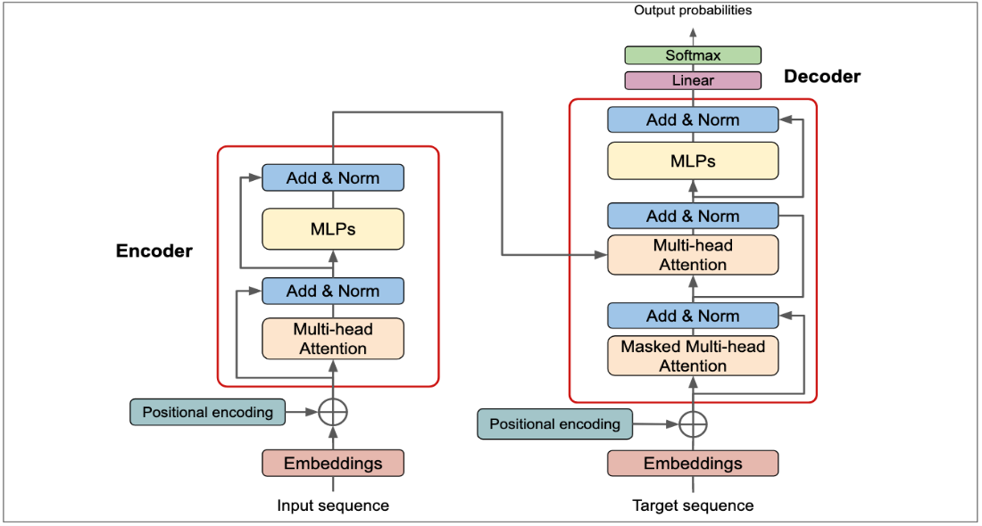

**FIG: TRANSFORMER ARCHITECTURE**

**High-Level System Architecture**

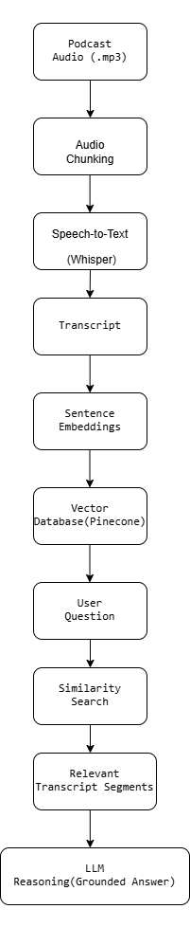

**FIG: SYSTEM ARCHITECTURE**

**Audio Processing Pipeline**

**Audio Chunking**

Long podcast audio files are split into smaller segments to:

Avoid transcription limits

Improve transcription accuracy

Reduce memory usage

Each chunk has a fixed duration (30–60 seconds).

**Mathematical Representation**

Given audio duration (D) and chunk size (c):

N=[D/c]

Where (N) is the number of chunks.

**Speech-to-Text (Whisper)**

**Whisper Model**

The system uses Whisper Large v3, a transformer-based speech recognition model.

Audio signal (A) is mapped to text (T):

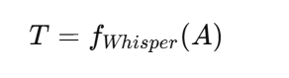

Whisper employs:

Log-mel spectrograms

Encoder–decoder transformers

Multilingual training

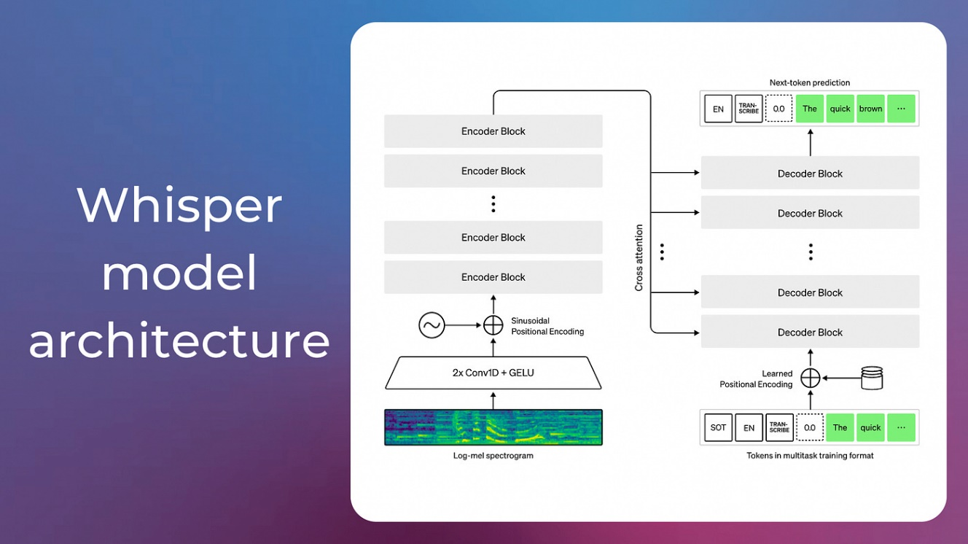

**Transcript Aggregation**

Each transcribed chunk produces partial text:

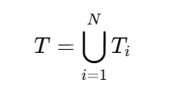

All segments are concatenated into a single coherent transcript.

**Embedding Generation**

**SentenceTransformer Embeddings**

The model all-MiniLM-L6-v2 converts text into dense vectors:

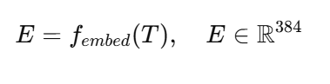

These embeddings preserve semantic meaning and enable similarity search.

**Vector Database (Pinecone)**

**Storage**

Each transcript (or chunk) is stored as a vector in Pinecone.

**Similarity Search**

For a query vector (q):

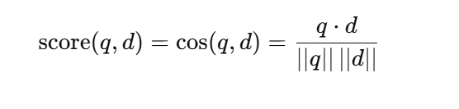

Top-k most similar transcript segments are retrieved.

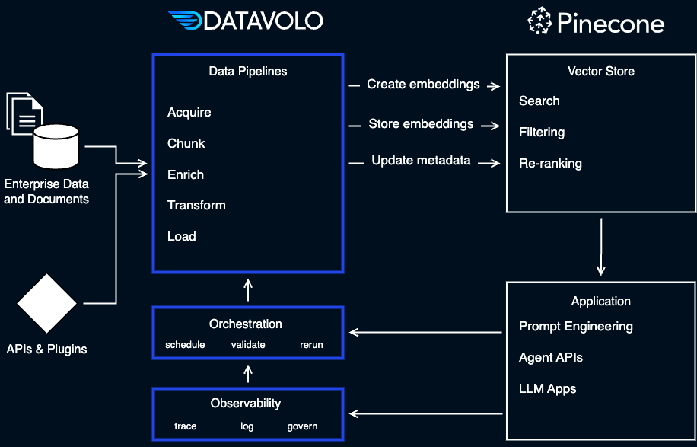

**Fig:  [vector retrieval with Pinecone](https://datavolo.io/vector-retrieval-pinecone/" \t "_blank)**

**Retrieval Augmented Generation (RAG)**

The system follows a RAG paradigm:

Answer=LLM(Question|RetrievedContext)

This ensures answers are:

Grounded

Explainable

Podcast-specific

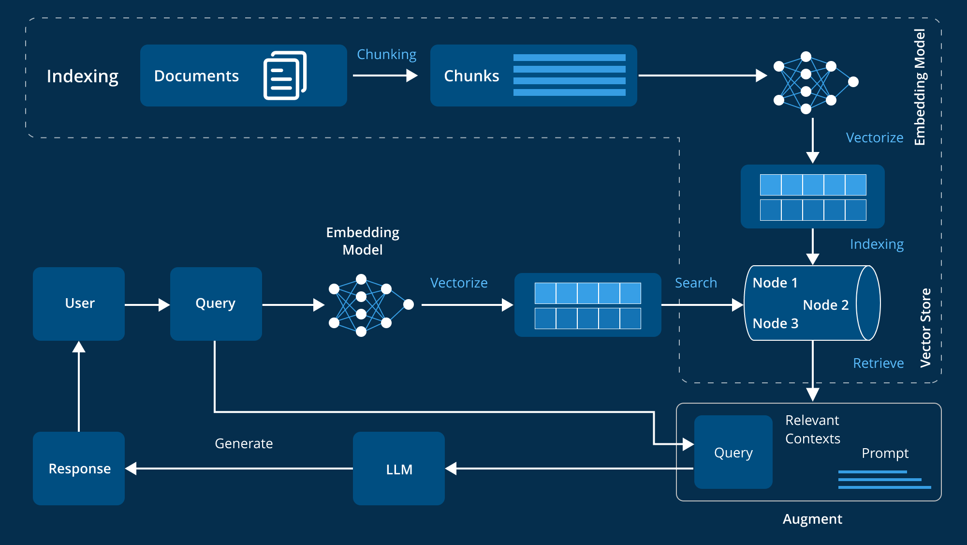

**FIG: Retrieval Augmented Generation (RAG)**

**LLM-Based Question Answering**

**Prompt Conditioning**

The system prompt explicitly constrains the LLM:

Use this transcript to answer the question, citing specific quotes*.*

This minimizes hallucination.

**Autoregressive Generation**

The LLM computes:

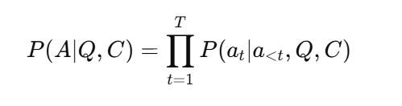

Where:

(Q) = user question

(C) = retrieved transcript context

**Backend API Design**

**Transcription Endpoint**

POST /api/podcast/transcribe

Upload audio

Chunk processing

Whisper transcription

Embedding storage

**Q&A Endpoint**

POST /api/podcast/ask

Accepts user question

Performs similarity search

Generates grounded answer

**Performance Considerations**

Chunked audio processing

Lightweight embedding model

Top-k retrieval

Stateless API design

**Conclusion**

This Podcast Q&A system demonstrates a production-grade Retrieval-Augmented AI pipeline combining speech recognition, semantic embeddings, and large language models. It enables users to interact intelligently with long-form audio content using natural language, making podcasts searchable, explorable, and actionable.

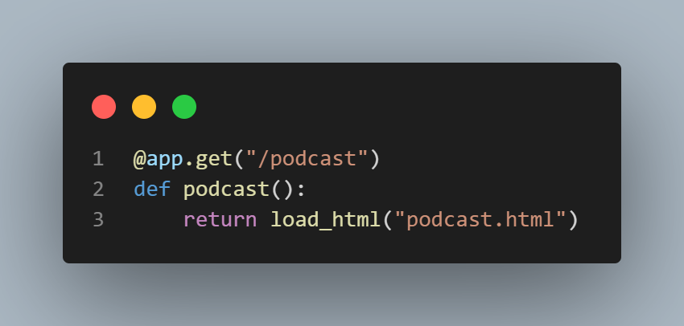

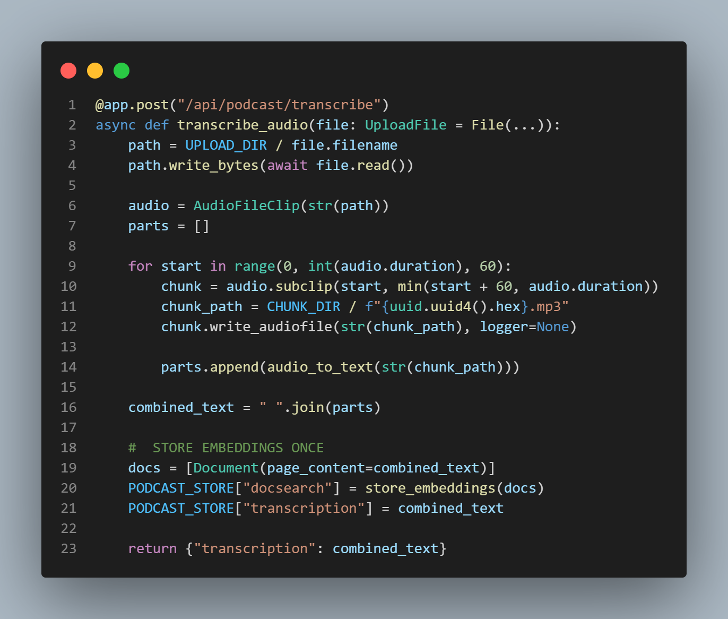

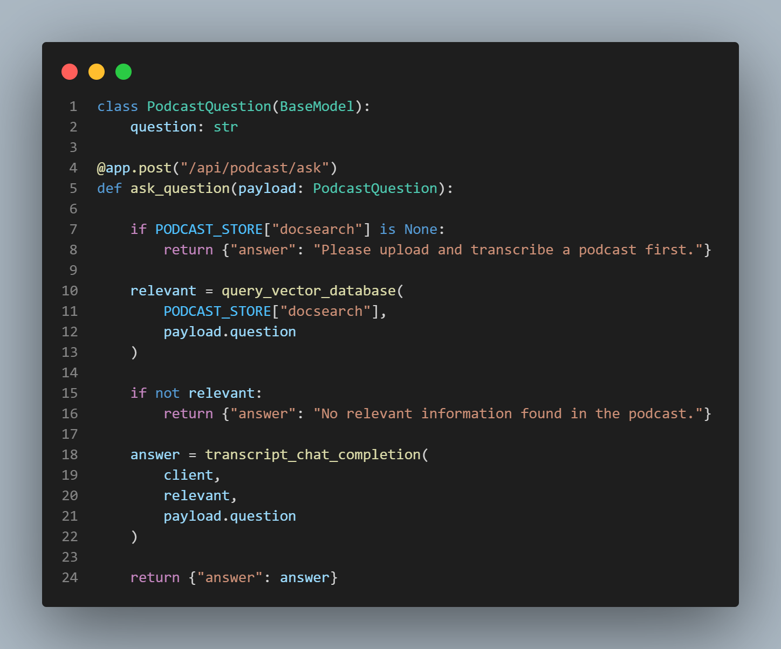

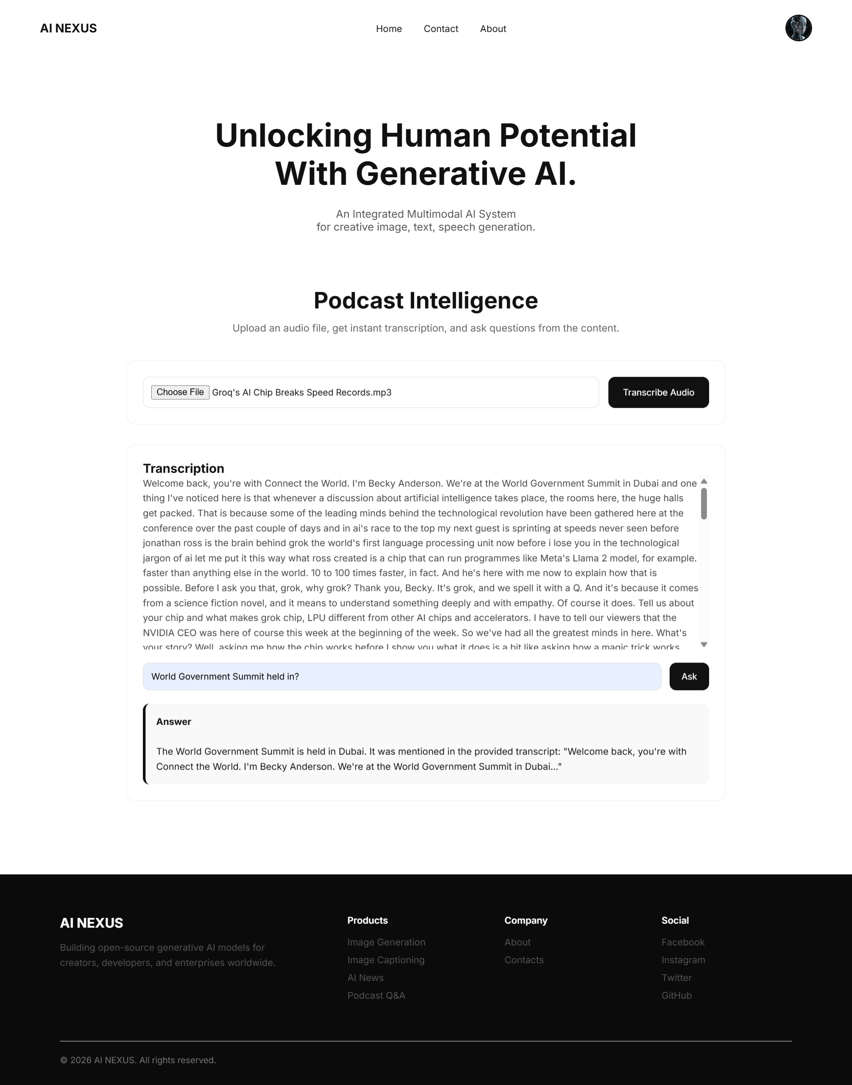

# 9.RESULTS AND DISCUSSIONS

The experimental evaluation of AI\_NEXUS demonstrates that integrating multiple AI paradigms within a unified framework significantly enhances system versatility and practical usability. The image captioning module consistently generated semantically rich and contextually accurate descriptions, validating the effectiveness of BLIP in vision–language alignment tasks. Image classification results achieved high accuracy due to transfer learning from ImageNet-pretrained CNNs, confirming the reliability of feature reuse in low-data scenarios.

Generative image models based on diffusion techniques produced high-quality and visually coherent outputs aligned with textual prompts. Stable Diffusion demonstrated strong generalization across diverse prompts, while DDPM-based generation successfully learned domain-specific image distributions. The AI news generation system effectively combined LLM reasoning with real-time web retrieval, producing factually grounded and structured news content, further enhanced through audio and video synthesis.

The Podcast Q&A system showed substantial improvements in answer accuracy and contextual relevance when using Retrieval-Augmented Generation compared to purely generative responses. The integration of Whisper enabled accurate transcription even under challenging audio conditions.

System-level evaluation confirmed that the FastAPI-based architecture supported low-latency inference and modular scalability. Overall, AI\_NEXUS validates the feasibility and effectiveness of integrated multimodal AI systems, highlighting their potential for real-world deployment in intelligent content generation, conversational platforms, and multimedia analytics.

# 10.PERFORMANCE ANALYSIS AND VALIDATION

The performance of AI\_NEXUS is evaluated using a combination of quantitative metrics, qualitative assessment, and system-level validation strategies tailored to each AI module.

## ****1.Module-Level Evaluation****

**Image Captioning (BLIP):**  
Evaluated using qualitative caption relevance and semantic correctness. Generated captions are manually compared against visual content to assess coherence and descriptive accuracy.

**Image Classification (CNN):**  
Performance is measured using standard classification metrics such as accuracy, precision, recall, and validation loss.

**Text-to-Image & Diffusion Models:**  
Image quality is assessed using visual fidelity, prompt alignment, diversity of outputs, and subjective human evaluation.

**Speech-to-Text (Whisper):**  
Transcription accuracy is evaluated through word error rate (WER) and qualitative robustness in noisy or multilingual scenarios.

**Retrieval-Augmented Generation (RAG):**  
Validation focuses on answer grounding, relevance to retrieved context, and reduction of hallucinations.

## ****2.System-Level Evaluation****

**Latency and Throughput:**  
Inference response time is measured across modules to ensure real-time or near-real-time performance.

**Scalability:**  
Stateless API behavior and modular design are tested for concurrent request handling.

**Reliability:**  
Error handling, fallback mechanisms, and consistency of outputs are validated through repeated trials.

## ****3.Validation Scheme****

1.Pretrained models are validated using standard benchmark expectations.

2.End-to-end workflows are tested using real-world inputs across modalities.

3.API endpoints are validated using functional and integration testing.

4.Human-in-the-loop evaluation is used for generative outputs where quantitative metrics are insufficient.

# 11.TASKS REMAINING

The remaining work in the AI\_NEXUS project focuses on enhancing system security, data persistence, and user interaction features required for real-world deployment. Key tasks include implementing a secure **user authentication system** with email–password login and OAuth-based authentication using Google and Facebook. This will ensure controlled and secure access to platform services.

Another major task is the integration of **SQLite database storage** to enable persistent data management. This includes storing user credentials, authentication metadata, and application-related records in a structured and secure manner.

Additionally, a **Contact Us module** is to be developed, allowing users to submit queries or report issues through the AI\_NEXUS website. User-submitted information will be stored in the SQLite database for administrative review and support handling.

Completing these tasks will improve usability, security, and deployment readiness, transforming AI\_NEXUS into a fully functional, user-centric, and production-ready multimodal AI platform.

# 12. PROPOSED DELIVERABLES / OUTPUTS

The AI\_NEXUS project aims to deliver a comprehensive, modular, and production-ready multimodal artificial intelligence platform. The key deliverables and outputs of the proposed system are as follows:

**1.Integrated Multimodal AI Platform**  
A unified system capable of processing and generating data across multiple modalities, including text, images, audio, and video, through a centralized architecture.

**2.Image Understanding Modules**

Image captioning system using BLIP for semantic image-to-text generation.

Image classification module utilizing ImageNet-pretrained CNN models for accurate visual recognition.

**3.Generative AI Modules**

Text-to-image generation using Stable Diffusion for high-quality image synthesis.

Diffusion-based image generation using DDPMs for dataset-specific image synthesis.

**4.Conversational AI System (NexusGPT)**  
An enterprise-grade chatbot supporting structured, professional, and multimodal interactions through local LLM inference and prompt orchestration.

**5.AI News Generation and Media Synthesis System**  
An autonomous agent-based system capable of generating real-time news content, converting it into speech and video formats, and delivering multimedia outputs.

**6.Podcast Question-Answering System**  
A speech-to-text and Retrieval-Augmented Generation (RAG) based system enabling intelligent querying over long-form audio content.

**7.RESTful APIs and Backend Services**  
FastAPI-based endpoints enabling real-time access to all AI modules with scalable and stateless communication.

**8.Documentation and Deployment Artifacts**  
Technical documentation, architecture diagrams, model descriptions, and deployment guidelines for reproducibility and future extension.

# 13. PROJECT TASKS AND TIME SCHEDULE

We had created a workflow based on the amount of time we had until the final semester is over. Thus, that gave us less than three months to work on. Our project progress is divided into designing, coding and testing phases. A final release has done after packing and finalization to the application. The project schedules have been followed as per requirements and time constraints involved in chart below. The chart does not include numerous informal conversations with the users of the system which had further aided in the development of the system.

## 13.1 LIST OF TABLES

### TIME SCHEDULE (Gantt Chart)

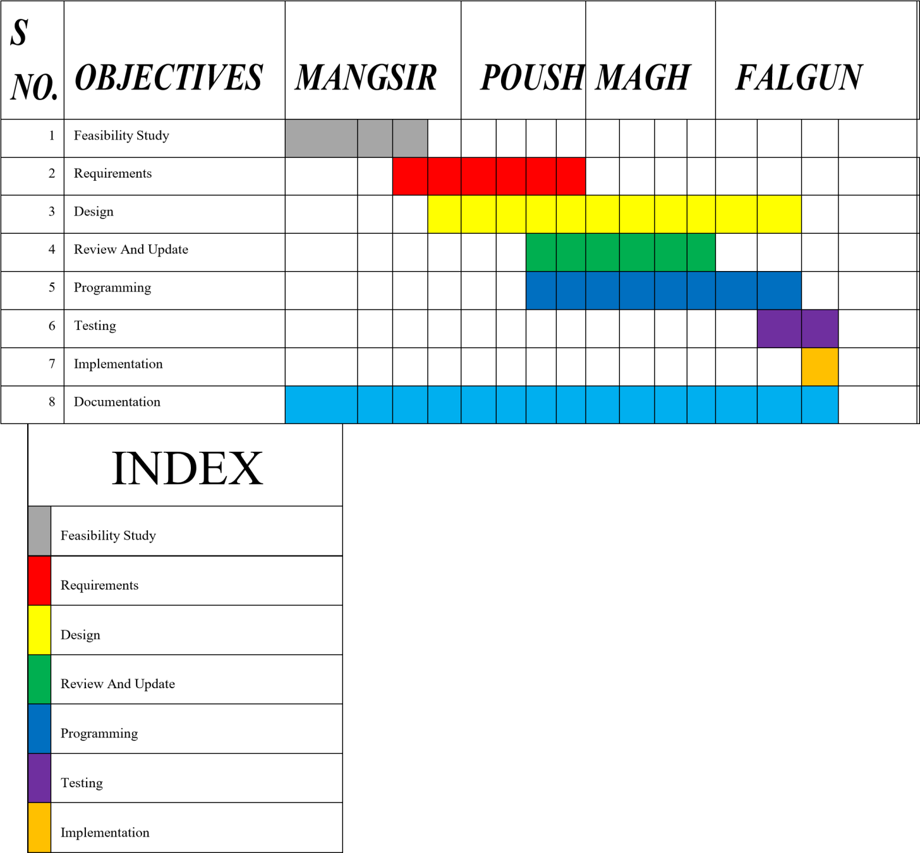

### WORKLOAD DISTRIBUTION

|  |  |
| --- | --- |
| **MEMBER** | **MAIN ROLE** |
| Mehfuz Alam | AI, Frontend, Backend, Documentation |
| Subash Magar | Frontend, UI/UX, Documentation |
| Ashok Bhujel | Backend, Documentation, Analysis |
|  |  |

# 14. BIBLIOGRAPHY/REFERENCES

1. H. C. e. al., "LangChain Documentation," LangChain Community, 10 October 2025. [Online]. Available: https://docs.langchain.com/. [Accessed 10 December 2025].
2. A. Radford, "Whisper: Robust Speech Recognition via Large-Scale Weak Supervision," OpenAI, San Francisco, USA, 2022.
3. I. DuckDuckGo, "DuckDuckGo Search API – Technical Documentation," DuckDuckGo, Inc., 9 March 2023. [Online]. Available: https://duckduckgo.com/api. [Accessed 12 January 2025].
4. I. Hugging Face, "Transformers Documentation," Hugging Face, Inc., 20 June 2024. [Online]. Available: https://huggingface.co/docs/transformers. [Accessed 12 January 2025].
5. E. P. e. a. Patrick Lewis, "Retrieval-Augmented Generation for KnowledgeIntensive NLP," NeurIPS / Meta AI, Vancouver, Canada, 2020.
6. R. Rombach, "High-Resolution Image Synthesis with Latent Diffusion Models," in *Proceedings of the IEEE/CVF Conference on Computer Vision and Pattern Recognition (CVPR)*, New Orleans, USA, 2022.
7. S. Ramírez, "FastAPI Documentation," FastAPI Project / Sebastián Ramírez, 1 September 2024. [Online]. Available: https://fastapi.tiangolo.com/. [Accessed 12 January 2025].
8. J. W. K. e. a. Alec Radford, "Learning Transferable Visual Models From Natural Language Supervision," PMLR, Virtual Conference, 2021.
9. P. Team, "Agno AI Documentation," Agno AI, 15 August 2024. [Online]. Available: https://docs.agno.ai/. [Accessed 12 January 2025].
10. S. I. (. team), "Streamlit Documentation," Snowflake Inc. (Streamlit), 5 October 2024. [Online]. Available: https://docs.streamlit.io/. [Accessed 12 January 2025].